

Inclusive Peer Learning with Augmented Reality Apps

O1.2 Evaluation of Educational AR apps and Toolkit with Unified Guidelines for Educators

Authors: George Terzopoulos and Avgoustos Tsinakos (IHU)
Start date of Project: 2020-09-01
Duration: 36 months
Grant Agreement: 2020-1-DE01-KA203-005733

Executive summary
Inclusive Peer Learning with Augmented Reality Apps (iPEAR) project is a three-year Erasmus+ ΚΑ3 project with a mission to streamline the adoption of Augmented Reality (AR) technology in educational practice. The project combines the collaborative expertise of technology-enhanced learning researchers, computer scientists, and educators to build a strategic partnership.
AR is a rapidly growing market amongst ICT technologies. AR provides an enriched view onto the physical world, adding layers with contextually useful information, delivered visually or by stimulating other senses using hand-held or wearable devices. Many industrial use cases of AR in, for example, manufacturing, construction, health, the service sector, or in trade can be found. While the AR R&D community is growing stronger in Europe, the adoption of the technology in education is still very fragmented.
The iPEAR project aims to mainstream the adoption of educational AR apps by assembling a comprehensive overview of available offers, collecting best practices, creating guidelines for educators and developing an online course to deliver these materials. The project will create innovative open educational resources for educators that help implement and integrate active and collaborative learning pedagogical approaches supported by AR.
The project targets higher education (educators and their students) and maps the educational use of AR, focusing on collaborative and peer learning approaches. It intends to facilitate the adoption of AR in education by creating open access teaching and learning material for educators. It also aims to create and maintain a community of experts in educational AR and other stakeholders that will ensure sustainability of the project and keep the most useful results up-to-date.
This document constitutes the “Evaluation of educational AR apps and unified guidelines for educators” for Task O1.2 of the iPEAR project. This evaluation aims to depict the uses and capabilities of the available tools for building educational AR experiences. Educators can use this information in order to select the appropriate tool and design an educational AR experience based on the guides provided. Section 1 presents online platforms for creating AR experiences that can be viewed with a mobile device through an application, while Section 2 presents platforms that create WebAR experiences that can be viewed in a browser without the need of a specific application. Section 3 presents AR Head Mounted Displays (HMDs) and specific HoloLens2 applications for AR experiences through HMDs. Annex 1 contains links to all available AR platforms, while Annex 2 depicts available repositories for 3D models that can be used in AR experiences.
Users of this toolkit please note, that we do not grant the privacy compliance of the tools presented here. The use of these tools is at your own responsibility.
Table of Contents
Development of the document 4
Table of Abbreviations 4
Partners 5
Section 1. Mobile Applications 6
1. 3D Bear 6
2. AR-Media 12
3. ARTutor 22
4. CoSpaces Edu 32
Section 2. WebAR 43
5. AR Scavenger 43
6. AWE 49
7. BlippBuilder 57
8. Onirix Creative Studio 63
Section 3. AR Head Mounted Displays (HMDs) 70
9. 3D Viewer 71
10. Microsoft Mesh App 76
11. 3D Graffiti 80
12. HoloAnatomy 81
13. Nevrolens 83
14. Develop application for HoloLens 85
List of Figures 86
Annex 1: Web links 89
Annex 2: 3D models repositories 89

Development of the document

Revision | Date | Author(s) | Status | Description
1 | 01/08/2021 | George Terzopoulos, Avgoustos Tsinakos | Draft | First initial draft version containing guides for all platforms.
2 | 01/09/2021 | George Terzopoulos, Avgoustos Tsinakos | Draft | Second full draft version containing examples and best practices.
3 | 20/09/2021 | George Terzopoulos, Avgoustos Tsinakos | Draft | Third version ready for review by AKTO.
4 | 29/09/2021 | George Terzopoulos, Avgoustos Tsinakos | Final first version | First version of O1.2, after review from AKTO.
5 | 29/09/2022 | George Terzopoulos, Avgoustos Tsinakos  Maria Nylund | Final second version | Second version of O1.2, after review from AKTO.
6 | 15/02/2023 | George Terzopoulos, Avgoustos Tsinakos  Maria Nylund | Final third version | Third version of O1.2, after review from AKTO.

Table of Abbreviations

Acronym | Full name
iPEAR | Inclusive Peer Learning with Augmented Reality Apps
AR | Augmented Reality
EUCEN | European university continuing education network
FAU | Friedrich-Alexander-Universitaet Erlangen Nuernberg
NTNU | Norges Teknisk-Naturvitenskapelige Universitet
IHU | Diethnes Panepistimio Ellados
AKTO S.A. | AKTO

Partners

Organization | Country of organisation | Project Role
FRIEDRICH-ALEXANDER-UNIVERSITAET ERLANGEN NUERNBERG (E10209513, DE)  FAU | Germany | Applicant Organization
NORGES TEKNISK-NATURVITENSKAPELIGE  UNIVERSITET NTNU (E10209399, NO)  NTNU | Norway | Partner Organization
EUROPEAN UNIVERSITIES CONTINUING EDUCATION NETWORK (E10082854, BE)  EUCEN | Belgium | Partner Organization
DIETHNES PANEPISTIMIO ELLADOS /  INTERNATIONAL HELLENIC UNIVERSITY IHU  (E10162117, GR)  IHU | Greece | Partner Organization
AKTO S.A.  (E10162068, GR)  AKTO | Greece | Partner Organization

Section 1. Mobile Applications

A common way to experience AR is through a mobile device (phone or tablet). The user opens up the device camera and sees the real world with digital augmentations added to it. The quality of the experience heavily relies on the quality of the camera and the processing power of the device. When a lot of moving 3D augmentations are displayed, the processing power that is needed in order to be displayed correctly and in high quality is significant. In most cases, AR experiences are provided through mobile applications. Many of them require the support of ARCore and ARKit by the device, Google’s and Apple’s libraries for AR experiences. It must be noted that ARCore supports specific devices, and it is not based only on the Android version of the device. This section presents platforms for creating AR experiences that can be viewed through a mobile application.

3D Bear

Link: https://www.3dbear.io/
YouTube: https://www.youtube.com/channel/UC4xbSSrYWDA5bF5B1n8pm_Q/featured
Facebook: https://www.facebook.com/3dbear/
Tutorials: https://www.3dbear.io/tutorials
Cost: Trial version for 30 days and then starting from 119$/year for 1 teacher with 10 student devices.
Description: 3DBear is an official partner of Google for Education and recommended by Google under "Resources for Distance Learning". It is also Microsoft in Education Global Training Partner and recommended by Apple in categories "Learn With AR" and "Remote Learning for Educators". Also, it is selected as part of the 2022 Nordic Baltic EdTech 50 by Holon IQ. 3D Bear includes basic lesson plans for pre-K, elementary schools, middle schools, upper secondary and libraries in ELA, Social Studies, Math, Science, Coding, Design Thinking, Computational Thinking, and STEM/STEAM. Students can "illustrate" stories in 3D and create AR scenes by adding 3D objects into the real world.
Functionality: Teachers can Sign Up for free through the website or through the mobile application and provide their information (Fig. 1.1 and 1.2).

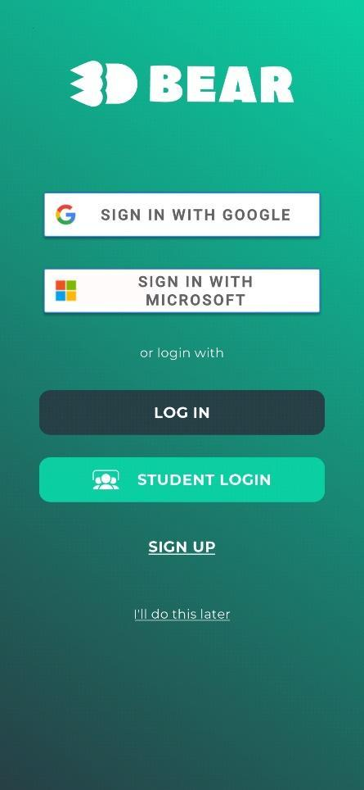  Figure 1.1. Start screen | 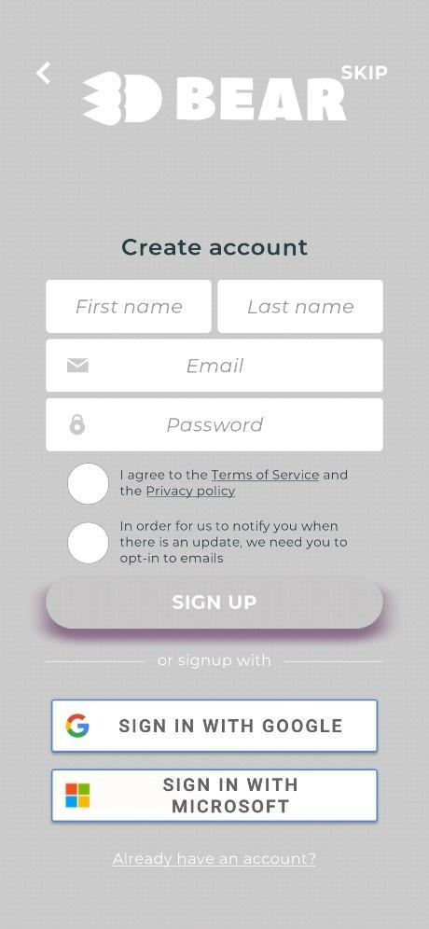  Figure 1.2. Sign Up
The next step for teachers is to create a class. The name of the class can be a project or a lesson, for example: 3A Geography (Fig. 1.3).

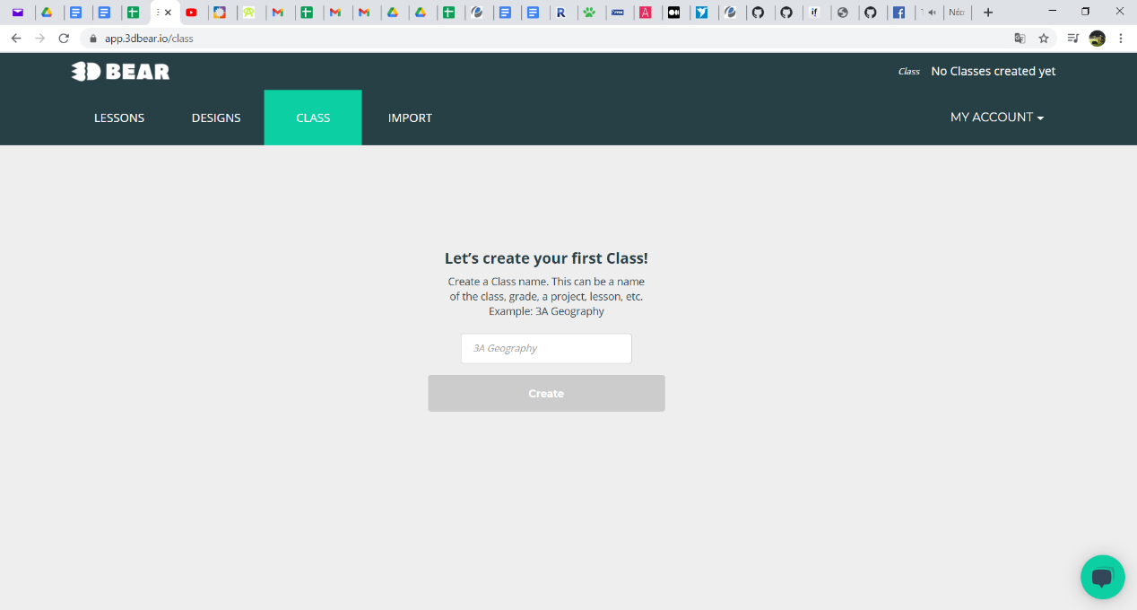
Figure 1.3. Creating a class

After the creation of the class, the class ID is generated by the platform and the teacher can add usernames (Nicknames) to the class (Fig. 1.4).

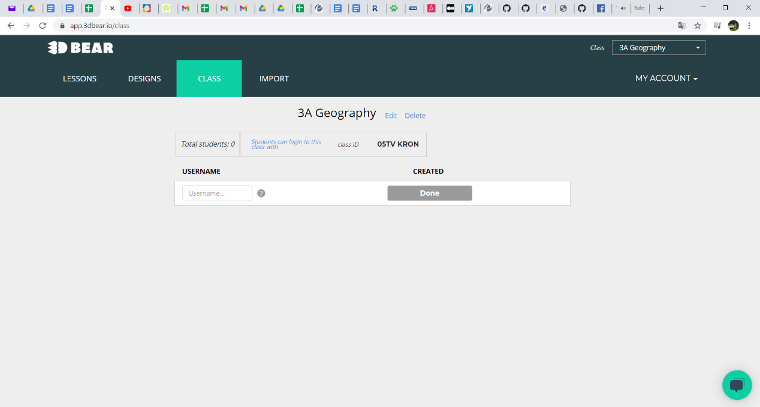
Figure 1.4. Adding students to a class

This process is done manually and there is no automated way. The teacher can add up to 30 students in a class. Students are then provided with the class ID and their nicknames (Fig. 1.5) so that they can use them to login to the application (Fig. 1.6).

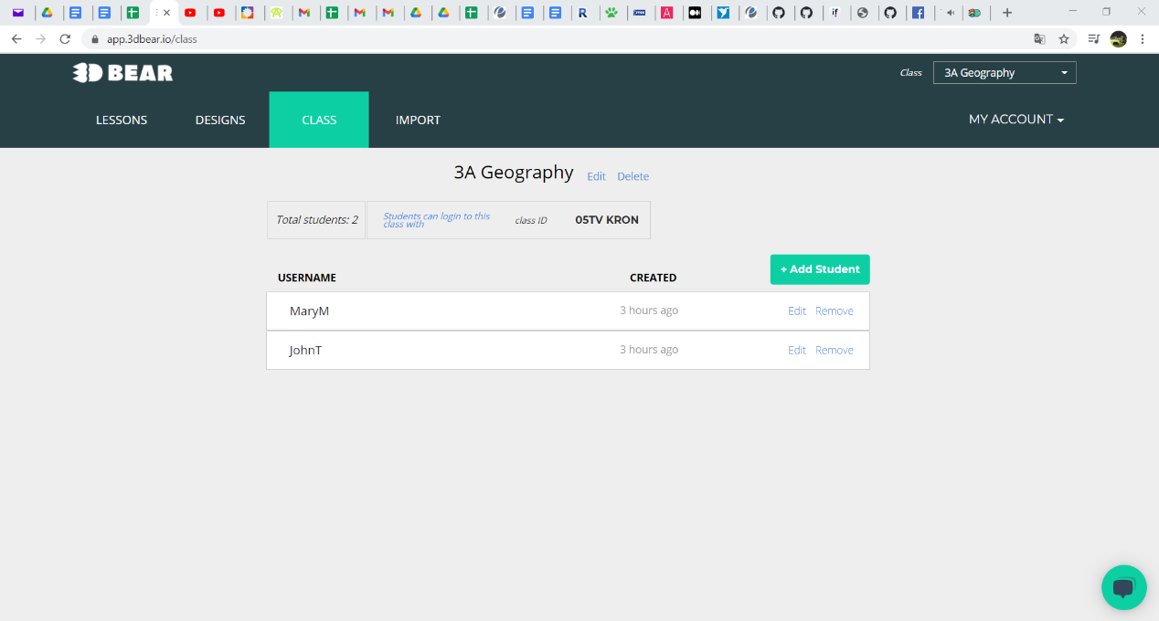
Figure 1.5. Students’ nicknames

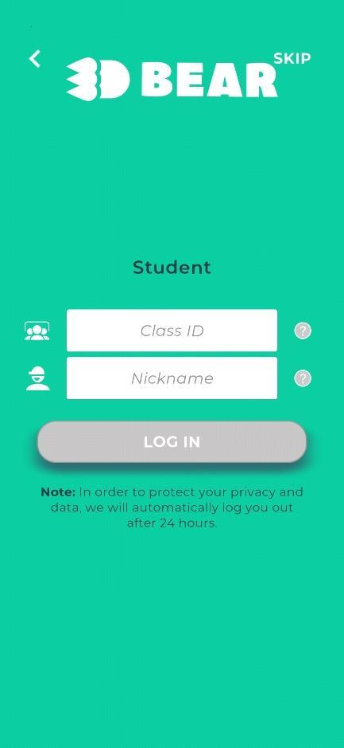
Figure 1.6. Student login

In order to create an AR scene, a student must move the mobile device and scan the environment so that the application can recognize a surface. Then, the student can add 3D objects on the surface, scale them and attach color or textures on them (Fig. 1.7). Many 3D objects can be added in a scene. An image or a video of a scene can be captured. 3D objects can also include animation. There are many 3D objects available divided into categories. Students can add 3D models from Sketchfab or import their own objects (Fig. 1.8). When logged in, students can share their AR scene with the class. Teachers can also create and share AR scenes through the same procedure using the application.

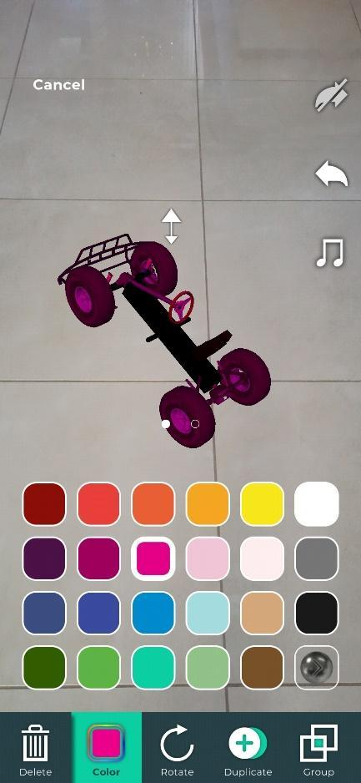  Figure 1.7. Adding 3D objects | 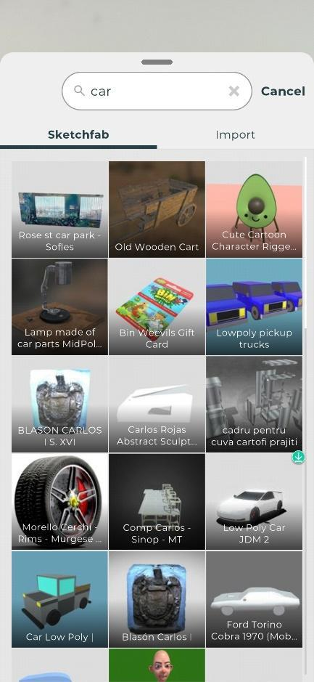  Figure 1.8. Import 3D objects from Sketchfab

All AR scenes can be shared using #hashtags and a caption as a file, or they can be included in the application’s home screen (Fig. 1.9).

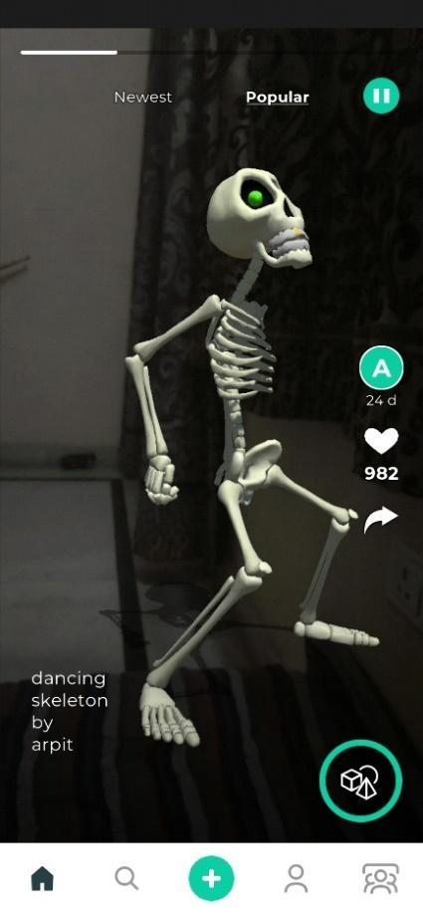
Figure 1.9. Sharing AR scenes in the application’s home screen

Teachers can use the available lesson plans on the web platform (Fig. 1.10).

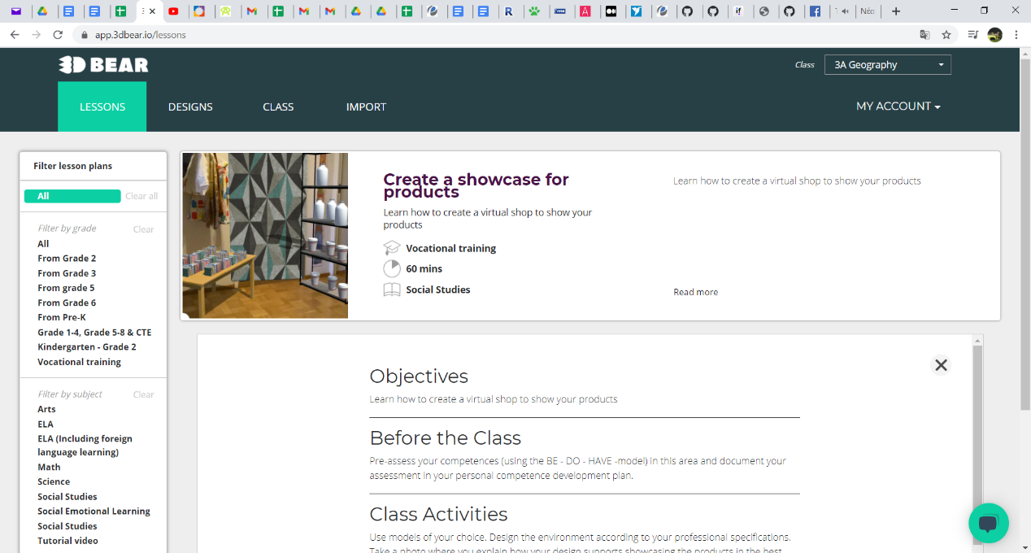
Figure 1.10. Available lesson plans

All AR scenes created by the students of a class are accessible by the teacher in the Designs tab (Fig. 1.11).

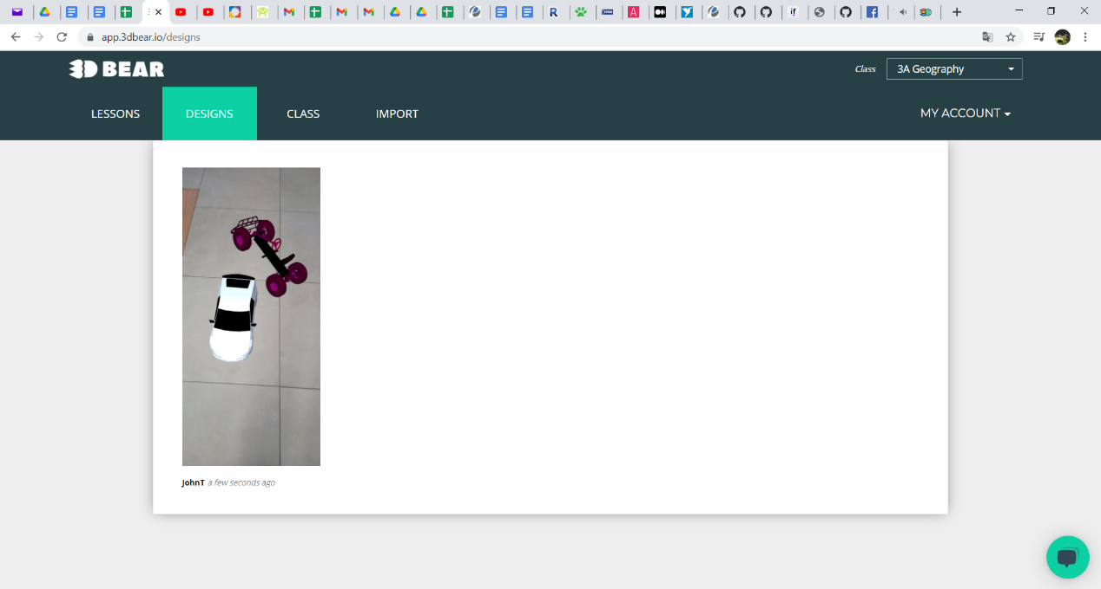
Figure 1.11. AR scenes created by the students of a class

Teachers can subscribe through the website or through the application for the all-access subscription service “3DBear Teacher plan”. The plan includes a licence for 1 teacher and 10 students. The duration of the subscription is one month.

AR-Media

Link: https://www.inglobetechnologies.com/ar-media
YouTube: https://www.youtube.com/user/inglobe
Facebook: https://www.facebook.com/watch/inglobe/
Tutorials: https://www.inglobetechnologies.com/ar-media/documentation/
Cost: Free with limitations (Allows the creation of 1 project). Full version for 25€/month. There are also student (4€/month) and teacher accounts (8€/month) available.
Description: The AR-media platform is a general-purpose Augmented Reality authoring platform, and its components are:
- AR-media Studio: The web authoring tool used to create, manage and distribute projects.
- AR-media Players: The mobile players for iOS and Android devices for displaying projects.
Functionality: The basic steps that are followed in order to create an Augmented Reality experience are:
- Creating the content: (3D models, images, videos).
- Importing the content: manually into the AR-media Studio web application.
- Distributing the content: use the AR-media Studio web application to publish a project or make it available privately to selected users that can view it using the AR-media Player mobile app.
The actions that the users (teachers or students) can do are:
- Import some assets into the Assets Manager.
- Create a new project in the Projects Manager.
- Add one or more experiences to projects.
- Add one or more scenes to the existing experiences.
- Use the available assets from the Assets Manager to adjust the scenes.
To begin with, the users must login through the website or sign up for a new account at https://studio.armedia.it/ (Fig. 2.1).

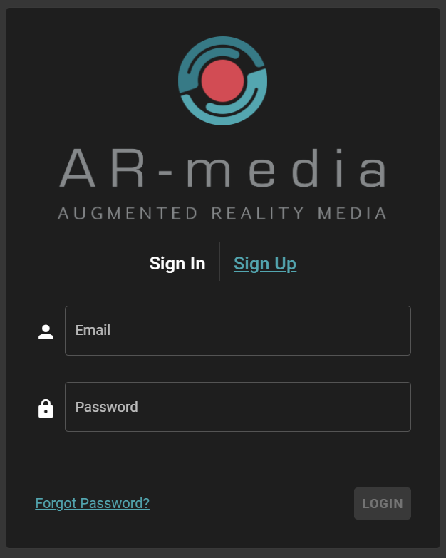
Figure 2.1. Sign in Page

As a first step, users can import a new asset which will be available for later use. The assets can be:
- 3D Models
- Images
- Videos (with or without alpha channel)
- 360 Panoramas
- 360 Videos
- Buttons
- HTML5 mini-apps
- Call to Actions
- Audio

When the assets are ready, users visit the Projects Manager area to start a new Project that can be (Fig. 2.2):
- Planar: allows detecting and tracking planar images.
- Spatial: allows anchoring a virtual content to a specific point in the real world.
- Geo Located: allows adding virtual objects to locations based on GPS coordinates.
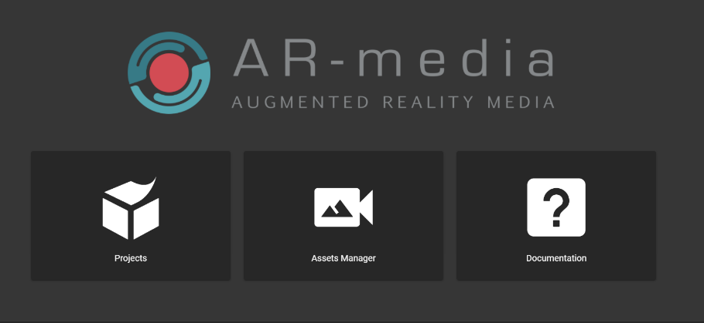
Figure 2.2. Selection of a new project

To create an empty Project, users must click the “+” button in the Projects Manager toolbar. Then, they will be asked for a name and a textual description (Fig. 2.3).

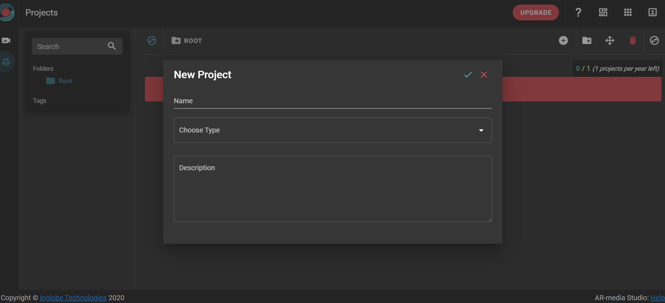
Figure 2.3. Starting a new project

There are three kinds of projects. The icon at the bottom of each project indicates the type of the project the users have selected (Fig. 2.4).
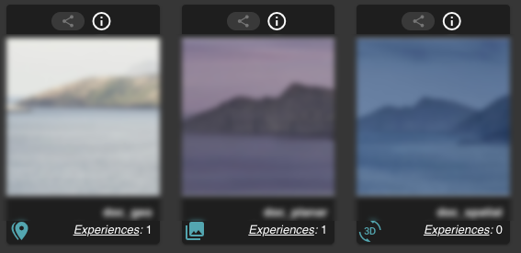
Figure 2.4 The types of projects

A Project consists of experiences that define which scenes are selected to be shown and how.
- A Planar Project can contain one or more Experiences, each defined by the trigger image that will be used to show the virtual scenes.
- A Spatial Project can contain a single Experience that will show virtual scenes in the real world in a surrounding space.
- A Geo-Located Project can contain one or more Experiences, each defined by a GPS location that will be used to show the virtual scenes.
In order to create a new Experience, users open an existing Project on the Project Manager page and click the “+” button. A name and a description are required for the experience. Also, a trigger image is required. In case it is a planar project, the virtual scene will be attached to this image. In a spatial project, the image will be only descriptive and will not play any role during the experience. For a Geo-Located project, users must provide GPS coordinates because the virtual scene will be shown only if the user is close to that location.
Once users have created a Project and at least one Experience is added to it, then, they can start adding scenes. They can arrange added assets and define their function and actions in the Augmented or Virtual Reality experience. To add a new scene, users must open a Project by clicking it in the Projects Manager. A name, a description and the scene type are required. The scene type can be AR, 360 or HTML5.
For Planar projects, assets will be arranged with reference to the trigger image chosen for the according Experience (Fig. 2.5).
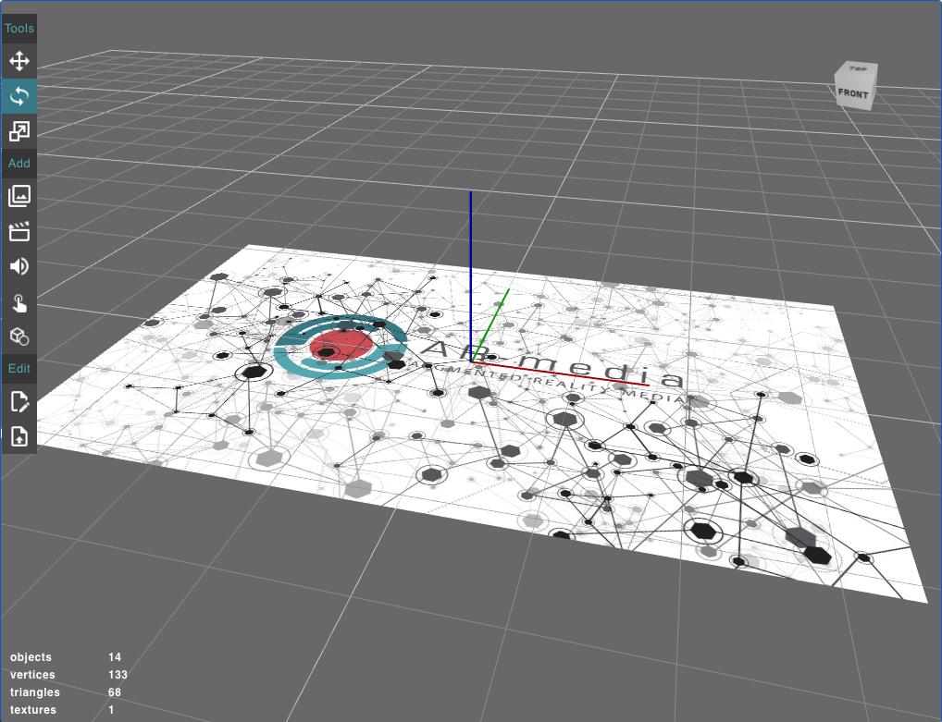
Figure 2.5. AR Scene for a Planar project (Scene Editor)

For a Spatial Project, an AR scene type means that the scene’s elements will be arranged with reference to the origin (0, 0, 0) (Fig. 2.6).

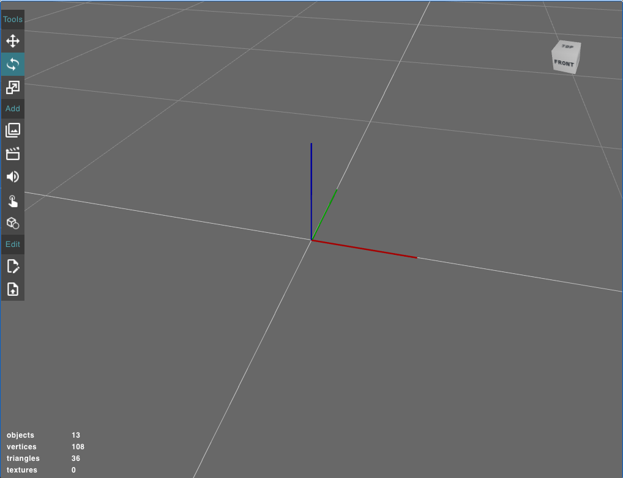
Figure 2.6. AR Scene for a Spatial project (Scene Editor)

Finally, for a Geo-Located project, an AR scene type means that the scene’s content will be arranged with reference to the origin (0, 0, 0) with the Y axis aiming to the North (Fig. 2.7).

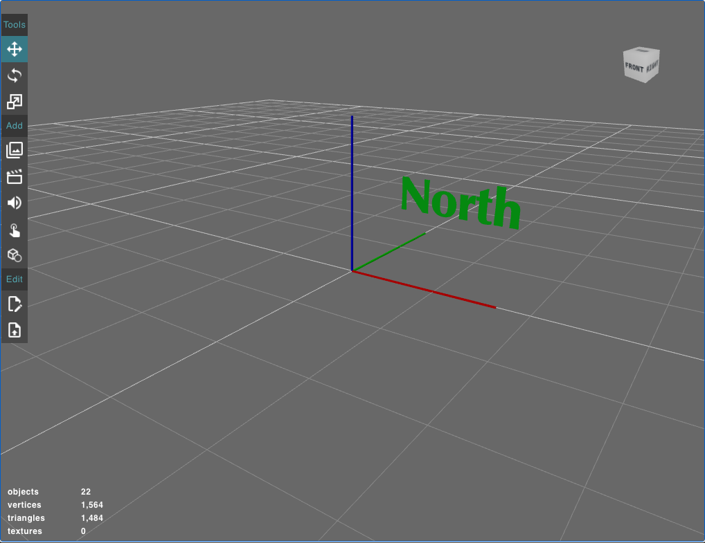
Figure 2.7. AR Scene for a Geo-Located project (Scene Editor)

At this point, the creator of the experience can introduce an image that will appear when the users scan with their mobile phone the environment of a certain location. For example, when a student is located at a place that a historical battle happened, then an image of the warriors and a video of a historical documentary can be projected.
For a 360-scene type, a 360-image or video must be set as the background of a VR experience. There, the creator of the experience can add points of interest and buttons (Fig. 2.8).
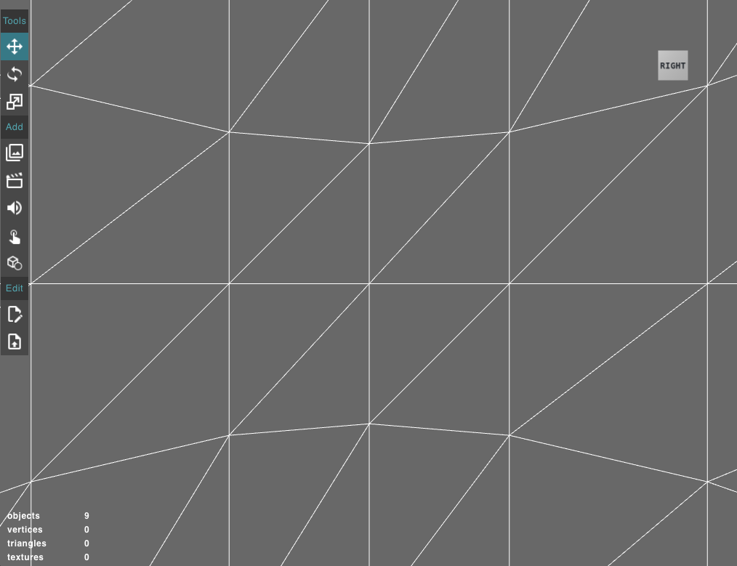
Figure 2.8. 360 Scene (Scene Editor)

This is a very interesting feature for teachers to show their students the anatomy of a human body or an object in 360, to better understand its parts or have a wider aspect of its view. Students can move their device to scan the environment and detect surfaces. Then, they can touch the screen to place the content around them (Fig. 2.9).

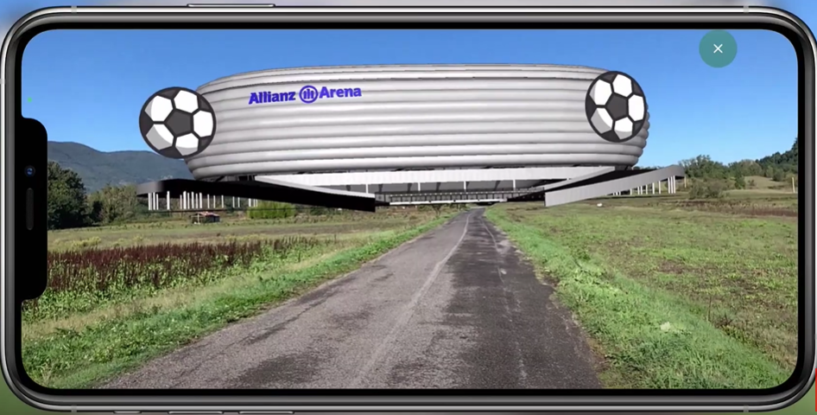
Figure 2.9. 360 view of a court

Regardless of the Project’s type, a HTML5 scene type means that the content is actually an HTML5 mini-app (Fig. 2.10a and b).

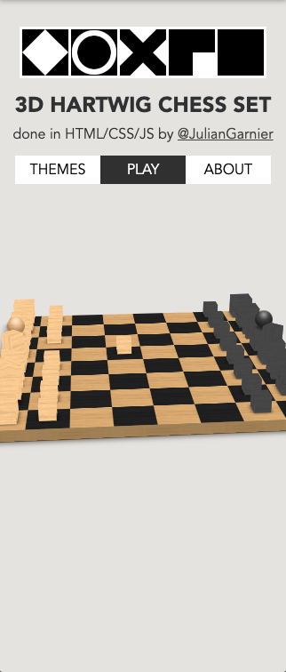  Figure 2.10a. HTML5 Scene Example |   Figure 2.10b. HTML5 Scene Example

Using HTML5 content, users can create a variety of interactive mini-apps, like a chess game, questionnaires and so on. The Scene Editor allows users to preview, arrange and connect 3D models, multimedia assets and user interface elements. Users can connect actions through the Behaviours Manager and, accordingly, connect them to events. They can also preview the assets and user interface elements (Fig. 2.11).
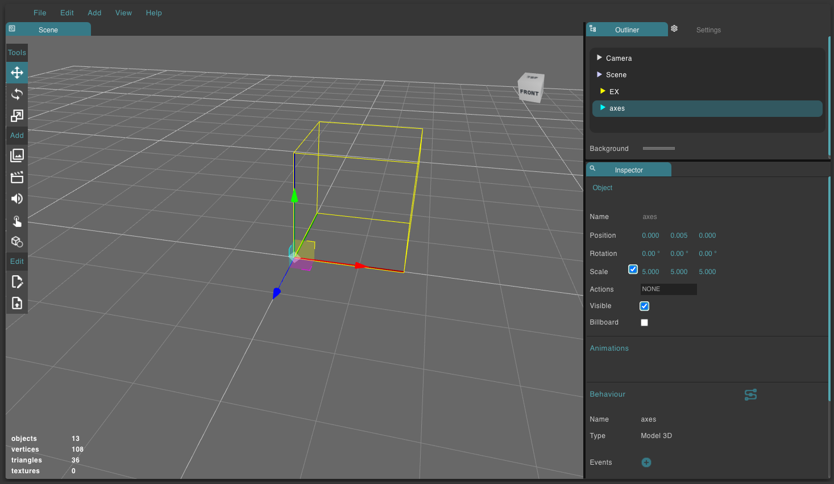
Figure 2.11. The Scene Editor

Users can preview an experience using the QR code that the platform generates for each experience after its creation (Fig. 2.12).

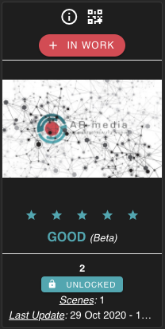
Figure 2.12. The Experience’s card

The QR code for the selected Experience will popup (along with the image trigger used if the project is planar). When users are satisfied with an Experience, they can mark it as COMPLETED (Fig. 2.13).

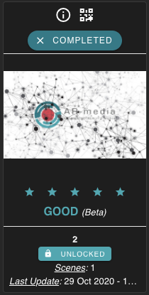
Figure 2.13. The Experience’s card (COMPLETED)

When a project contains at least one Experience marked as COMPLETED then users can distribute them either publicly or privately:
- A publicly distributed Project will appear in the Public Gallery and every user that has the AR-media Player app can open it on his/her mobile device.
- A privately distributed Project can be opened only by providing the Project’s specific QR code to users allowing them to open it.
In order to publish a project publicly, a user can select the project from the Projects Manager card (Fig. 2.14) and then, click the icon in the project’s card and select the Public Gallery option (Fig. 2.15).
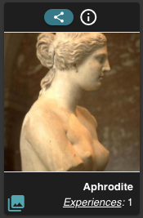
Figure 2.14. Project’s card

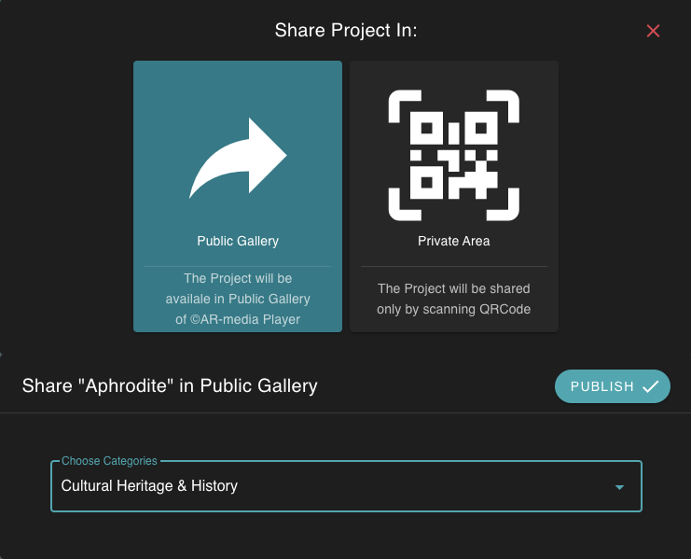
Figure 2.15. Public Gallery option

ARTutor

Link: http://artutor.ihu.gr/
YouTube: https://www.youtube.com/channel/UCUD9StMxHR-hFyAyJKo7-Hg
Facebook: https://www.facebook.com/AetmaLab
Tutorials: http://artutor.ihu.gr/support/
Cost: Free.
Description: ARTutor is an augmented reality platform that consists of an online web portal and a mobile application. The mobile application is used to access the augmented reality Books that were created in the web application.

Functionality:

Web portal

Initially, users can access the Web portal at http://artutor.ihu.gr/ (Fig 3.1) which serves as the gateway to the authoring tool and provides supporting material and tutorials.

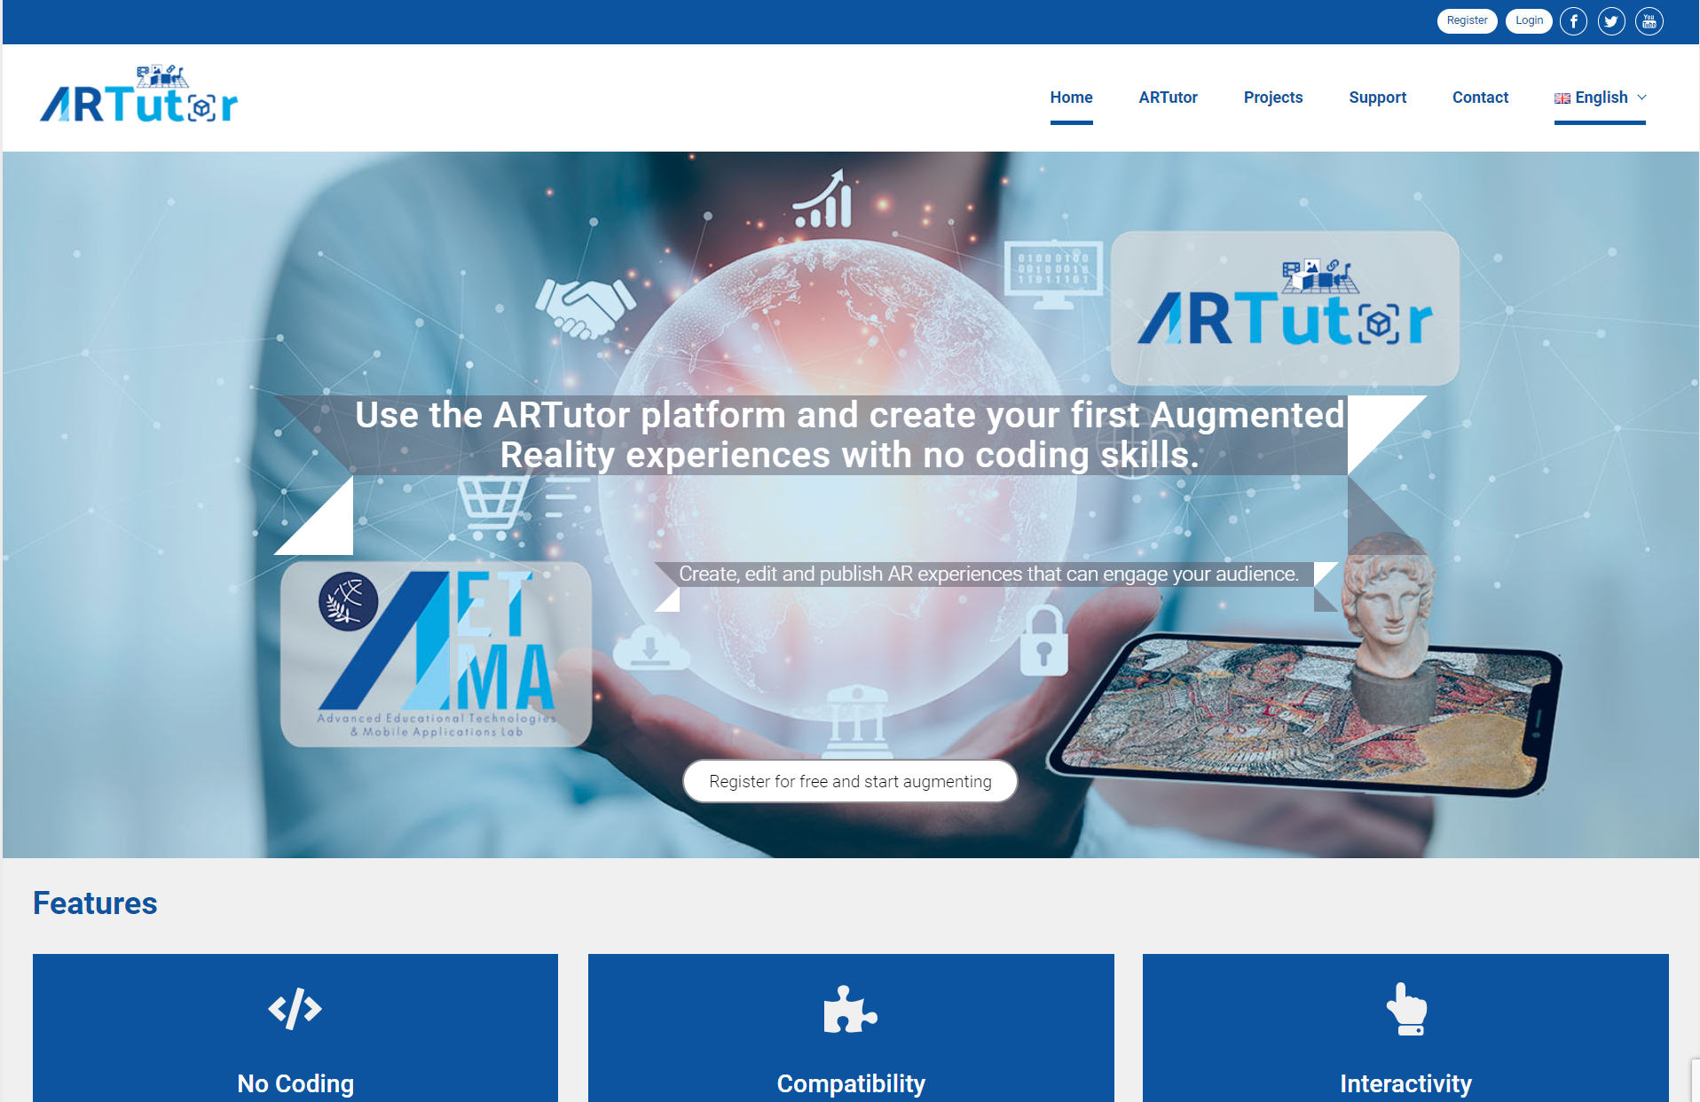
Figure 3.1. Web portal

Users can register for free and after login, they can view a list of all available public Books in the “Public Books” section (Fig. 3.2).

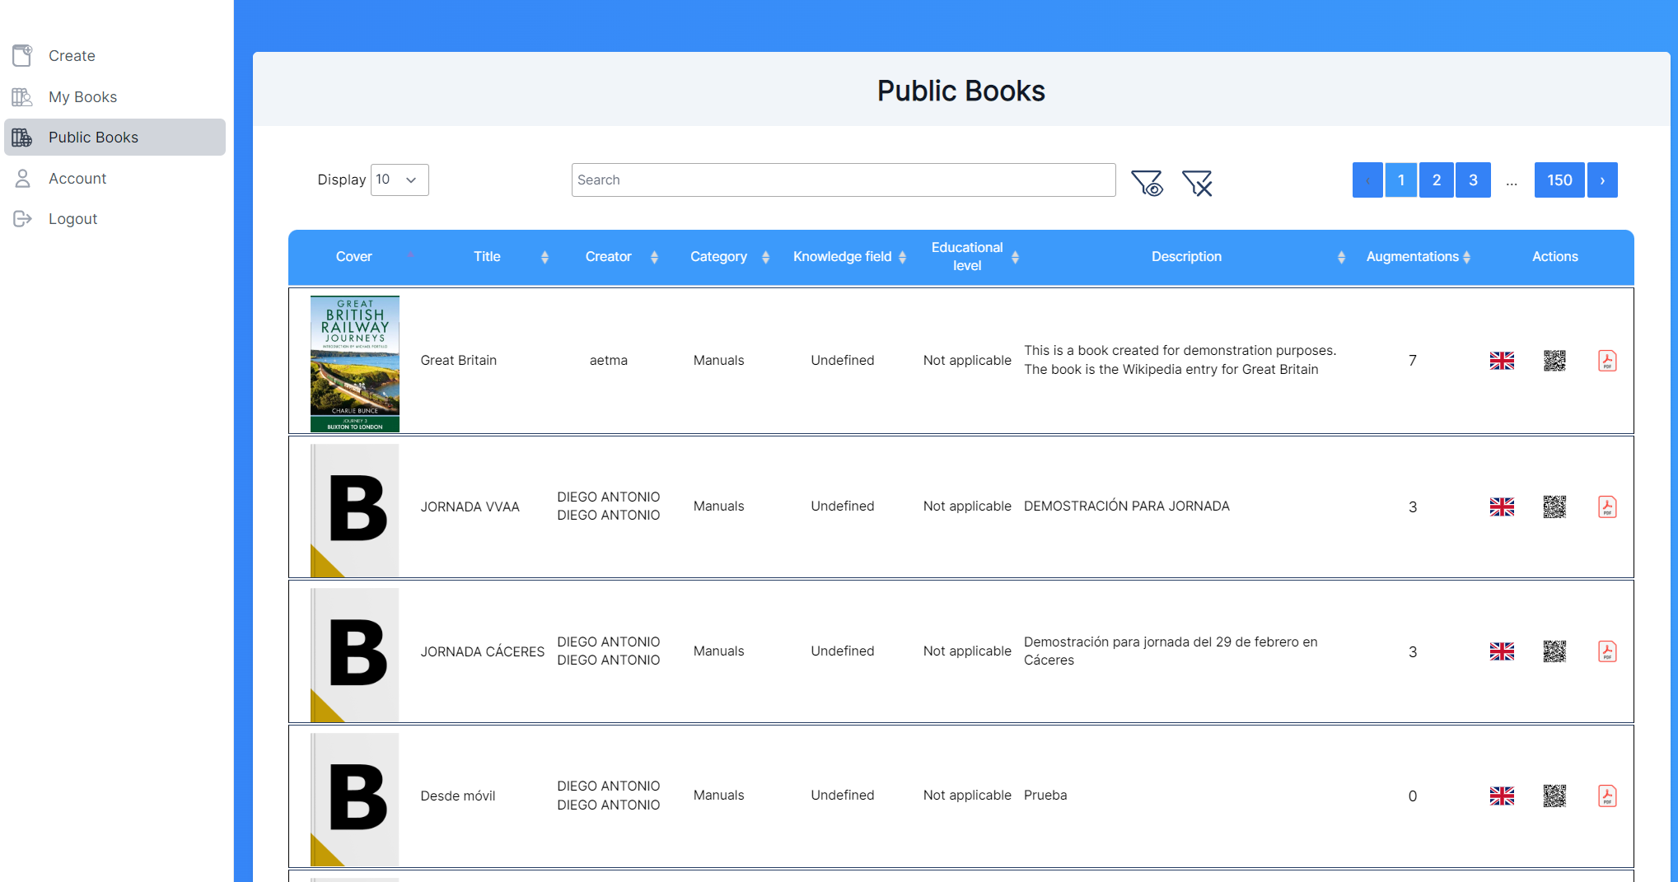
Figure 3.2. Public Books section

Users can search books by title, category, or author or use the filters on top of the page (Fig. 3.3).

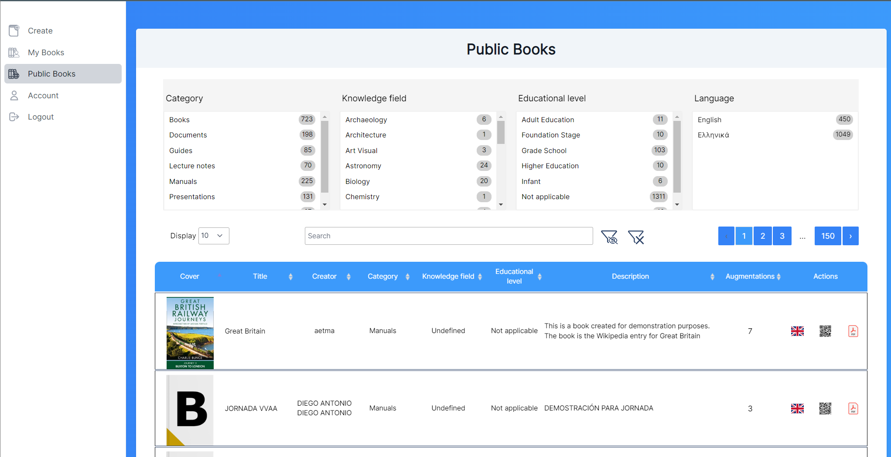
Figure 3.3. Search filters

From the “Augmentations” column, after clicking on the number on the row of a specific Book, users can see the augmentations available for the Book (Fig. 3.4)

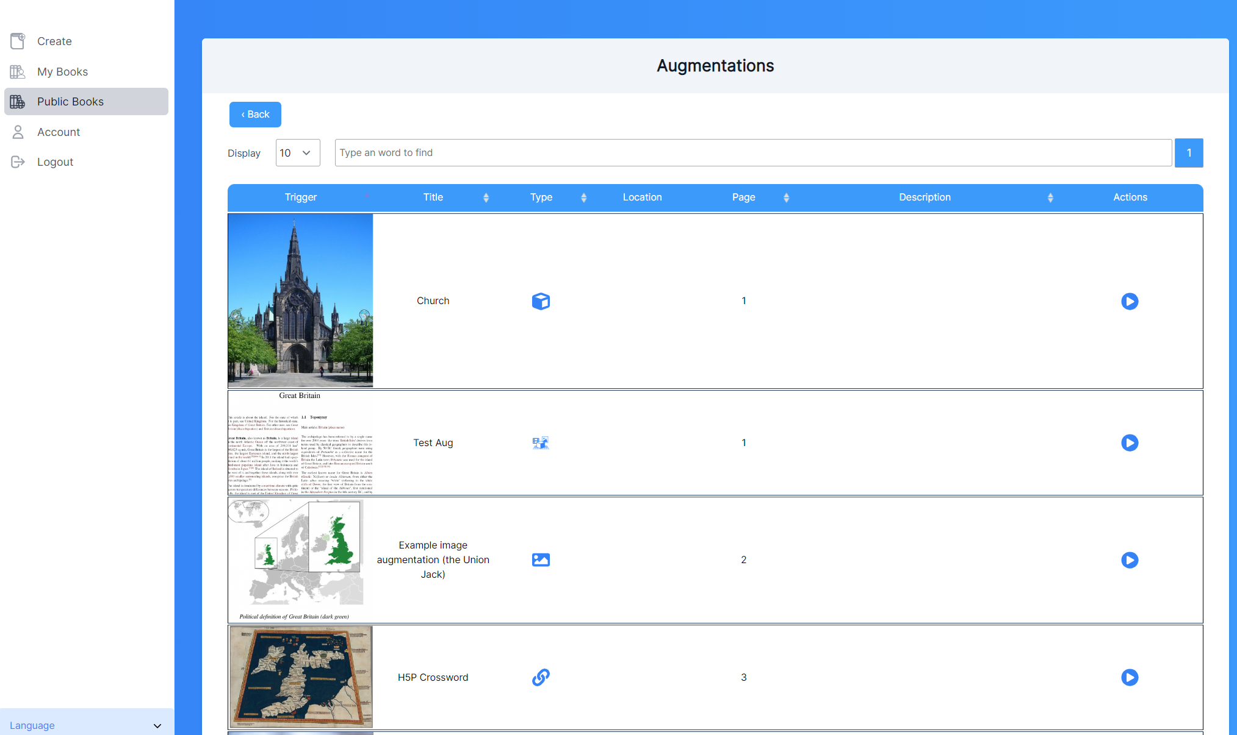
Figure 3.4. Augmentations of a Book

From the Books list, users can click on the QR Code icon to print a page with the QR Code of the Book and the related information of the Book (Fig. 3.5). The printed QR Code can be used by the ARTutor mobile application to directly open the specific Book. From this window, users can also download or view the Book in pdf format.

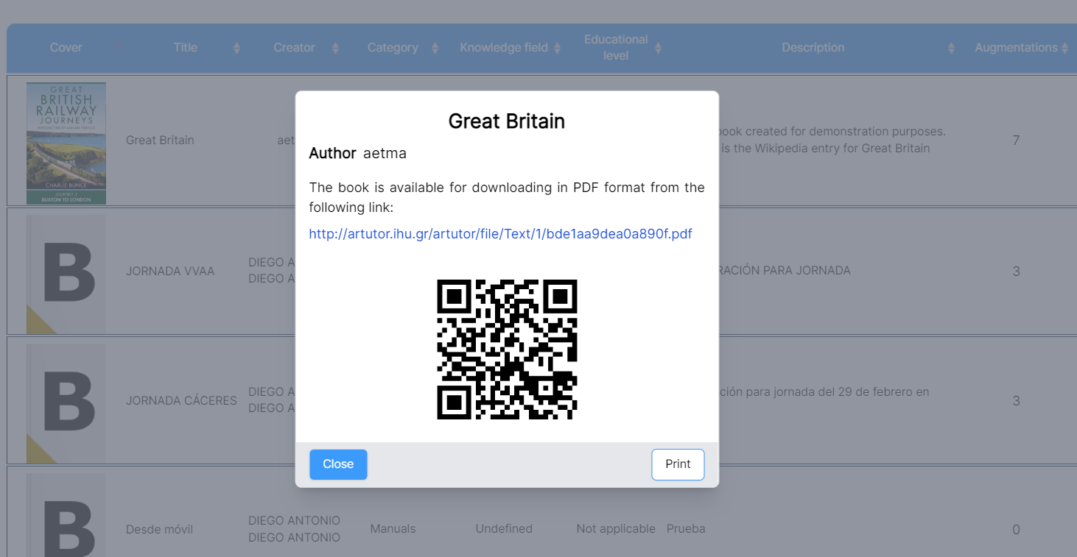
Figure 3.5. Display QR Code

Authoring tool
To create augmented Books, users need to register and then login to their personal account. After the registration is completed, a confirmation email is sent to the users’ email address. Users can then login to the system and create a new Book or edit their Books. After login, users are directed to the “My Books” section where they can see a list of the Books they have created and edit them (Fig 3.6).

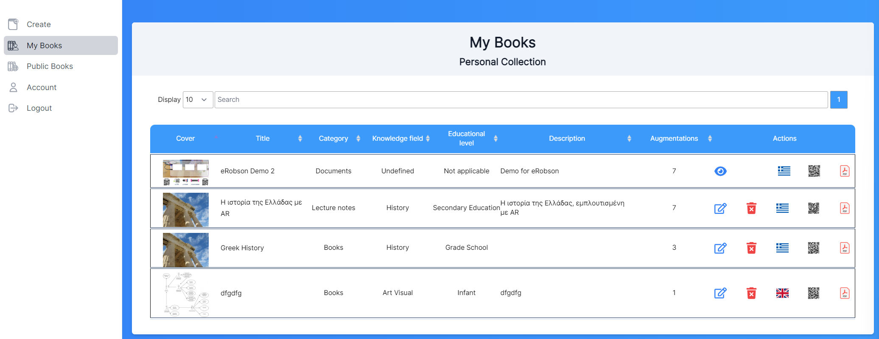
Figure 3.6. My Books section

Book creation
To create a new Book, users can go to the “Create” menu on the left. When creating a new Book, a form appears (Fig. 3.7) where the Book's information is entered (title, description, category, language, knowledge field, educational level) and a picture for a cover and a pdf file for the Book must be uploaded. The Book must be in PDF format and smaller than 50MB in size. This Book will be used as the source where the ARTutor mobile application will display the augmentations.

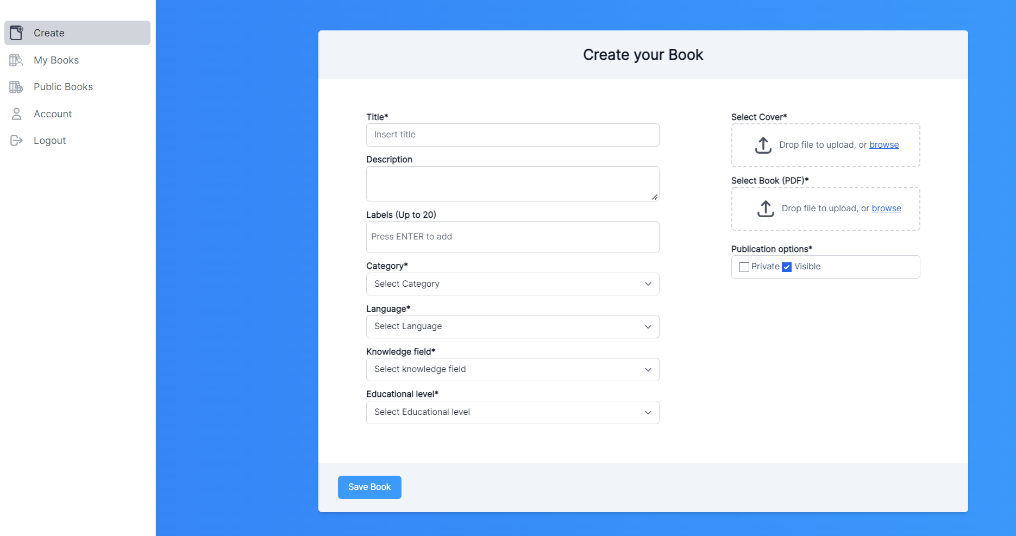
Figure 3.7. Create your Book section

When the Book is created, the Book information is displayed and the QR code of the Book is generated (Fig 3.8). Users can then edit all the information.

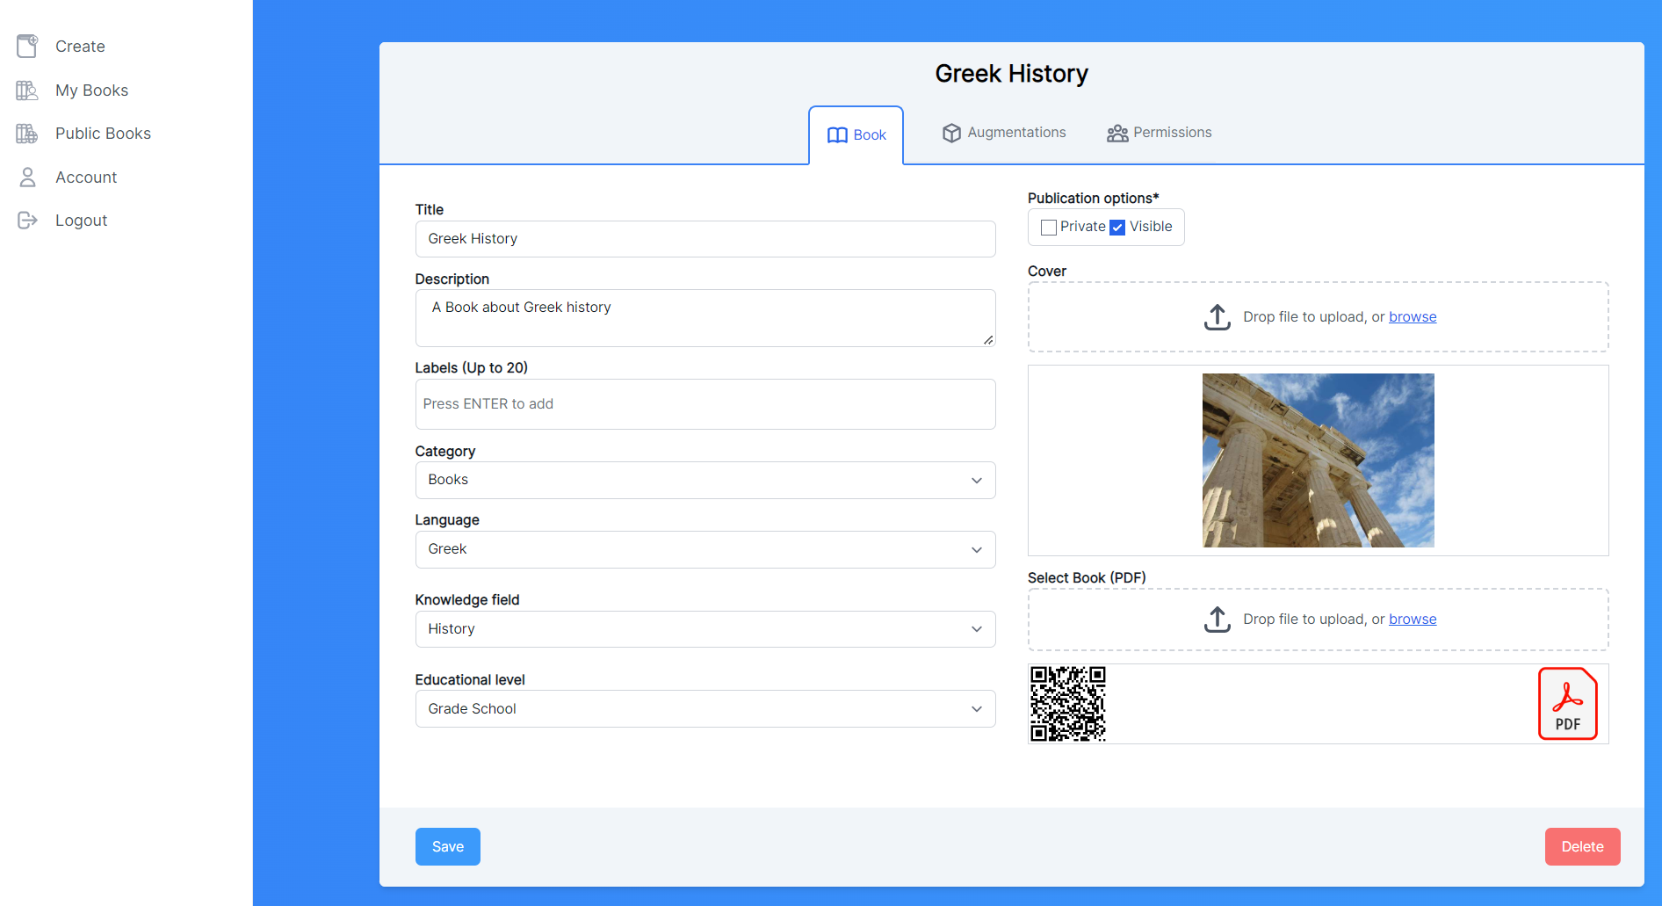
Figure 3.8. Book details section

From the “Augmentations” tab, users can add augmentations by clicking on the “add augmentation” button (Fig 3.9).

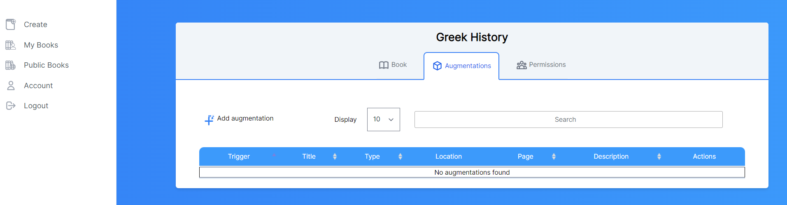
Figure 3.9. Augmentations section

Multiple augmentations can be added to a Book. The steps that users need to follow in order to add an augmentation (Fig. 3.10) are:
- Provide a title and a description.
- Select the page and the area of the Book that can be recognized by the mobile application, i.e., generate the trigger image (“Crop” button)
- Select the augmentation type (image, video, 3D Model, URL-HTML, Audio, AR Experience Editor) and upload the augmentation file. The augmentation will be displayed on top of the specified area when recognized by the camera using the mobile application.
- Save the augmentation (“Save” button) and add other augmentations.
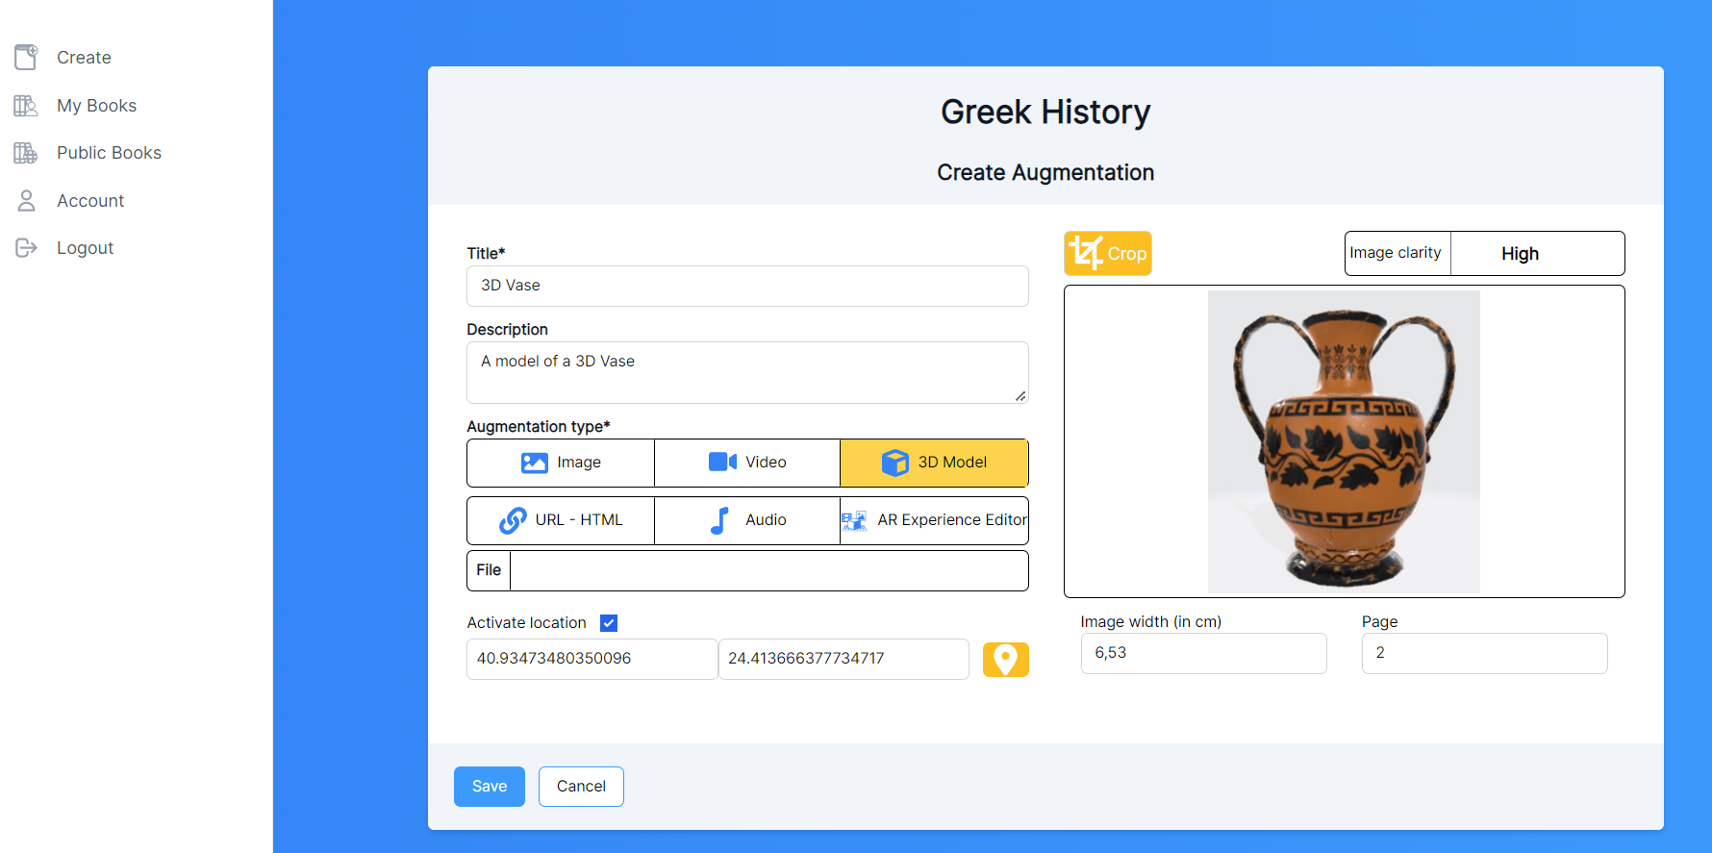
Figure 3.10. Create augmentation section

Selection of the area of the Book that can be recognized by the camera using the ARTutor mobile application is achieved by opening the Book in a new window, selecting the corresponding page, and cropping the area with the mouse. First, users click on the “Crop” from the “Create Augmentation” section. Then a Book display window will appear as shown in Fig. 3.11.

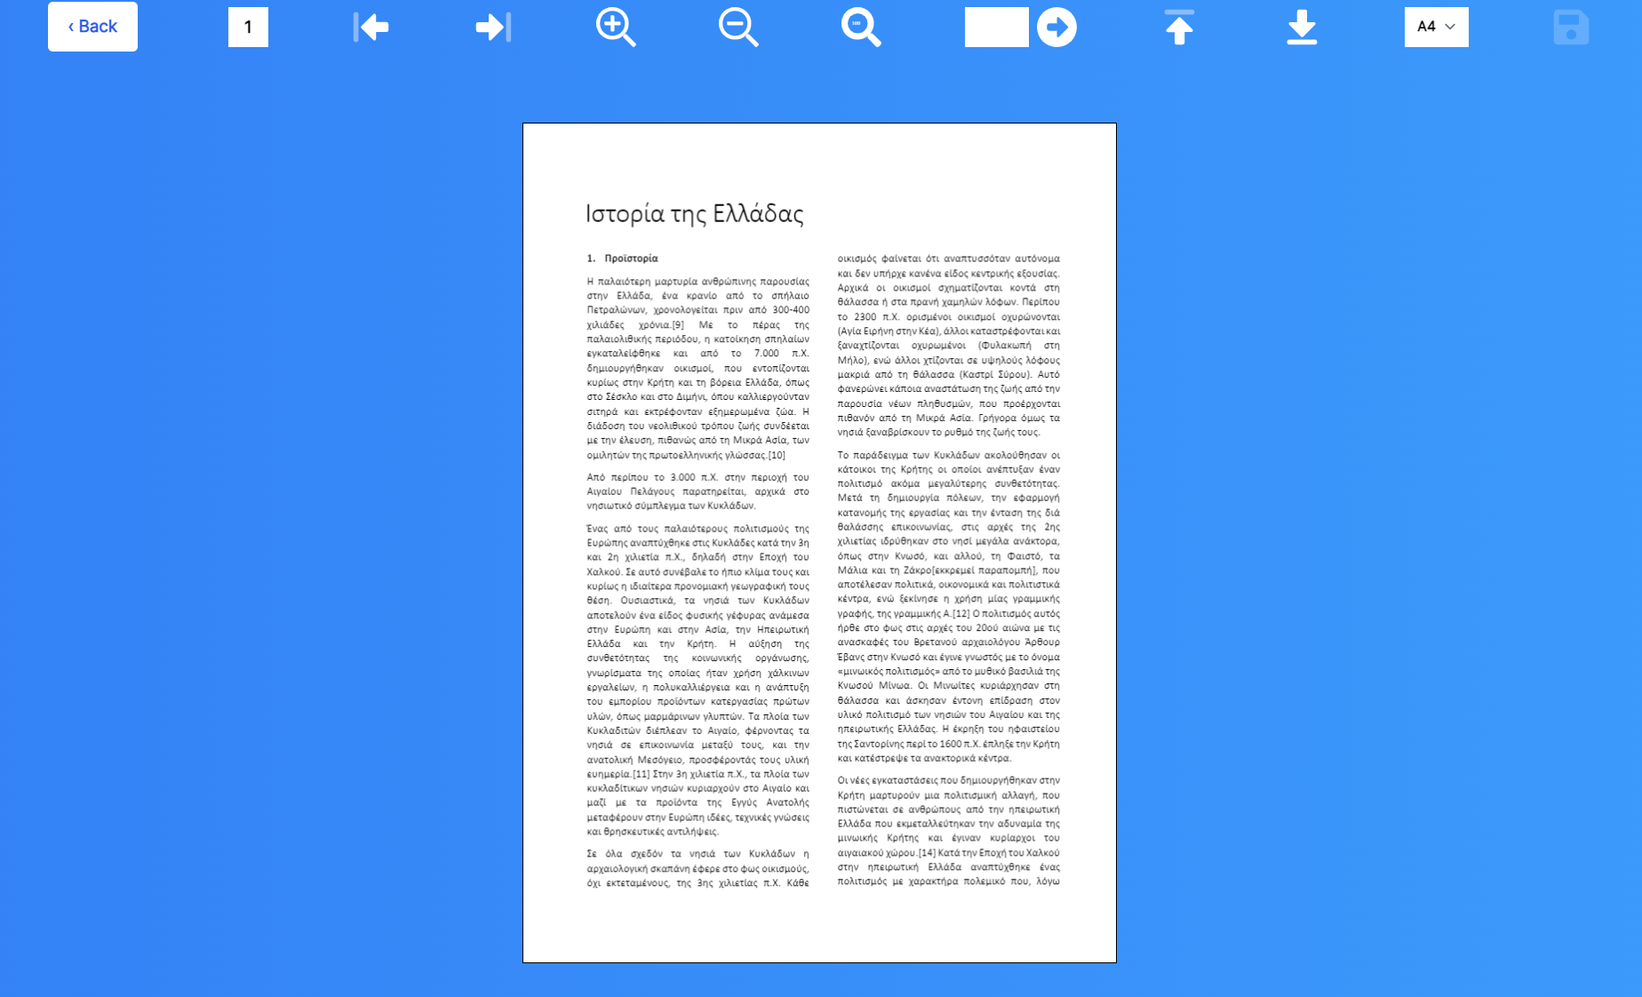
Figure 3.11. Book display for trigger image cropping

At this window, users can define or modify the augmentation trigger image. The trigger image is the one that must be scanned from the ARTutor application in order to display the augmentation.
By default, the paper size of the book is set to A4, but it can be manually changed for the drop-down menu on the upper right corner of the modal. Users can navigate from page to page or directly to the desired page. Zoom in or out is also available for a more comfortable point of view.
After the desired page has been reached, users can crop the selection of the page’s portion to be used as trigger image. By clicking, the crop operation will be started. The cropped area must be “unique” in the book in terms of appearance. If the selected area is the correct one, then the trigger image can be saved by clicking the “Save” button as shown in Fig. 3.12. An automatic check is being performed to check the uniqueness of the selected area.

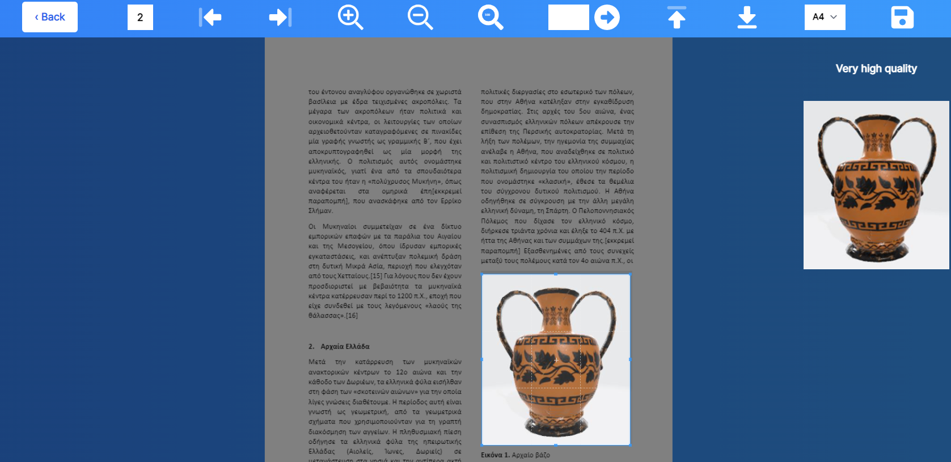
Figure 3.12 Finish cropping

After saving, the area selection window closes, and the form for augmentation creation is displayed, with a preview of the trigger image. After saving the augmentation, users can add more augmentations or edit existing ones.

Android and iOS application
The ARTutor mobile application can be downloaded for free from the Apple App Store or the Google Play Store. When opening the application, users will be navigated to the app’s home screen (Fig. 3.13).

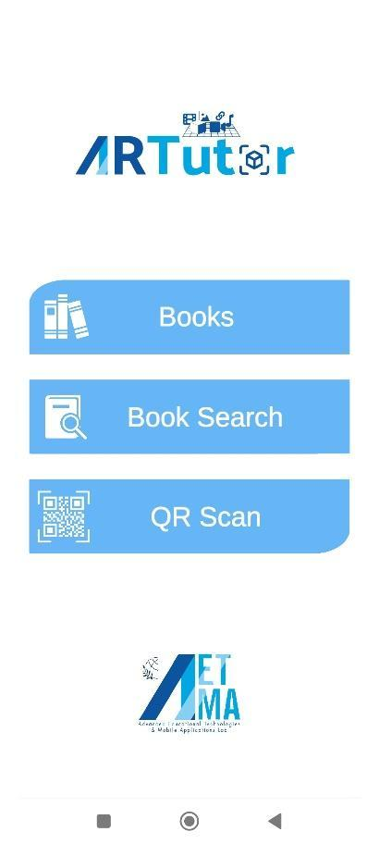
Figure 3.13. Home screen

From there, users have three options:
- See a list of all available Books
- Find a Book by using searching criteria.
- Scan a QR code of a Book.

By clicking “Books” on the app’s home screen a list of available books is retrieved and listed by category (Fig. 3.14). Selecting a category displays all the books in this category (Fig. 3.15). For each book, the title, description, author, and language of the Book are displayed.

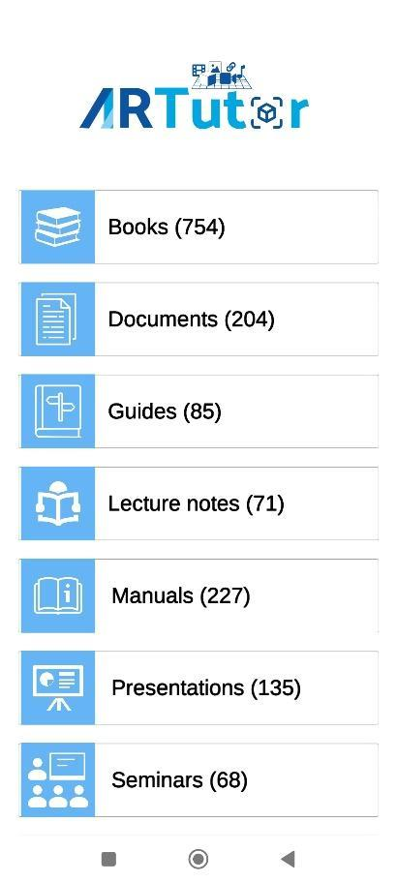  Figure 3.14. Category list | 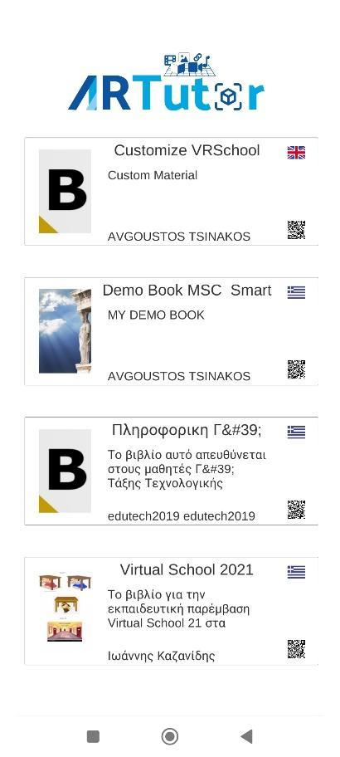  Figure 3.15 Book list of a specific category

When a Book is selected, all the augmentations that are assigned to the different areas of the Book are retrieved from the server. After that, a new screen opens where the camera feed is displayed, and the device is ready to scan the various pages of the selected Book and recognize the trigger images. As shown in Fig. 3.16, when an area of the Book is recognized, the corresponding augmentation over the trigger image is displayed. For example, when the augmentation is of type sound, the sound is played back while when the augmentation type is video, then the video is played on the top of the trigger image.

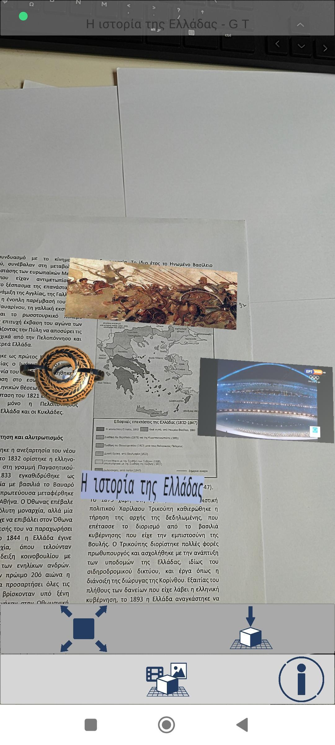
Figure 3.16 Augmentation over a trigger image

Users can also interact with the augmentation objects by doing a pinching gesture on them, or place them on any surface.

CoSpaces Edu

Link: https://cospaces.io/edu/
YouTube: https://www.youtube.com/channel/UC6VsnmaKQ9MNRpJbFsIhoGw
Facebook: https://www.facebook.com/groups/480579362131541
Tutorials: https://cospaces.io/edu/onboarding.html
Cost: Free up to 29 students and 1 class with 1 assignment. PRO version from 50$ per year with 30-day free trial.
Description: CoSpaces Edu is an AR and VR creation app that enables users to create digital content. Users can build virtual immersive 360° tours, create interactive stories, design virtual exhibitions and program games with a visual coding language. Teachers can use CoSpaces Edu in multiple languages and from any device, including computers, Chromebooks, smartphones or tablet devices all with the same account synchronised in real time. Also, the CoSpaces Edu mobile app for iOS and Android lets users create and explore their creations on a smartphone or tablet.
Functionality: In order to register, users visit the link https://cospaces.io/ and click Register to start creating their CoSpaces Edu account (Fig. 4.1). Then, teachers must choose the appropriate type of account, suitable for teachers (Fig. 4.2) and log into their account (Fig. 4.3).

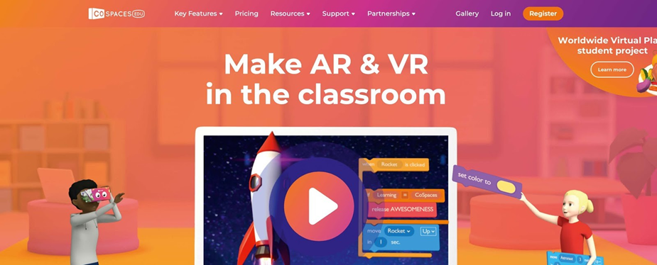
Figure 4.1. The Home Page for registering

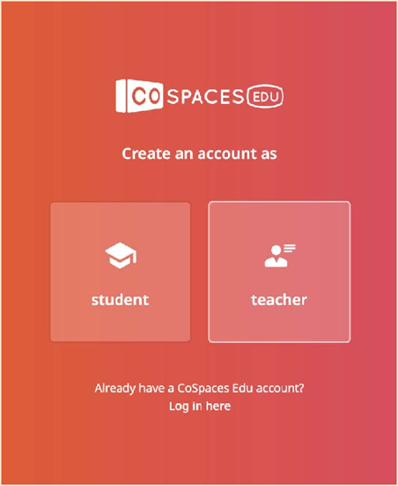  Figure 4.2 Choosing the type of account | 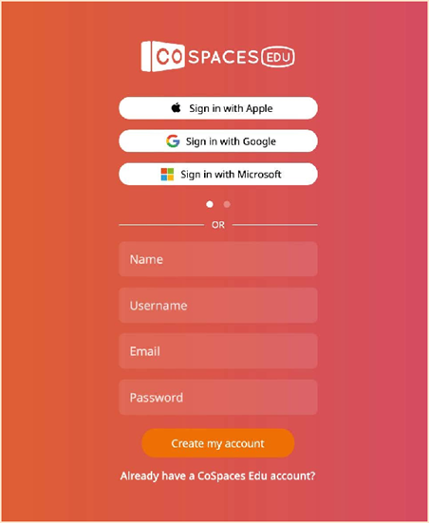  Figure 4.3. Create an account or Sign in
To start creating, users must go to CoSpaces where their creations are stored. To create their ﬁrst CoSpace, users will click on “Create CoSpace”. (Fig. 4.4)

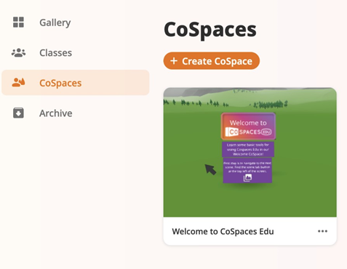
Figure 4.4. Create a new scene

Also, they can choose a ﬁrst scene to start with. They can build a 3D environment and view it in VR and AR. They can also build upon a 360° image of their choosing and view it in VR (Fig. 4.5).

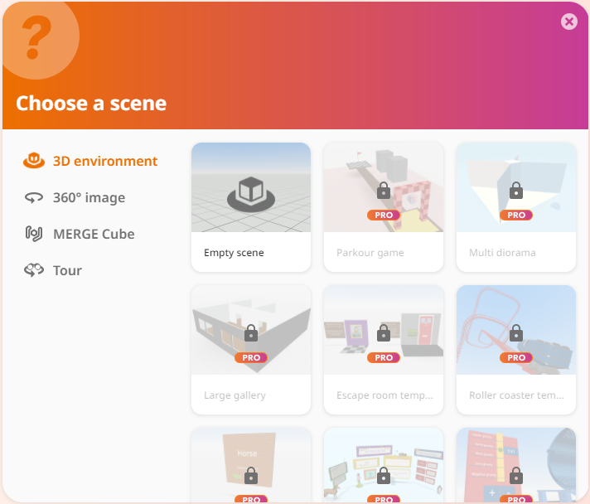
Figure 4.5. Choosing the type of scene

Users can drag and drop 3D objects from the Library and add them to the scene. They can even build their own objects using building blocks under “Building” by just selecting “Upload” to add 3D models, images and GIFs, videos and even sounds (Fig. 4.6).

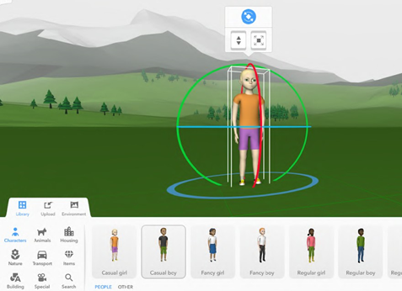
Figure 4.6. A drag-and-drop object scene
Creating 360° Images
This feature is one of the key applications of CoSpaces Edu and it is suitable for enriching teachers’ lesson plans. The first thing that a teacher will need in order to create a 360° image tour is to find the appropriate 360° photos either from a free online source or by using their own 360° camera or smartphone. Photos must have a 2:1 ratio.
After choosing the right type of scene and having their photos ready, teachers can click on “environment” and “edit” (Fig. 4.7) to choose the image they want to start the tour.

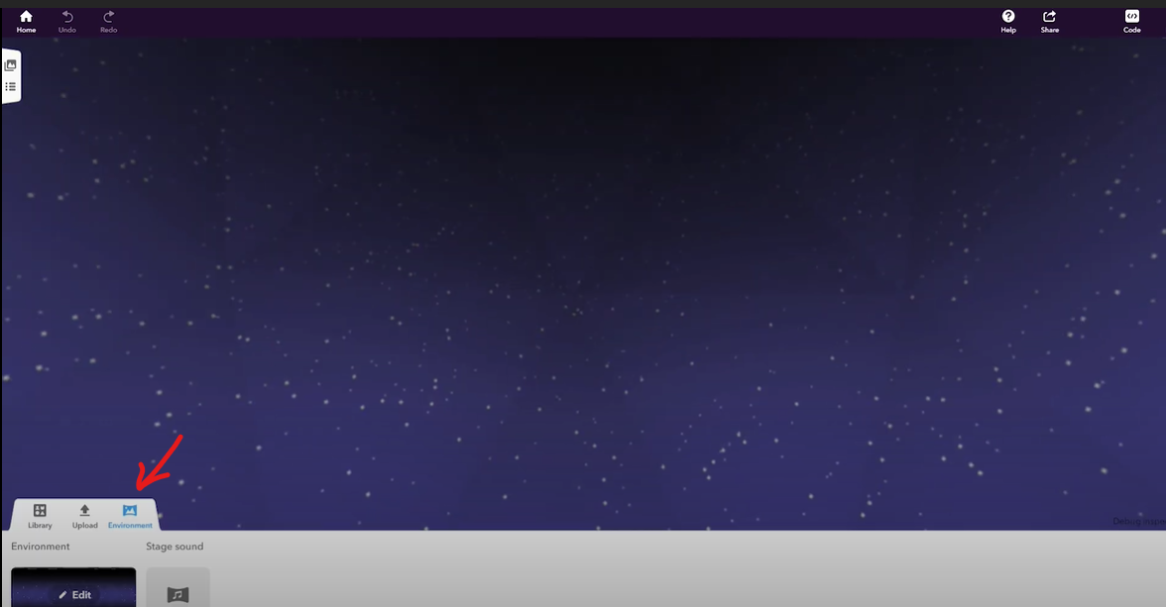
Figure 4.7. The Environment and Edit button that allow editing a scene of a 360° tour

Every time a new photo is added, there must be a new scene created for it (Figs. 4.8 and 4.9).
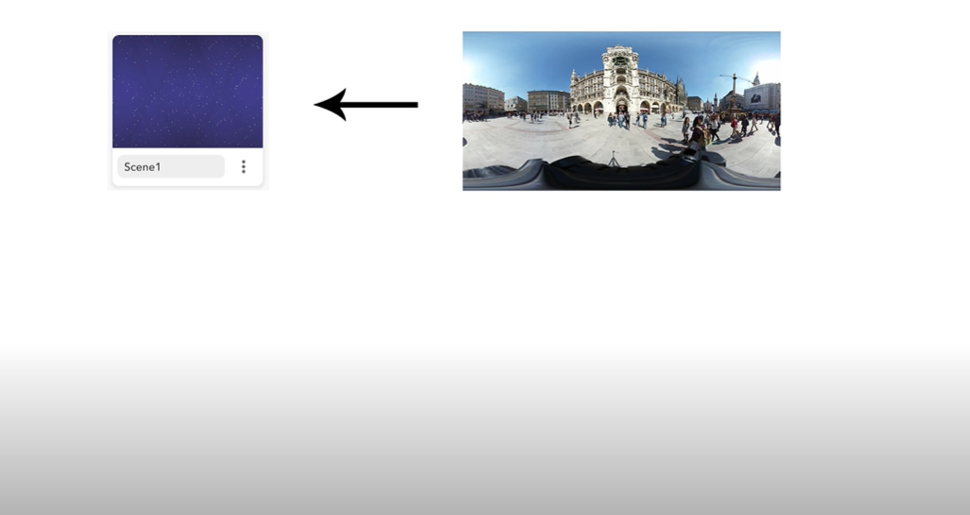
Figure 4.8. Choosing a picture and creating a new scene for it
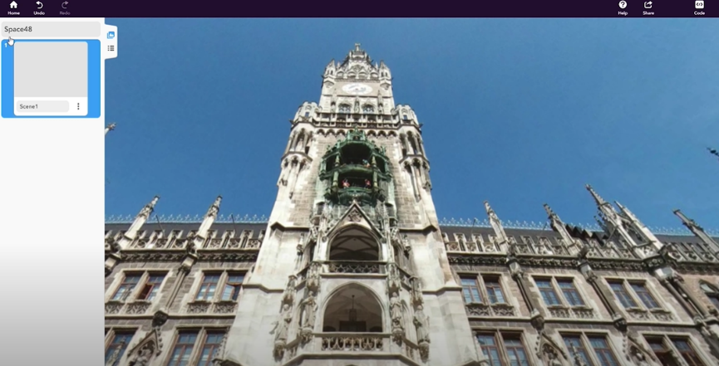
Figure 4.9. The menu for the overview of scenes

Teachers can insert objects and characters that will participate in the scene (Fig. 4.10). Also, they can use the “mask tool” to put them in the back of some elements of the photo and in the right place (Fig. 4.11).

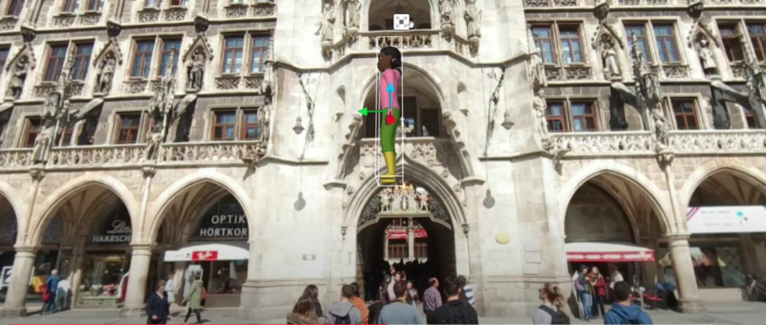
Figure 4.10. An object dragged and dropped in the scene

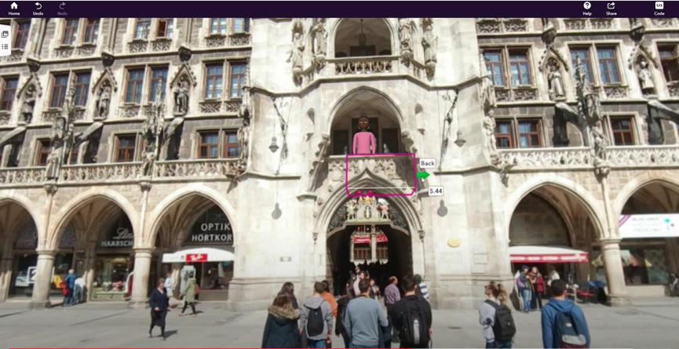
Figure 4.11. The mask tool for making objects look like they are behind elements

This is the point where teachers, by switching scenes (Fig. 4.12), can start coding and select motions and actions for their objects so that they can give life to their tour. In order to set the objects to execute various commands, there are several code blocks available (Fig. 4.13).

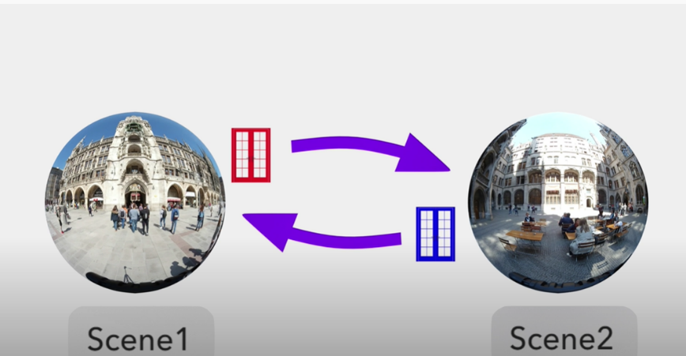
Figure 4.12. Switching Scenes

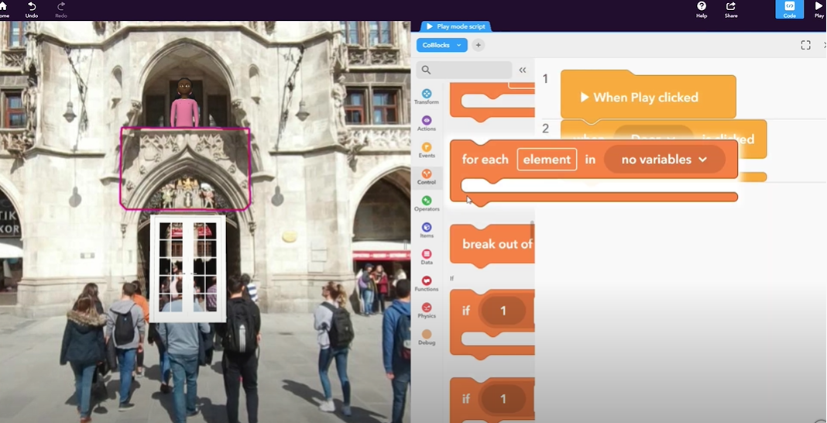
Figure 4.13. Using the code blocks

Teachers can also add some information about the experience, using info panels. They just add an object and make it clickable with a “when is clicked” code block that will open an info panel (Fig. 4.14). They can type the information they want or even add more objects in order to create more interactions (Fig. 4.15).

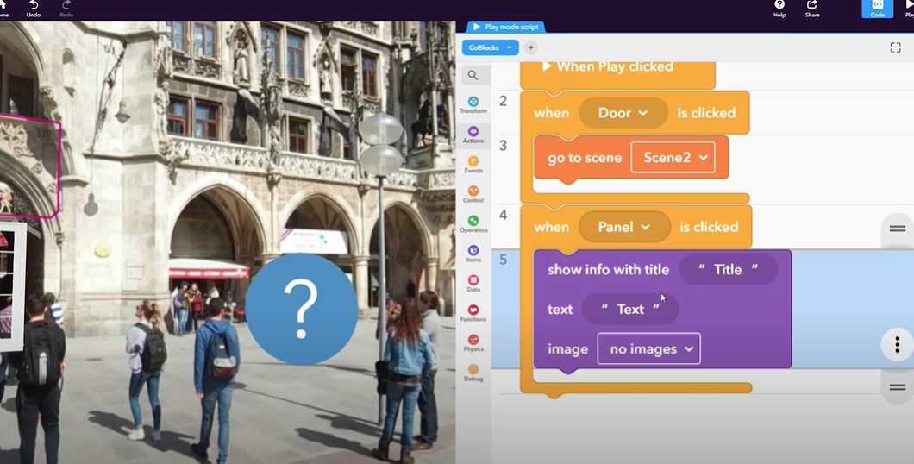
Figure 4.14. Adding information about a place
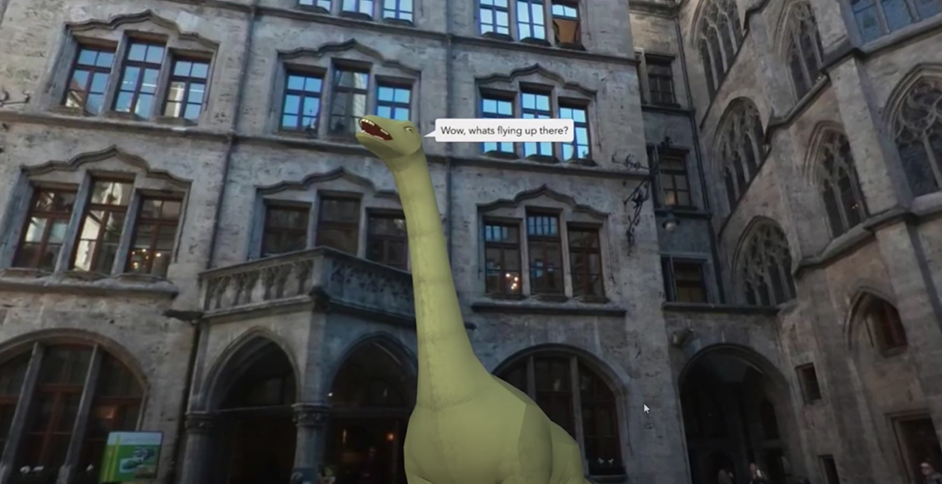
Figure 4.15. Adding more objects and interactions

With 360° images, teachers can demonstrate interesting places to their students to engage and motivate them, as well as to help them acquire spatial skills.

Creating an exhibition (PRO Version only)
In a similar way, teachers can create virtual exhibitions, storytelling, games and simulations. For instance, in a virtual exhibition (Large gallery option from 3D environment), teachers can exhibit objects and use different materials in order to create the space of the exhibition as they like (Fig. 4.16). Also, they can display explanatory labels and additional information using the info panels mentioned above (Figs. 4.17, 4.18, and 4.19).

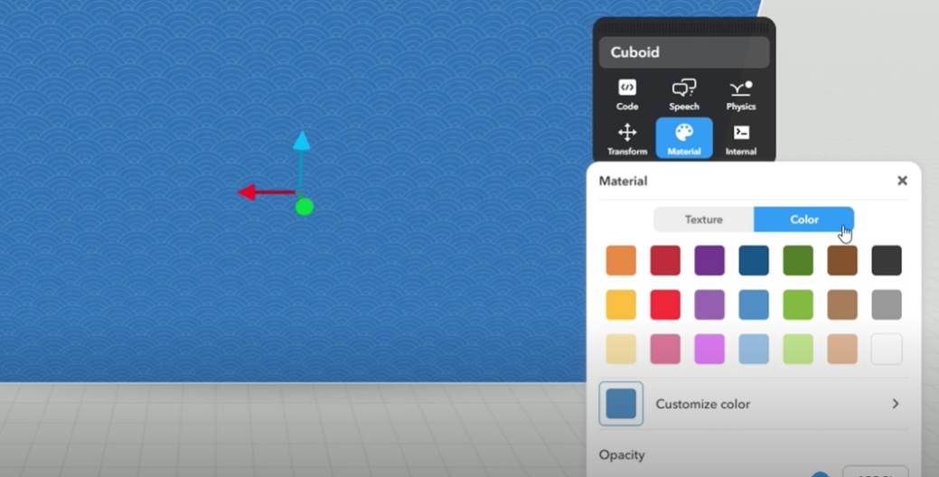
Figure 4.16. Various materials and colours that can be used for walls
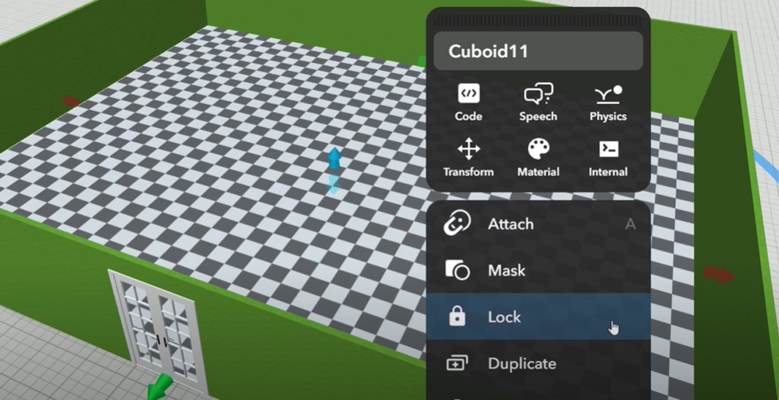
Figure 4.17. Locking the walls of an exhibition after creating them

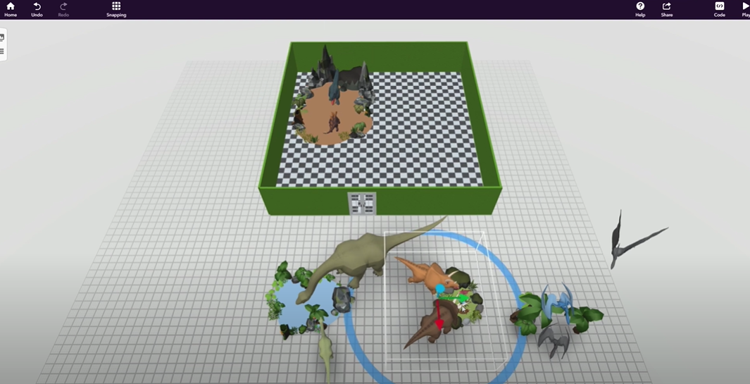
Figure 4.18. Putting objects in the exhibition to take their place in it

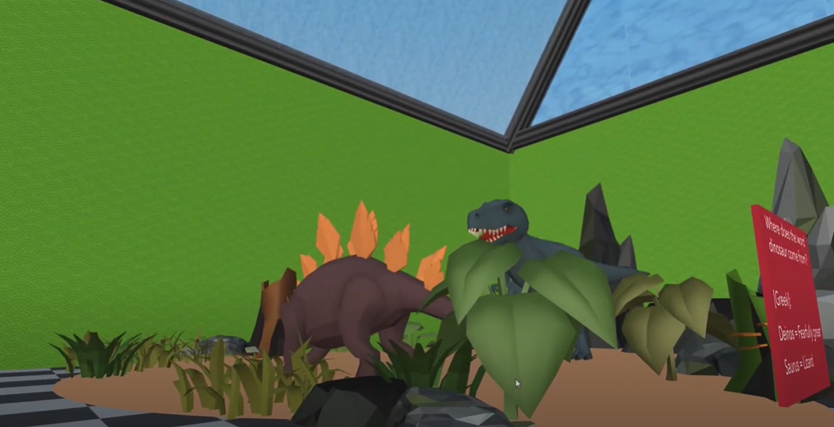
Figure 4.19. The actual exhibition

Creating storytelling
Especially when it comes to primary school, teachers need to engage their students with interactive stories to make them pay more attention to detail and help them acquire analytical and critical thinking skills. Having said that, they need to use scenarios from existing stories and re-create them in a way that is suitable for their own lesson plans. This way, they can personalise learning and adjust it to the level of their class. Following, there is an example of Hansel and Gretel’s famous story.
Using CoSpaces Edu, teachers can select the desirable environment for their story (Fig. 4.20) and record sounds to embed in it (Fig. 4.21).

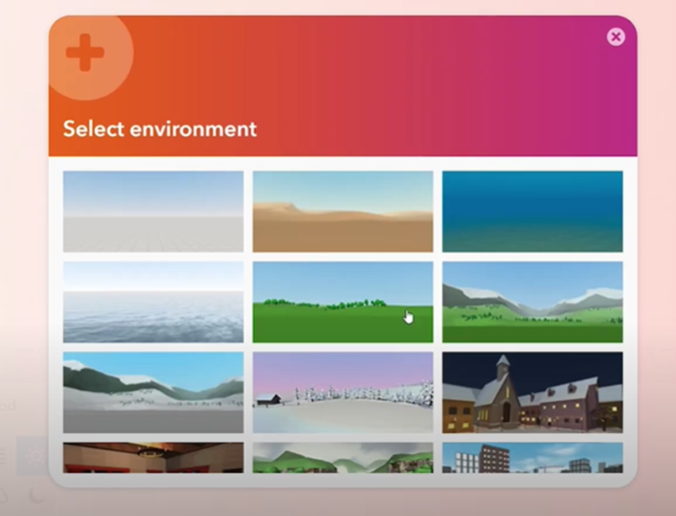
Figure 4.20. Selecting an environment of the story

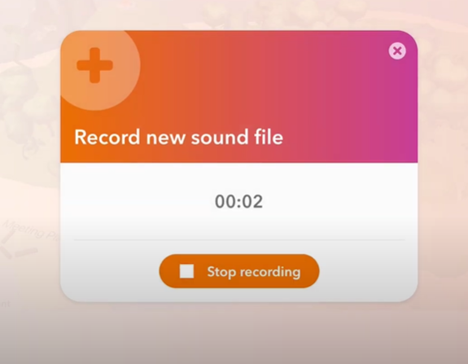
Figure 4.21. Recording a new sound for the story

Then, they can select their characters, put bubbles for displaying their words above them, just like a comic, and assign roles to them (Fig. 4.22).
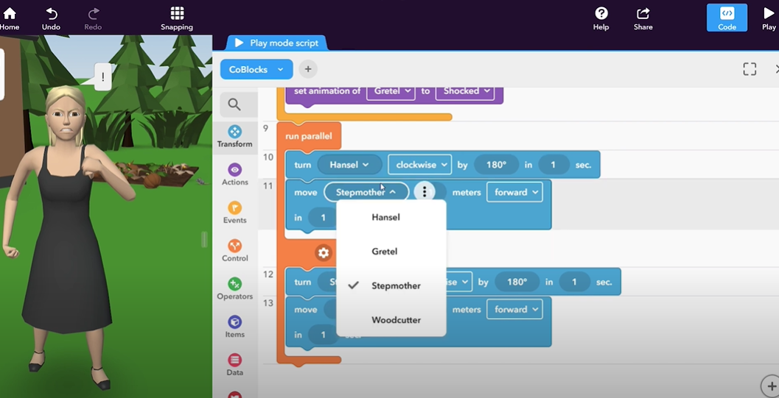
Figure 4.22. Assigning roles to the characters and putting bubbles for words above them

Finally, they can use the “CoBlocks” in order to animate the characters and define when they are going to do certain actions (Fig. 4.23). The story is like a puzzle of scenes that are respectively connected (Fig. 4.24).

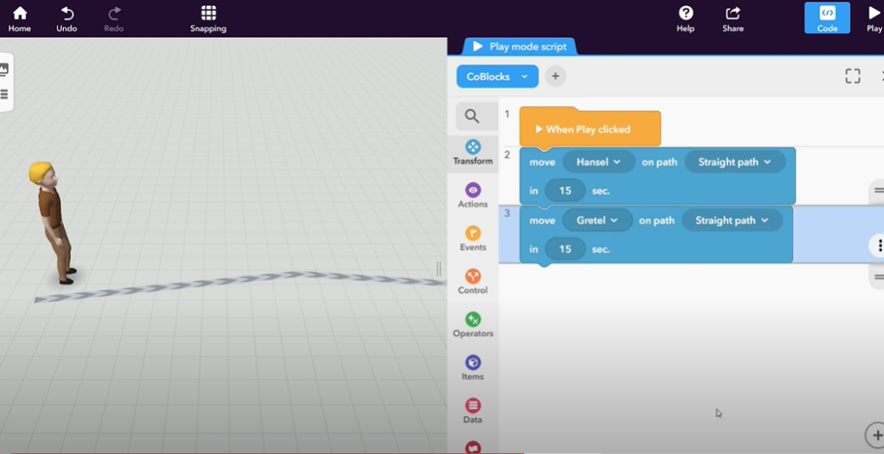
Figure 4.23. Deciding on characters’ actions

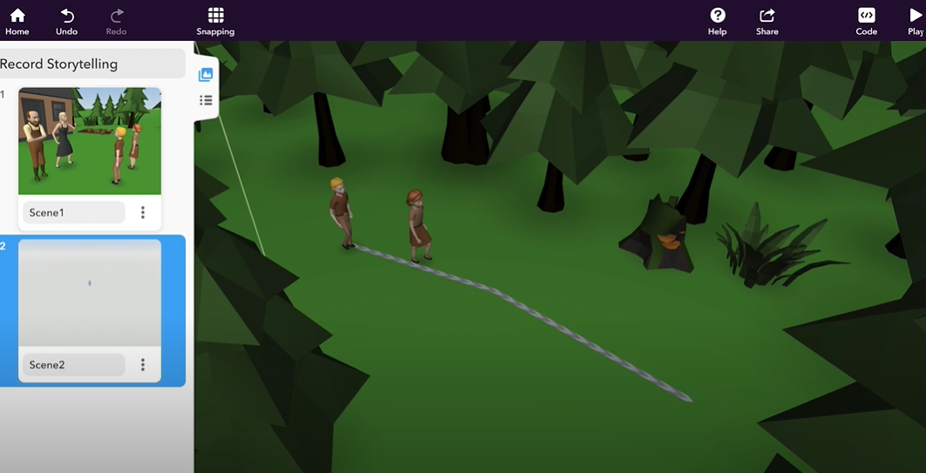
Figure 4.24. Connecting the scenes of the story

Creating Games
Gamification is another teaching method that enhances extrinsic and intrinsic motivation, personalises learning experience and reinforces critical thinking. CoSpaces Edu covers this need too, by allowing teachers to easily create various games for their classes.
For example, for teachers that need to teach a safety lesson, the example of a parkour game (available in PRO version) would be very useful. They just need to adjust the camera tool in terms of movements, as if the camera was the player (Fig. 4.25).

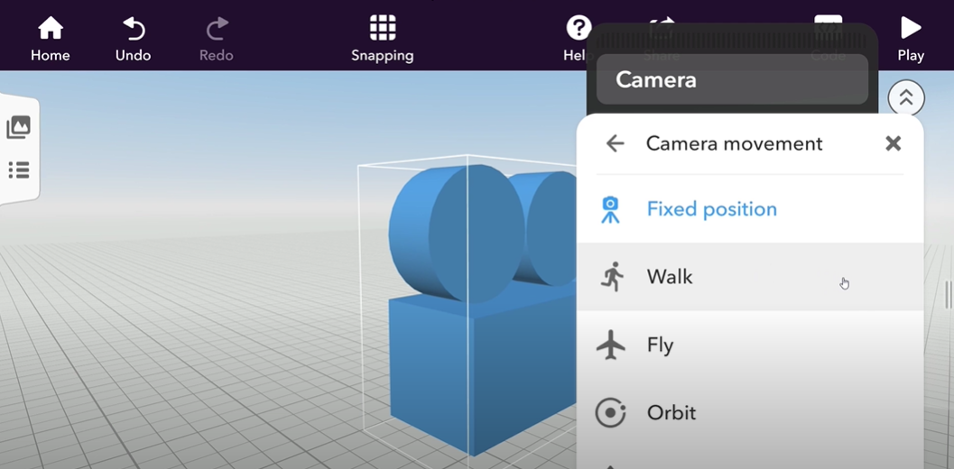
Figure 4.25. Setting the players’ movement
Also, they decide on the amount of the lives that a player has according to how the player proceeds with the game (Fig. 4.26).
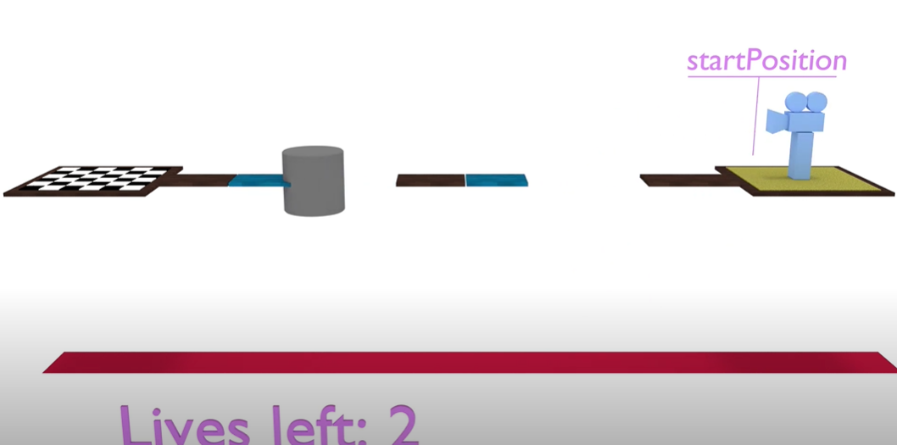
Figure 4.26. The lives of the player

Finally, teachers can create a code block script and define what happens according to the actions of the players. They can put obstacles and even change the direction of players’ course (Fig. 4.27).
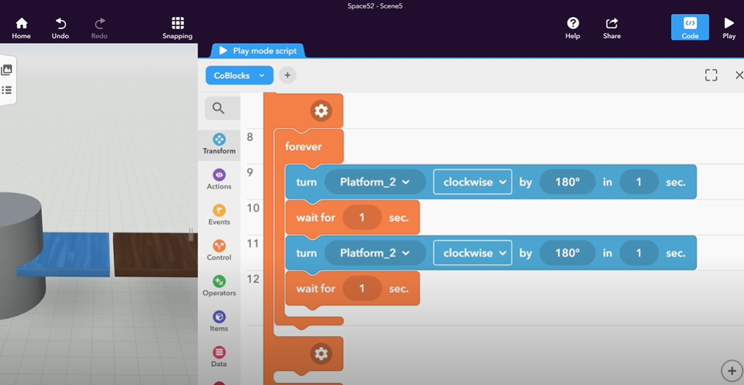
Figure 4.27. Creating a new code block script

Section 2. WebAR
In the case of WebAR, users can view the AR experience by using their browser (PC or mobile device). WebAR experiences are available for PCs if there is a web camera connected to the computer. WebAR experiences are OS independent although they provide less features than AR mobile applications. In this section, AR Scavenger, a web platform for creating WebAR experiences is presented.

AR Scavenger

Link: https://h5p.org/content-types/ar-scavenger
YouTube: https://www.youtube.com/watch?v=yB36QZUh-wY
Facebook: https://www.facebook.com/h5ptechnology
Tutorials: https://h5p.org/content-types/ar-scavenger
Cost: Free
Description: Content type for H5P, a plugin for existing publishing systems that enables the system to create interactive content like Interactive Videos, Presentations, Games, Quizzes and more, available for publishing systems like Canvas, Brightspace, Blackboard, Moodle and WordPress.
Users can create augmented reality experiences and view them without installing special software (WebAR). Users define markers similar to QR codes that others can scan with their device's camera. Those markers can trigger blending a 3D model with the camera view or display an H5P interactive content.
Functionality: To create an AR Scavenger Hunt, users can install the H5P plugin on a publishing system like Canvas, Brightspace, Blackboard, Moodle or WordPress. If they just want to try the H5P plugin, users can create a free account at https://h5p.org/user/register?destination=welcome-to-the-h5p-community (Fig. 5.1).

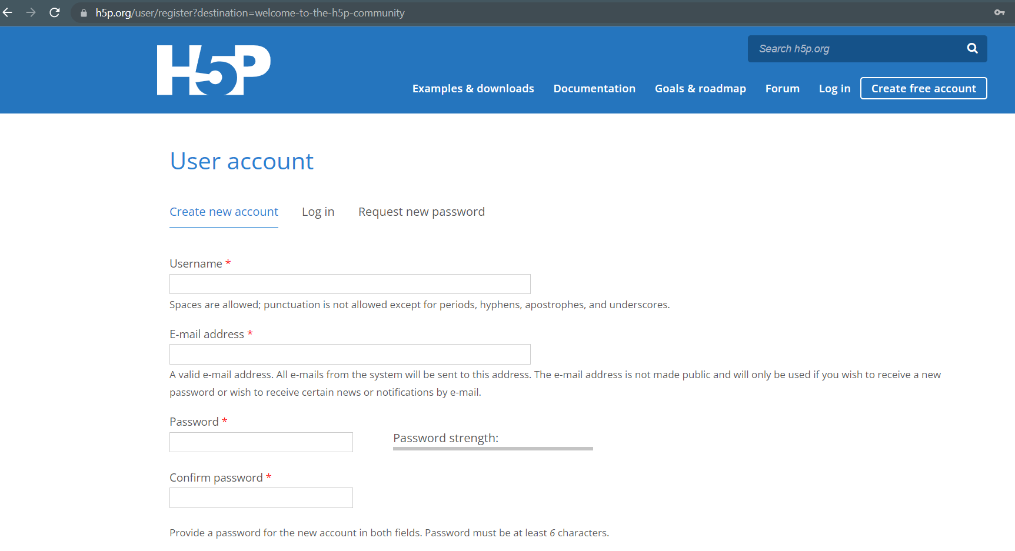
Figure 5.1. Register at H5P.org

After logging in, users can click on the “Try out H5P” button to create content (Fig. 5.2).
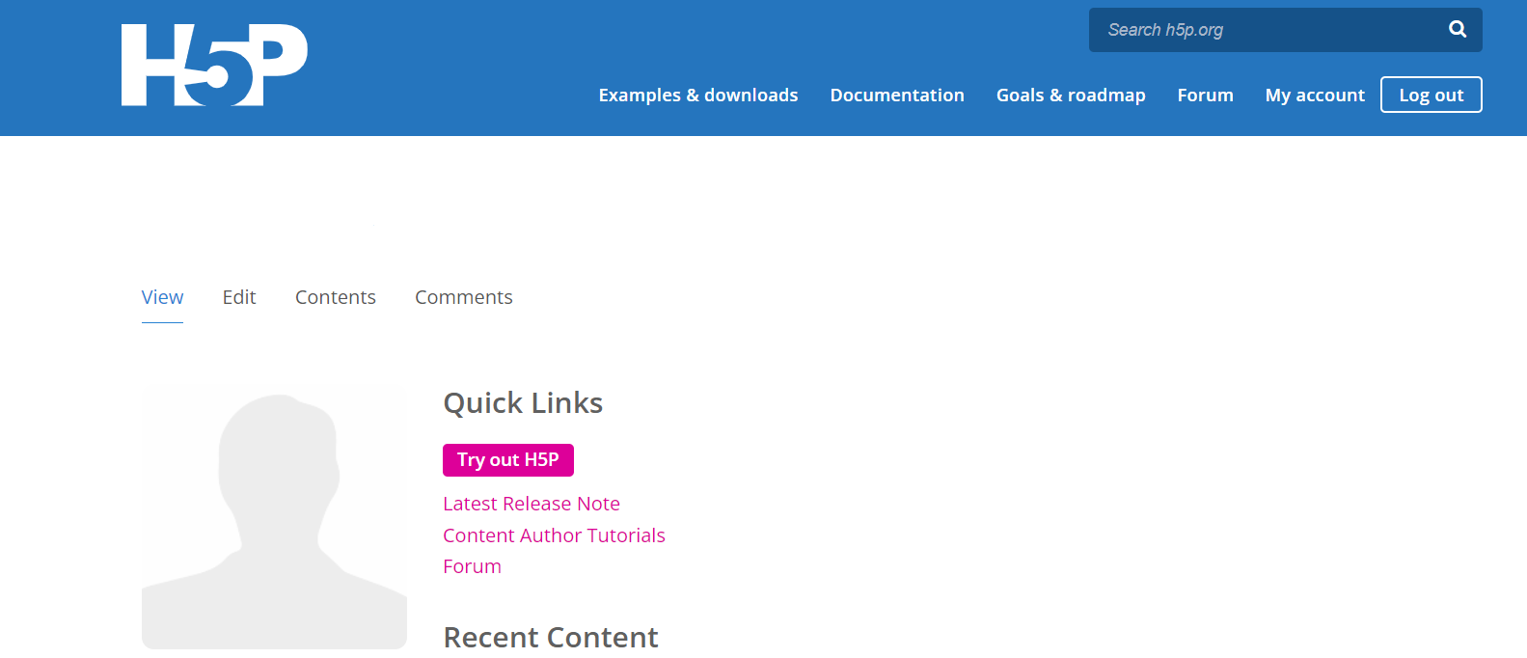
Figure 5.2. Menu after login

There are many content types available and in order to create an AR experience, users need to select AR Scavenger content type (Fig. 5.3).
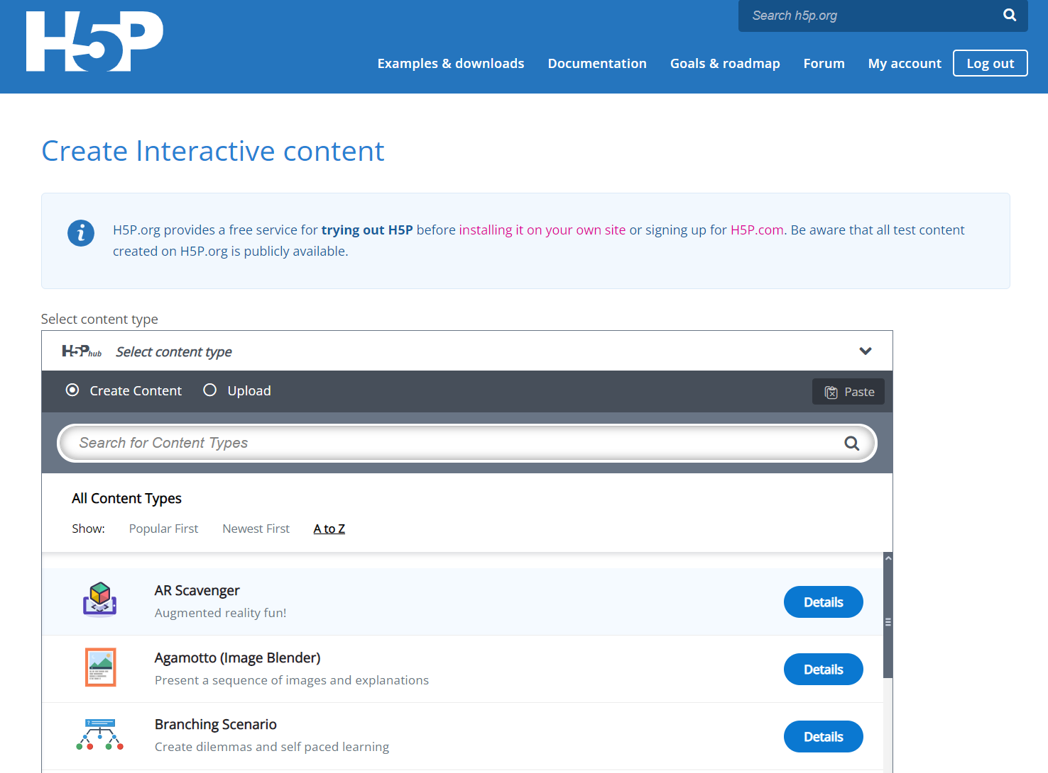
Figure 5.3. AR Scavenger content type

Then, users are directed to the creation page where they can create an AR Scavenger experience (Fig. 5.4). Users need to fill in a title and design an optional start screen that will be displayed at first, before the camera opens. The start screen can have some text and an image.
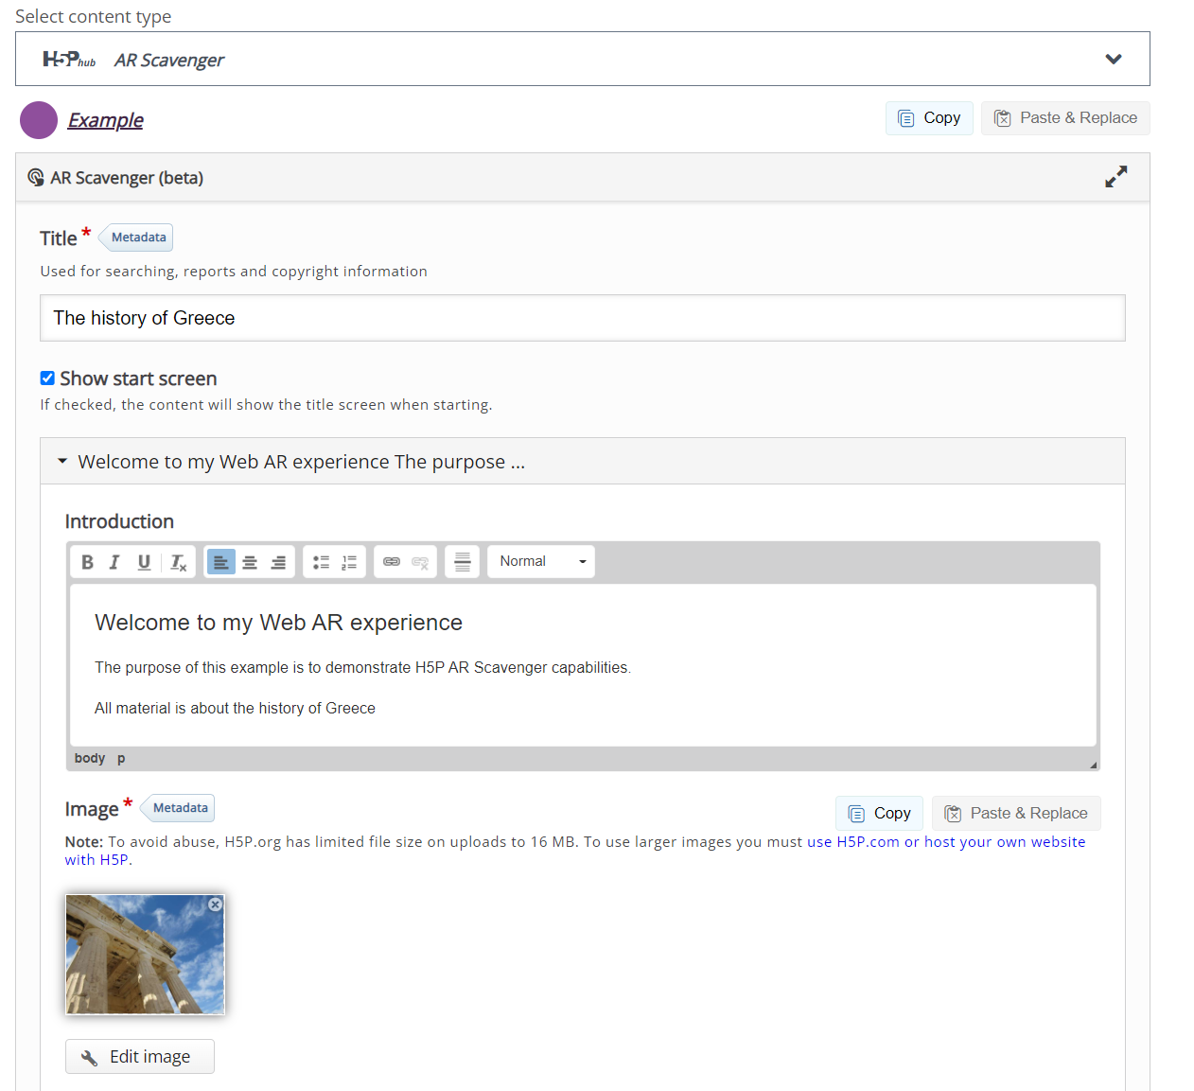
Figure 5.4. Provide title and design the start screen of AR Scavenger

Then, users can add markers to their AR experience. Markers are trigger images that will be detected by a camera of a mobile device or a PC in order to display augmentations. Add high contrast square images as markers since the internal resolution of a marker is 16X16 pixels. Example marker images are displayed in (Fig. 5.5).

Figure 5.5. Sample markers

For each marker, users can select the action that will occur when the marker is detected by the camera. Users can display an H5P interaction (Video, Image, Text, Table, Link etc.) as displayed in Fig. 5.6. In the case of a video, the video will be played in a new window if the marker is detected. The video will not be displayed over the marker.
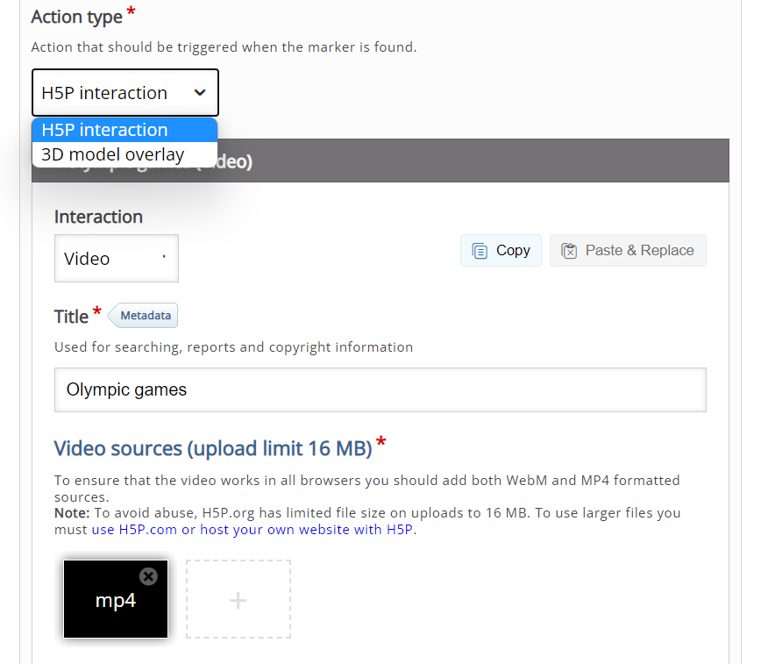
Figure 5.6. H5P interaction as augmentation

Users can select a 3D model (.glb or .gltf file) to be displayed on top of the marker (Fig. 5.7). Users can also alter the geometry settings of the model changing its position, scale and rotation. No touch interactions are available with the 3D model.

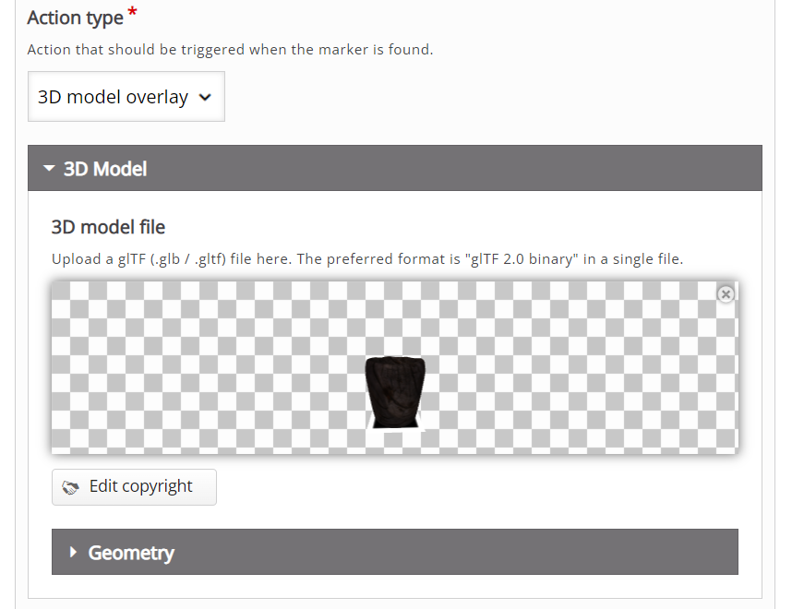
Figure 5.7. 3D model overlay as augmentation

Users can add as many markers as they like, save and re-edit the AR experience and save it again. Finally, users can optionally add an end screen which is displayed when all interactions have been completed. Text and image can be added to the end screen, similar to the start screen.
By clicking on the “View” button (Fig. 5.8). users are directed to a link in the form https://h5p.org/node/XXXXXX where they can view the AR experience in their browser.
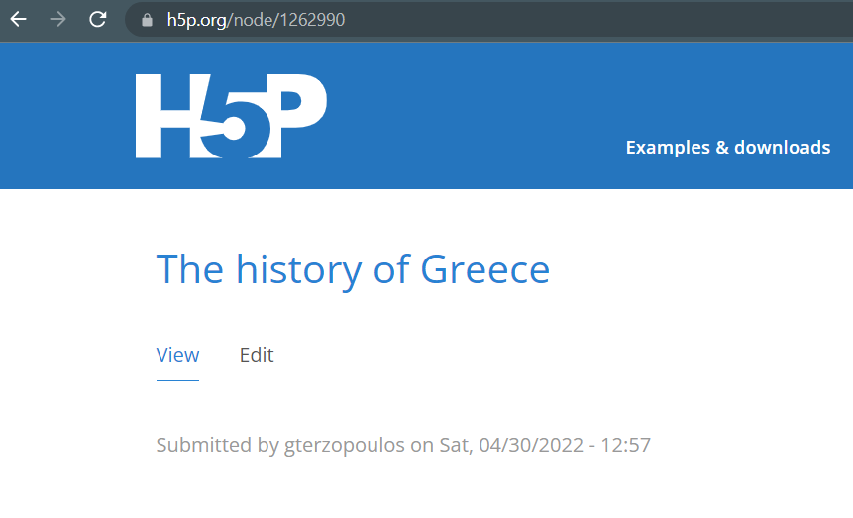
Figure 5.8. View button and URL link

If users are using a PC, they need a web-camera, while if they are using a mobile device, the phone’s camera will be used. When the marker is detected, the augmentation will appear (Fig. 5.9).
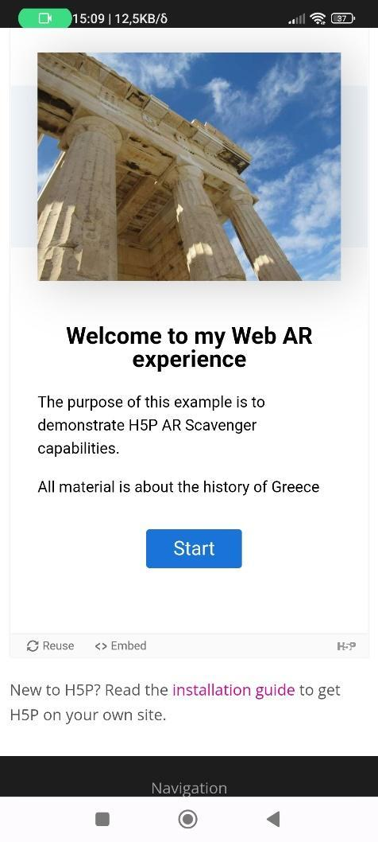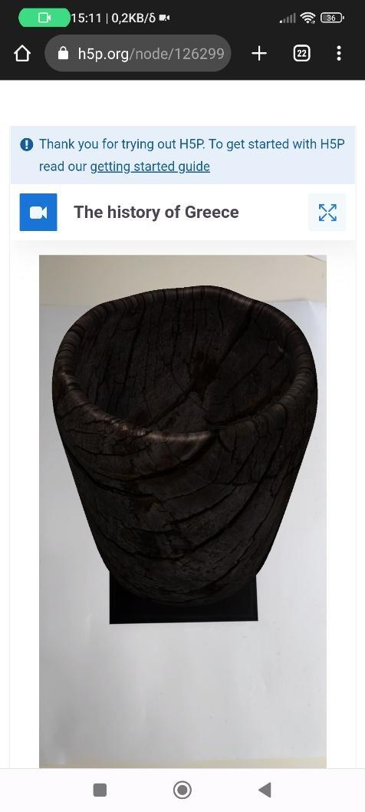
Figure 5.9. Final result in a mobile phone

AWE

Link: https://awe.media/
YouTube: https://www.youtube.com/channel/UCN9M2nLk0EwGiyDBG2fnpKg
Facebook: https://www.facebook.com/try.awe.media/
Tutorials: https://www.youtube.com/c/buildAR/videos
Cost: The Free Trial is available for 14 days and the yearly plan costs 19$ a month.
Description: AWE is a web-based platform through which the users can create AR and VR experiences. Experiences are compatible with different devices and viewable by opening a link on the web browser i.e. a current or recent version of either Chrome or Firefox on Android and Safari on iOS devices. Internet Explorer doesn't support the required web standards. There is no need for downloading any app or software. Users can create Mixed Reality experiences with a drag & drop interface, using their computer, smartphone or tablet.
Functionality:
The basic steps are as follows:
- Upload any types of common media (photos, videos, 3D & more).
- Manipulate these objects and add rich interactions to create an VR/AR experience.
- Share a single link that points directly to the web-based VR/AR experience.
A standard AWE project includes:
- Unlimited interactive objects per scene (images, videos, 3D models, audio, shapes)
- Support for 360° images & video
- Object’s animations and actions
- Up to 5 of each scene types:
  - Image AR (Natural Feature Tracking)
  - Spatial AR (SLAM or World Tracking)
  - Face AR
  - 360° / VR
  - GPS AR (location)
  - HTML page
As a first step, users create an account (Fig.6.1)
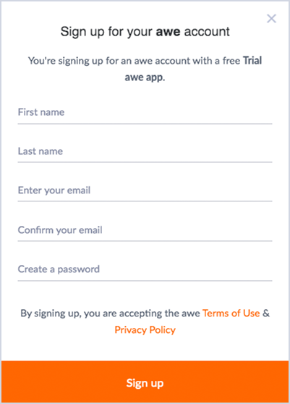
Figure 6.1. Signup Page

Pricing plans are available from https://awe.media/pricing (Fig. 6.2). Also, users can find the help/support link (Fig. 6.3).

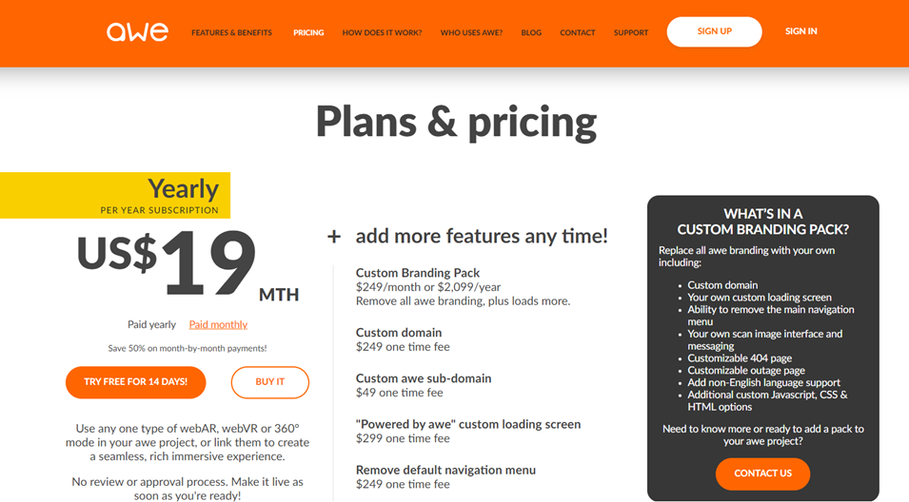
Figure 6.2. Pricing

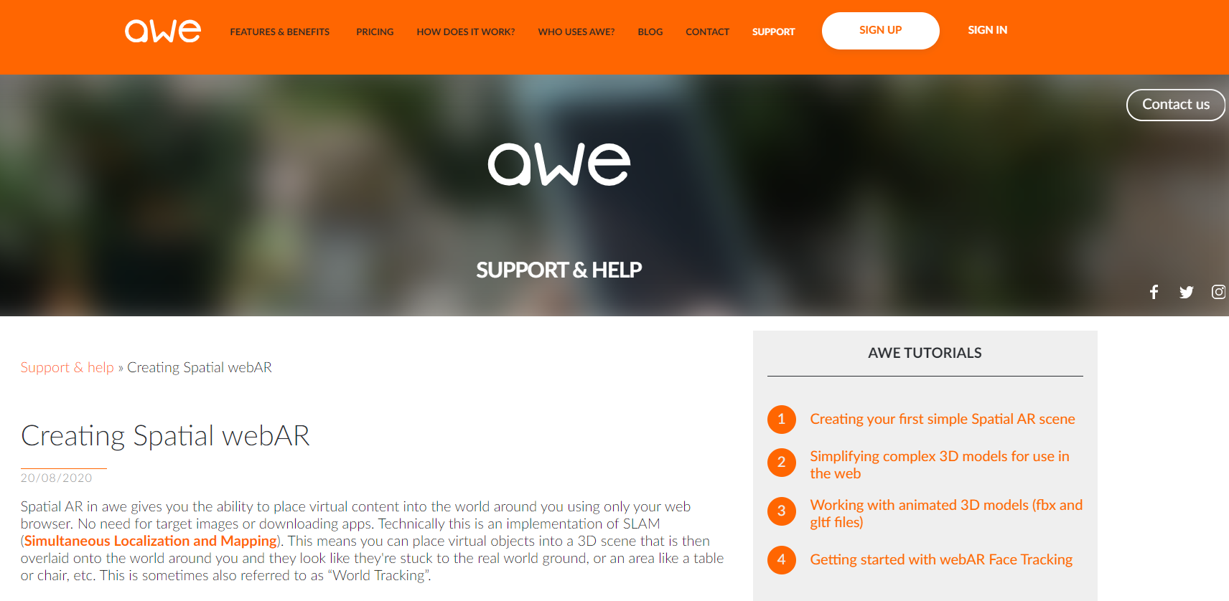
Figure 6.3. Support/Help link

After signing up and creating a new account, users are led directly to the page for creating a new project (Fig. 6.4). Every project created is saved in the users’ repository and it is visible on the projects’ page (Fig. 6.5).

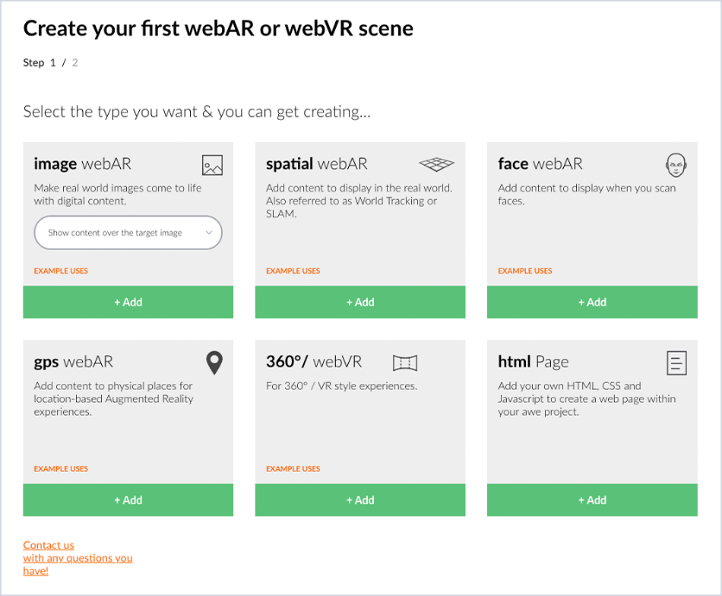
Figure 6.4. Page for creating the first project
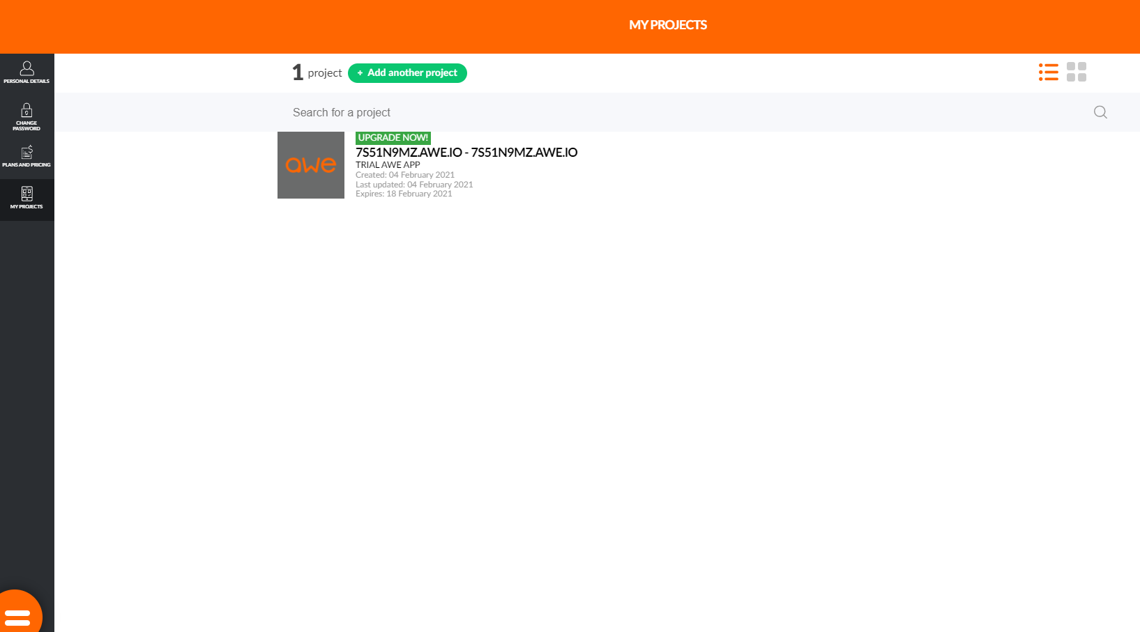
Figure 6.5. The “My Projects” page

The second step is to create the first scene depending on the preferable type (Fig. 6.6).

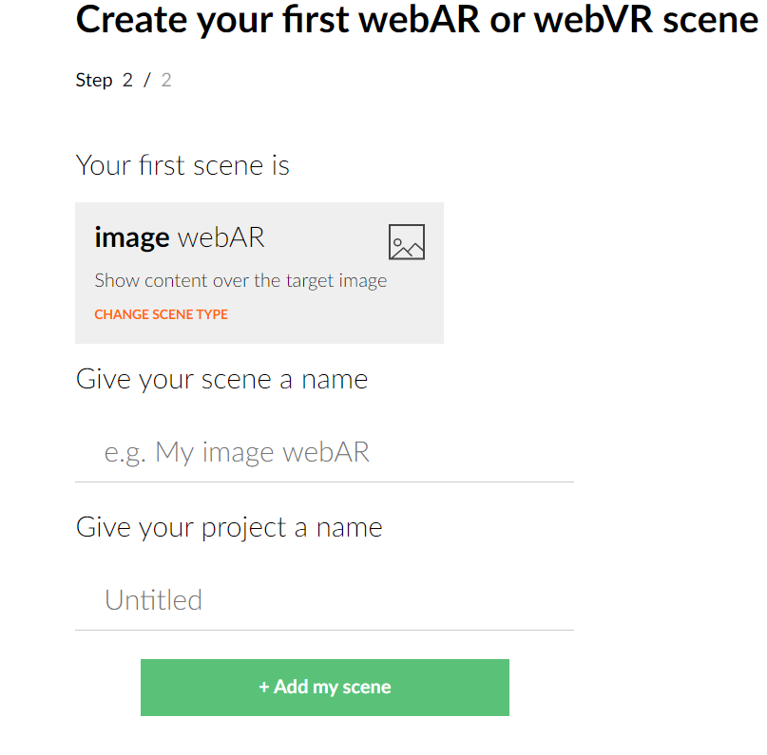
Figure 6.6. Creating a new scene

The scene opens in the object edit mode. WebAR face tracking scenes start with a pre-added face model projection (face mesh) which is invisible in live mode. Instead, it is shown in wireframe mode in the editor to allow accurate arrangements (Fig. 6.7).
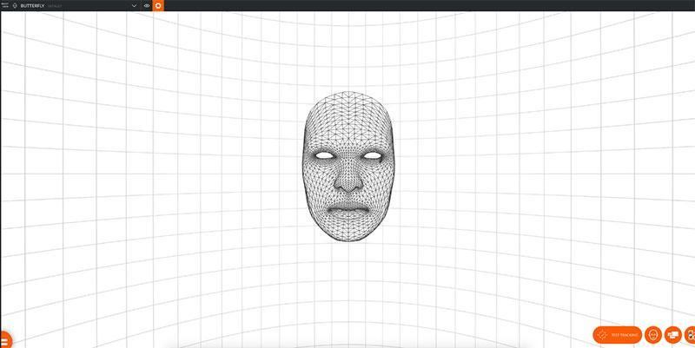
Figure 6.7. A scene in edit mode

Users can add digital objects from the media library or from the “+” (add new object) button in the bottom right corner of the object panel, selecting it from their device. These objects react to different facial movements or other events and the users can add, scale, rotate and transform them (Fig. 6.8).
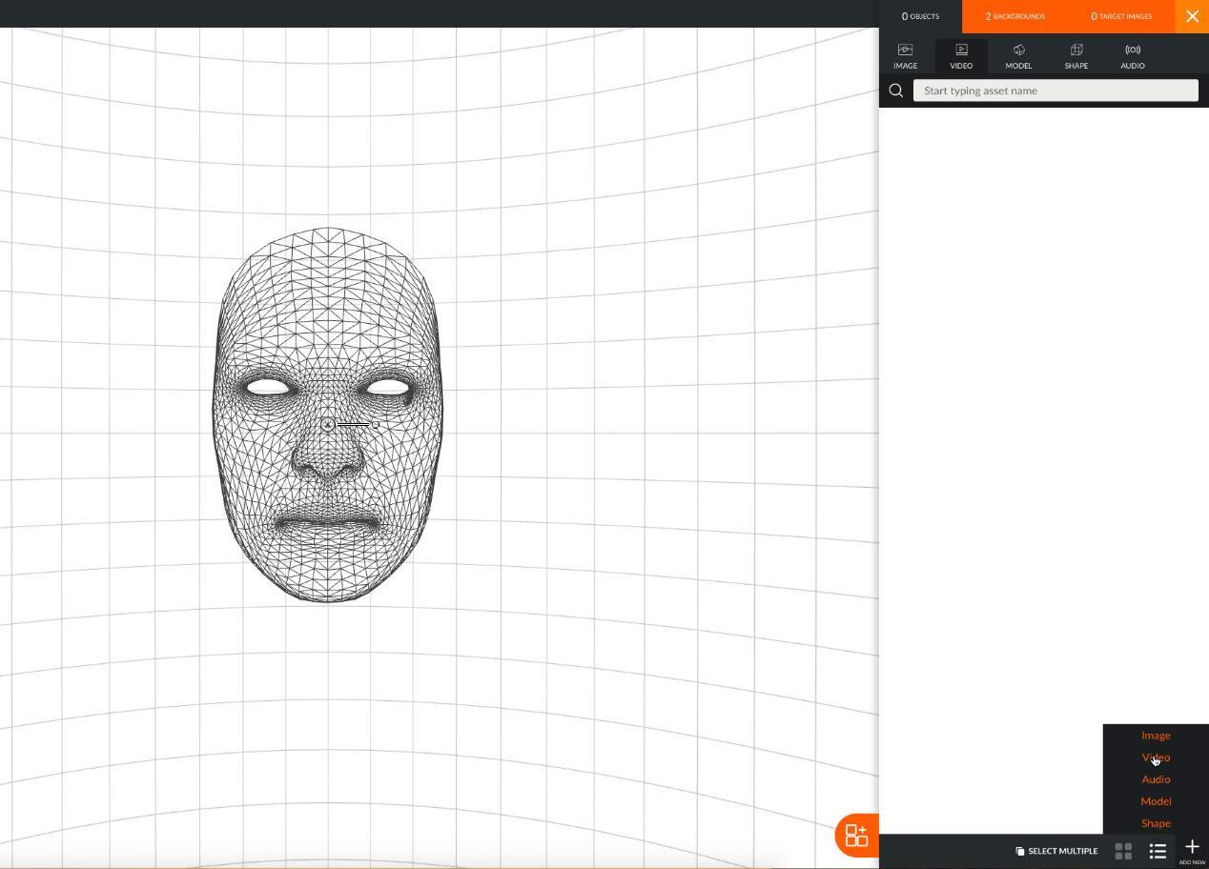
Figure 6.8. Adding objects to a scene

From the video object tab, users can choose a video and select the option “Use” (Fig. 6.9). Then, they can select the “Place button” to place it in the scene. Once placed, it will be automatically selected. Users can configure the video settings, turn off the toggle play/pause or set the audio to be muted (Fig. 6.10).
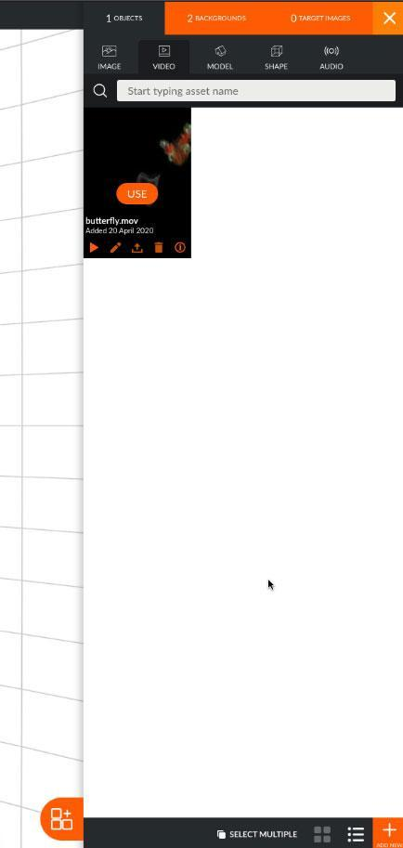
Figure 6.9. Selecting a video as an asset

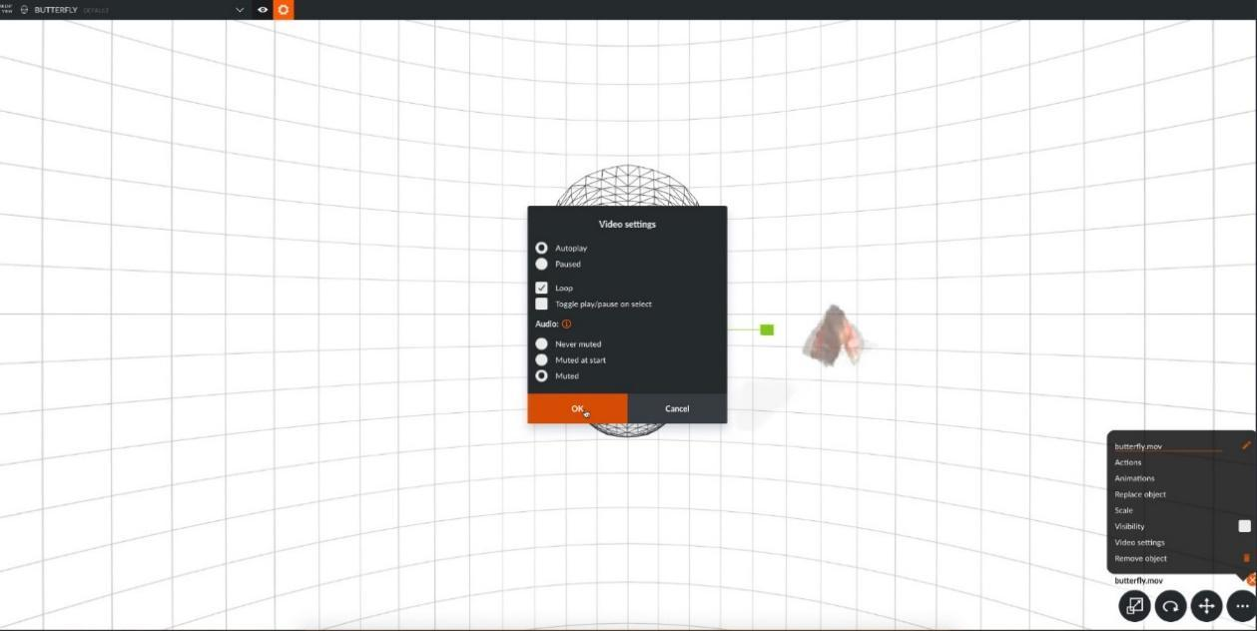
Figure 6.10. Configuring the video

Animations can also be added. With the object selected, users can select animations from the “More” icon (the one with the 3 circles when editing objects) (Fig.6.11).
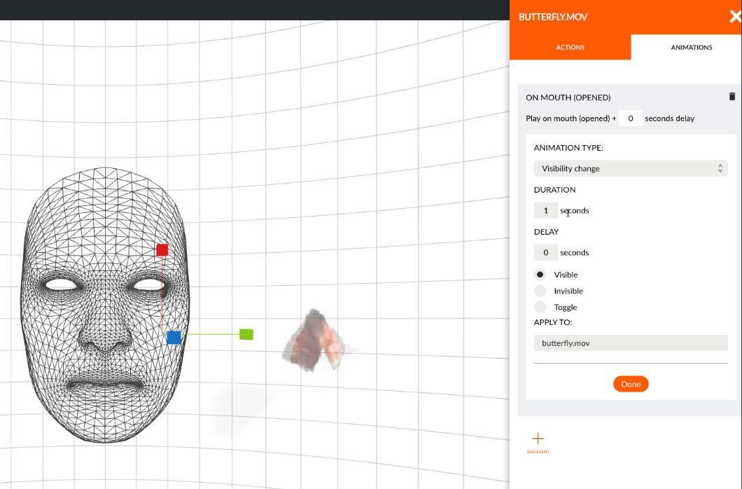
Figure 6.11. Adding animations

This is a nice feature for teachers that need to interact with their students. They can connect certain facial expressions with messages and videos that will appear after the interaction with certain information. In the above example, a butterfly video was uploaded, and its visibility was changed according to the timeline. When students open their mouths, the butterfly video will become visible. Accordingly, this can be applied to providing interactivity to a book depending on students’ reactions. Additional information and videos can appear connected to certain web links or disappear respectively.
Also, animations can be very useful for teachers that need to demonstrate smaller parts of an object in detail (Fig.6.12 and 6.13).
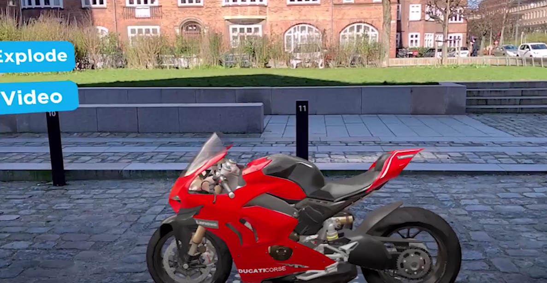
Figure 6.12. A motorbike as an introduced asset

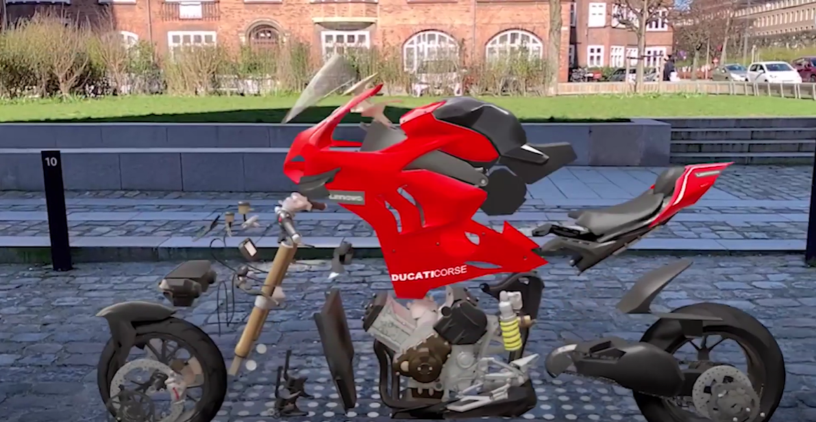
Figure 6.13. The parts of a motorbike after completing their animation

BlippBuilder

Link: https://www.blippar.com/build-ar
YouTube: https://www.youtube.com/channel/UC4E_enXpD_YH0rZhyB4crcQ/videos
Facebook: https://www.facebook.com/blippar
Tutorials: https://www.youtube.com/channel/UC4E_enXpD_YH0rZhyB4crcQ/videos
Cost: Free.
Description: Blippar’s AR Suite allows for creation of advanced AR experiences with a browser.
Functionality: Content can be organised as standalone experiences or as part of a group of experiences called “Projects”. Projects exist for grouping experiences together. Also, projects enable users to have access to analytics regarding a whole campaign, use common assets across all experiences, and organise content in a manageable way. AR experiences are called Blipps.

Users can create an account by opening the link blipps.blippar.com and then use the BlippBuilder tool to create a Web AR project. From there, they can choose the type of the AR experience they want to create (Fig. 7.1). Available types are:
- Around the user
- On a printed marker
- On a flat surface

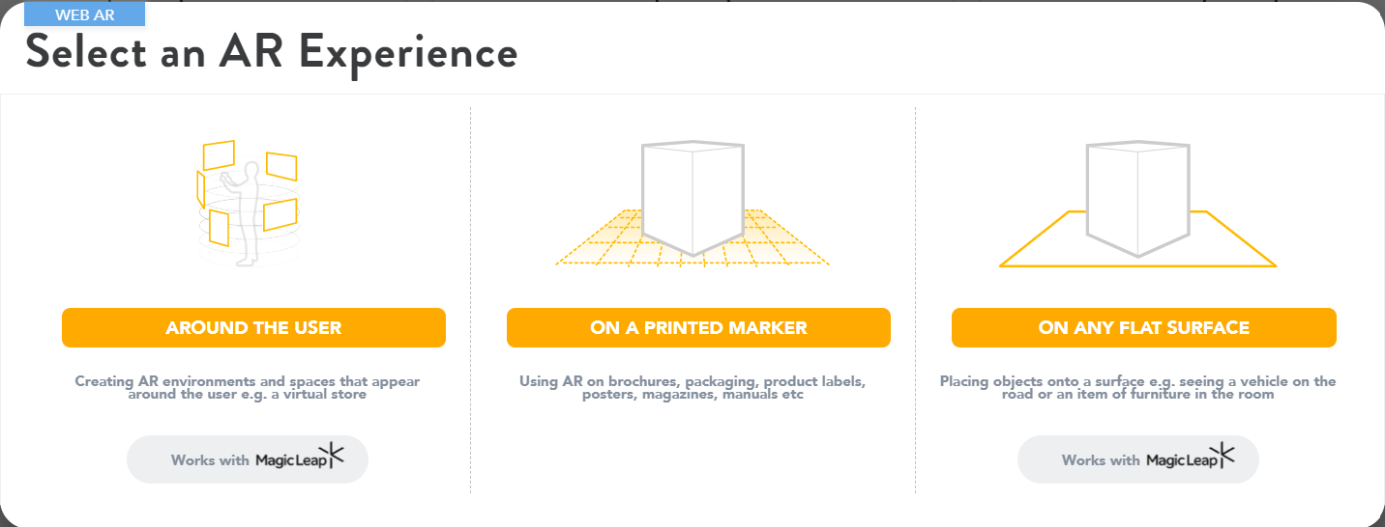

Figure 7.1. Project types

To create an AR experience where a user scans an image and digital content is displayed on top, like an augmented brochure, the “On a printed marker” option must be selected. Users can upload up to 3 markers or they can autogenerate one (Fig. 7.2).

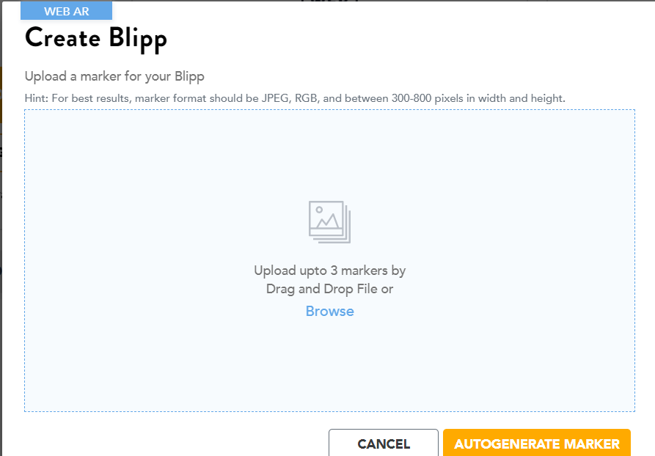

Figure 7.2. Creating a new Blipp and upload markers

The next step is to provide a name for the new Blipp and select the images to be used as markers (Figs. 7.3).

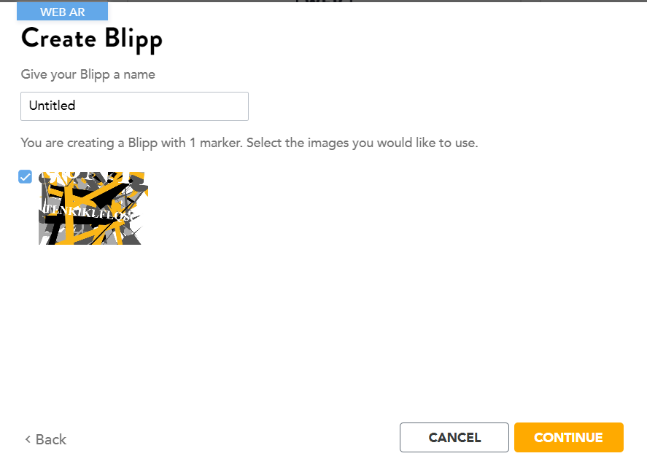

Figure 7.3. Providing a name and selecting images for the Blipp

Once the marker is uploaded, users will be directed to the BlippBuilder homepage. The marker will be in the centre of the screen (Fig. 7.4).
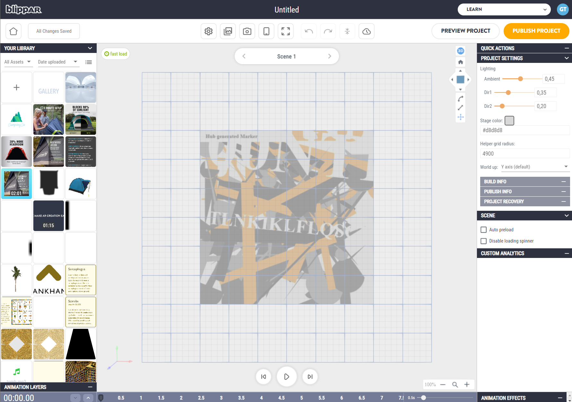

Figure 7.4. The selected marker for the Blipp

Then, the assets can be placed on the marker (Fig. 7.5). Users can upload their own assets and store them in their library.

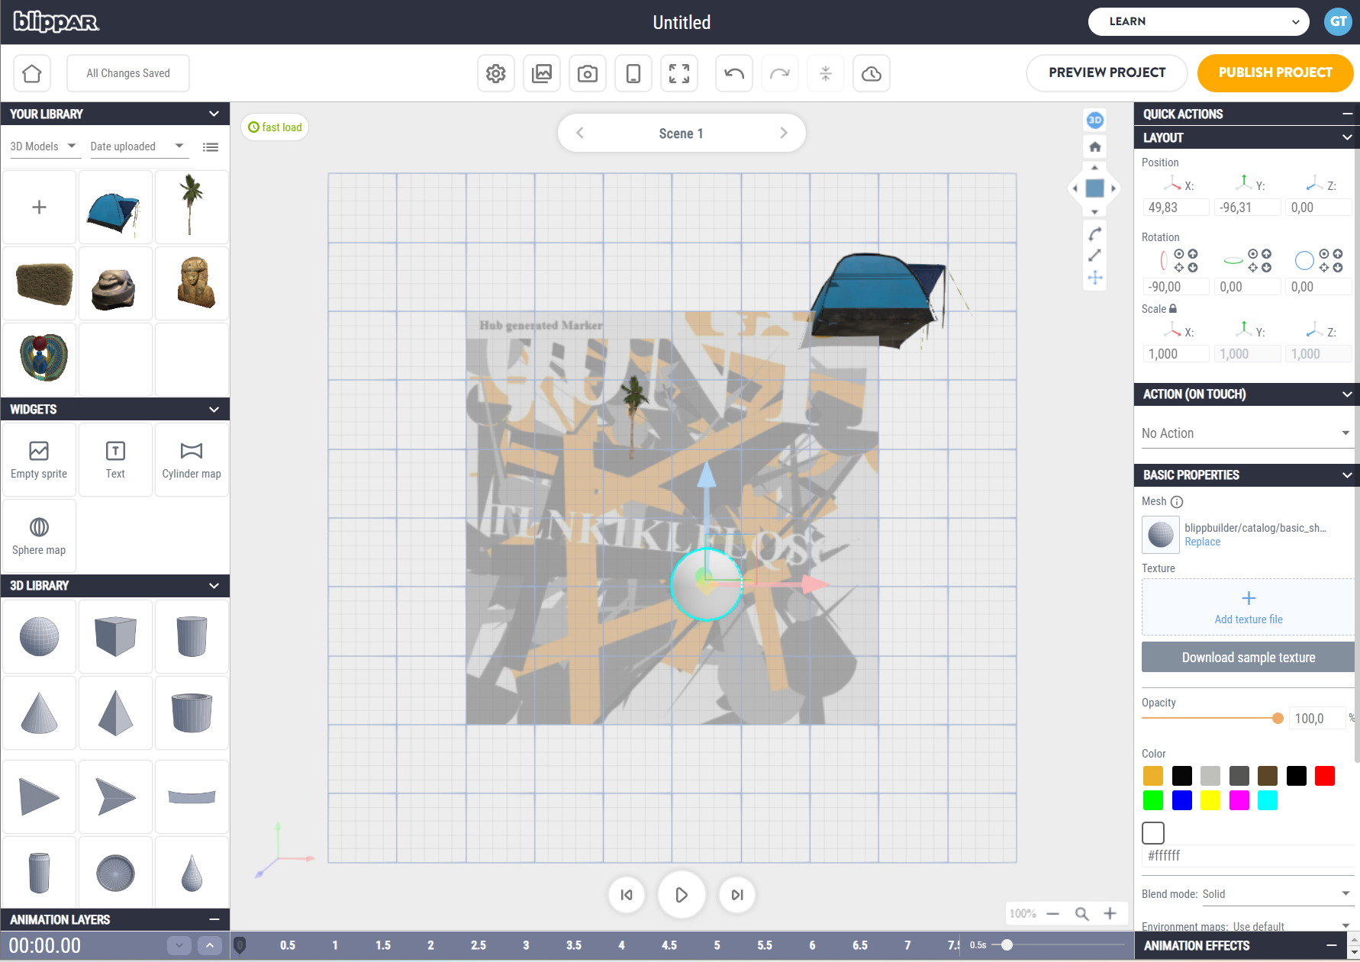

Figure 7.5. Placing assets on the marker

Users can check how their Blipp will look like in mobile version mode (Fig. 7.6).

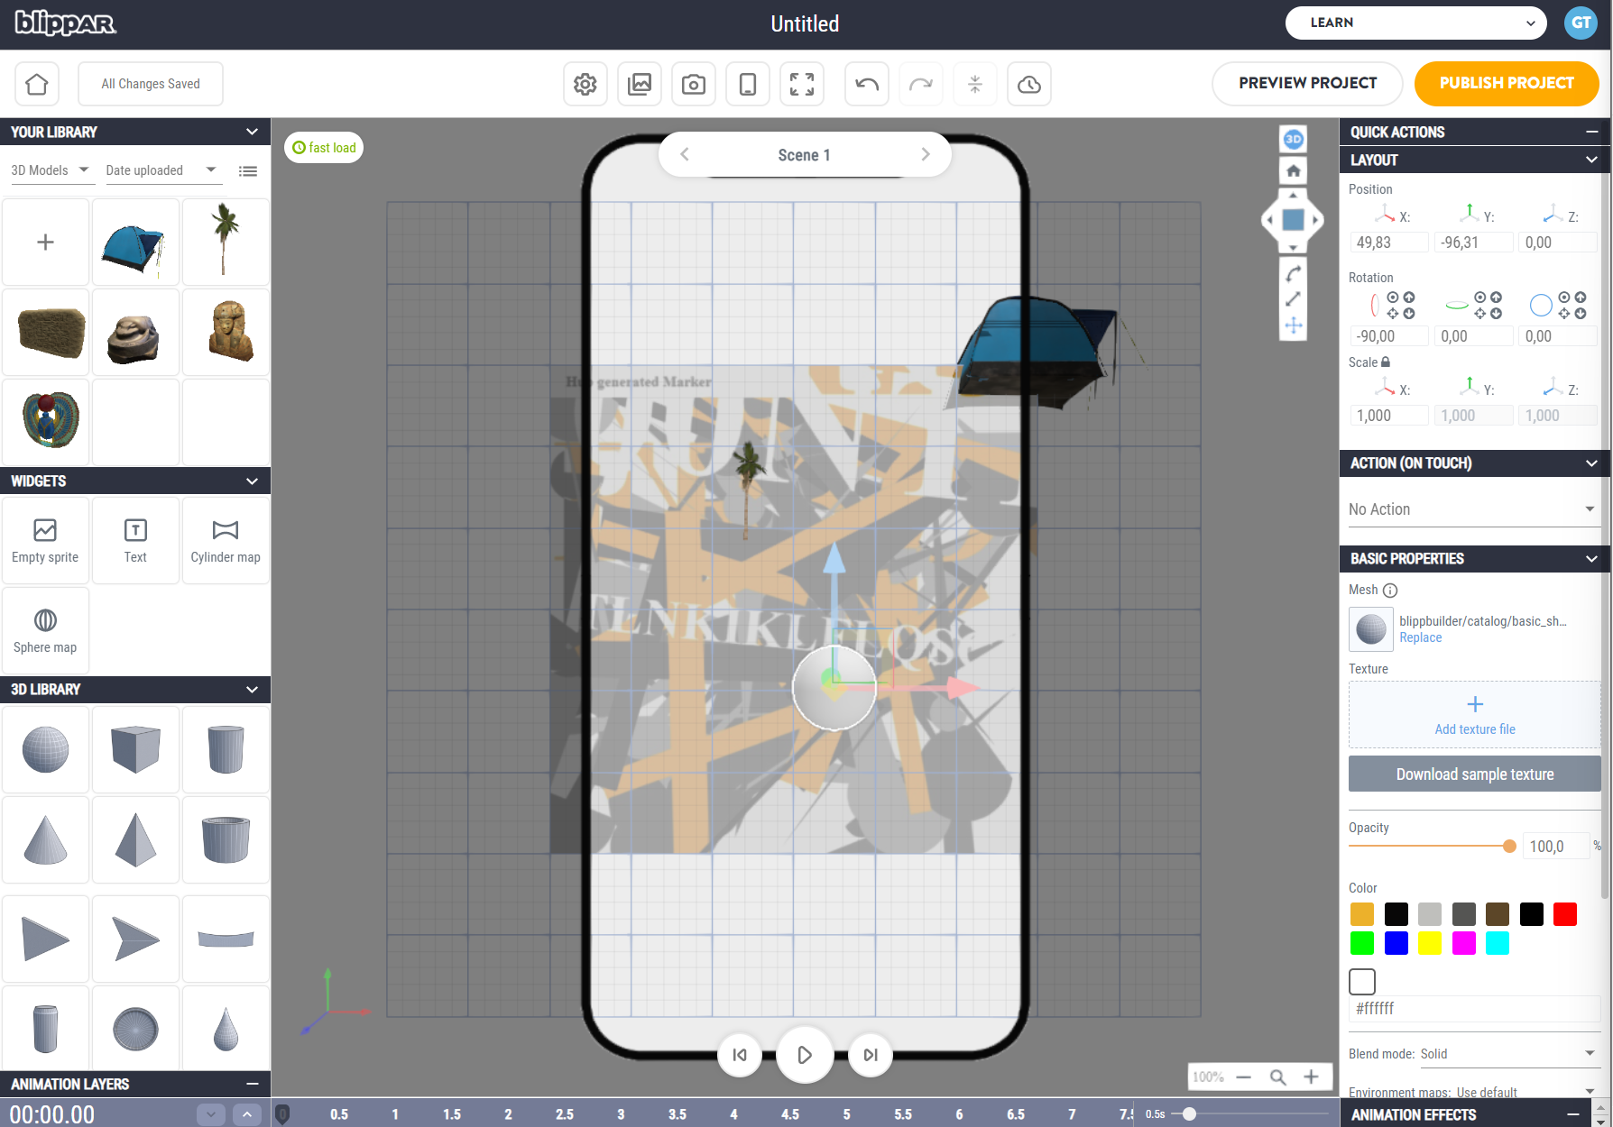

Figure 7.6. Preview in mobile version

Assets support actions and click events can make a sound or a video play (Fig. 7.7).
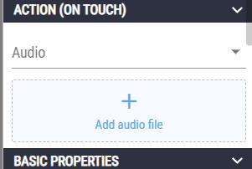

Figure 7.7. Actions on assets

Assets can be animated and have animated effects on a timeline (Fig. 7.8)
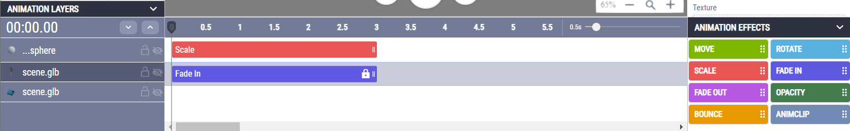

Figure 7.8. Menu for animations and effects

When a Blipp is finished, users can test it on their mobile device. By clicking the “Preview Project” button on the top-right corner of the screen a pop-up will appear displaying the QR code of the project (Fig. 7.9).
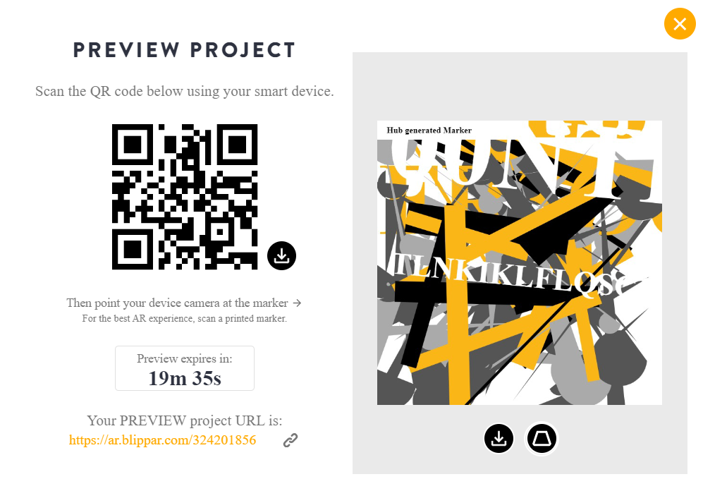

Figure 7.9. The QR code of the project for preview

Once the preview version is checked, users can publish their project and share the QR code of the project or the URL (Fig. 7.10).
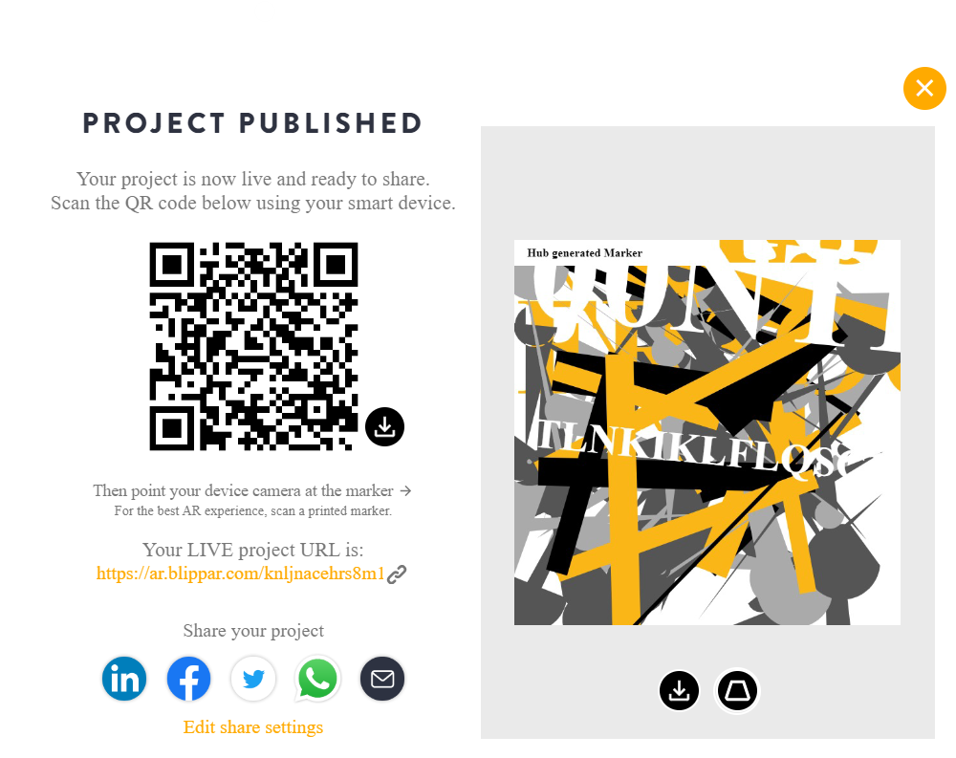

Figure 7.10. The QR code of the published project

Users can scan the QR code and see the final result in their browser (Fig. 7.11).

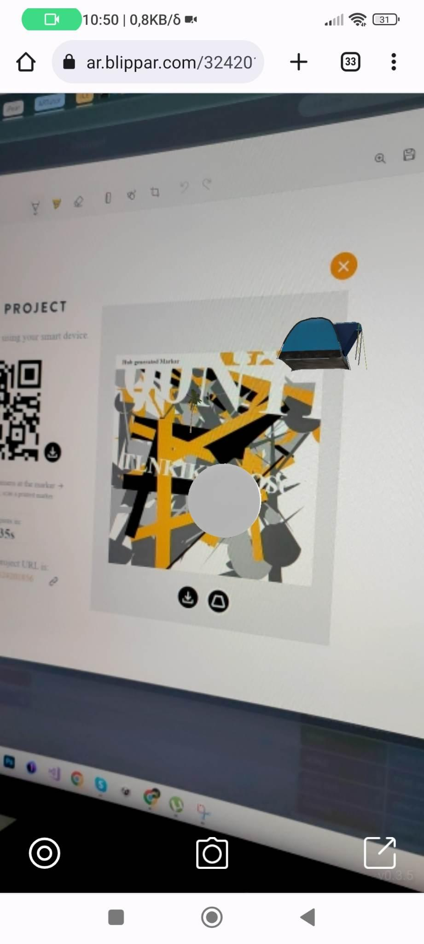

Figure 7.11. The final result displayed on the mobile phone

All these functions are very useful for teachers that would like to create whole experiences for their students. They can use a centre image and build a whole story around it. For instance, they can help young students decide on the plot of a story depending on their preferences. Teachers can create buttons and add triggers on them which will lead to certain actions or open certain information.

Onirix Creative Studio

Link: https://www.onirix.com/
YouTube: https://www.youtube.com/channel/UCTvD135hprc9jmWNHVjVOAw
Facebook: https://www.facebook.com/onirixAR/
Tutorials: https://docs.onirix.com/
Cost: Pro for €89 /month and 15 days free trial
Description: Onirix Creative Studio is a web application that allows users to create and configure various augmented reality experiences in a user-friendly manner. Onirix provides the opportunity to its users to embed virtual content on an object and enhance or augment it.
Functionality:
Onirix consists of two different components:
- Onirix Studio, a web application that helps users manage all their projects and contents. It allows to create augmented reality projects, and configure them by adding 2D, 3D or multimedia elements. All content is stored securely inside the Onirix Cloud.
- Onirix SDK, is a Source Development Kit for creating augmented reality applications from scratch. It allows the creation of White Labels or custom applications with custom style.

Onirix provides the selection among four two types of scenes within a project: Image tracking and surface tracking. Surface tracking refers to a virtual object that is displayed on different scales, while image tracking refers to magazine covers, posters or flyers that need to be enhanced through virtual content (Fig. 8.1).

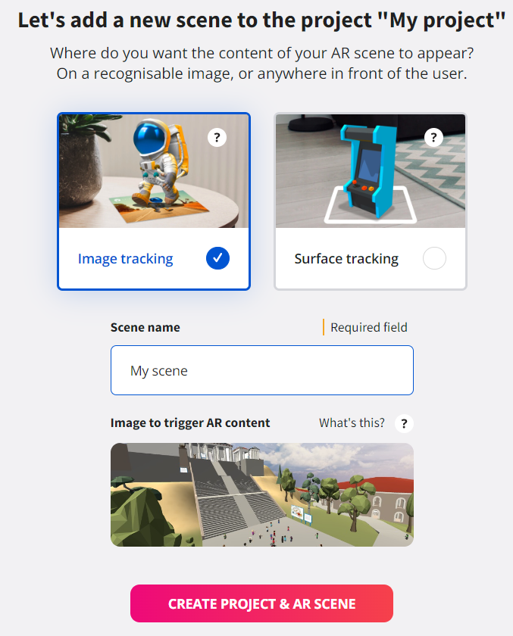
Figure 8.1. Selection of scene type within a project

Once users choose a scene, this can be modified from the "Settings" button, in the top bar of the Scene Editor. This tool will be automatically launched when opening a new project and it is used for designing and configuring the experiences (Fig. 8.2).

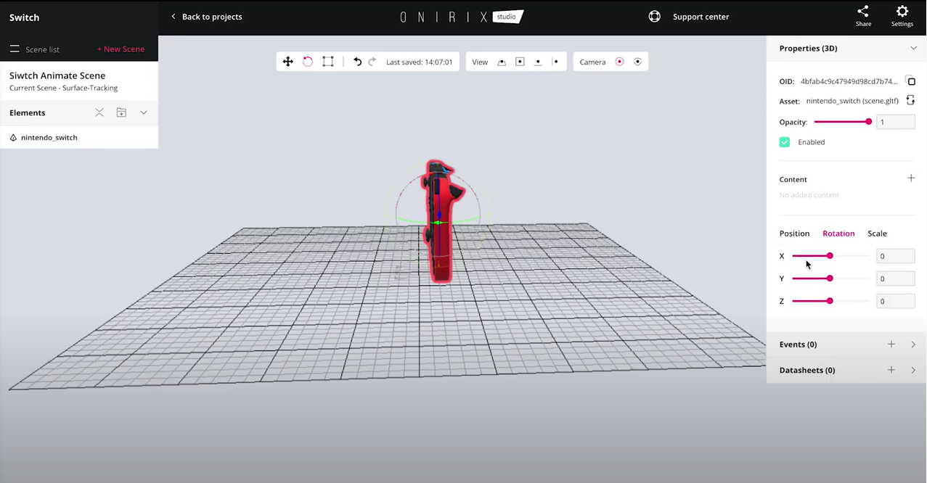
Figure 8.2. The Onirix scene editor
Users can use assets for creating virtual elements in the scenes. There are several types of assets related to 3D objects, images, sounds, video, URL link, sounds, among others. Users can upload an asset from the asset library in the scene editor or from the general assets page in the top menu. An example is shown below (Fig. 8.3).

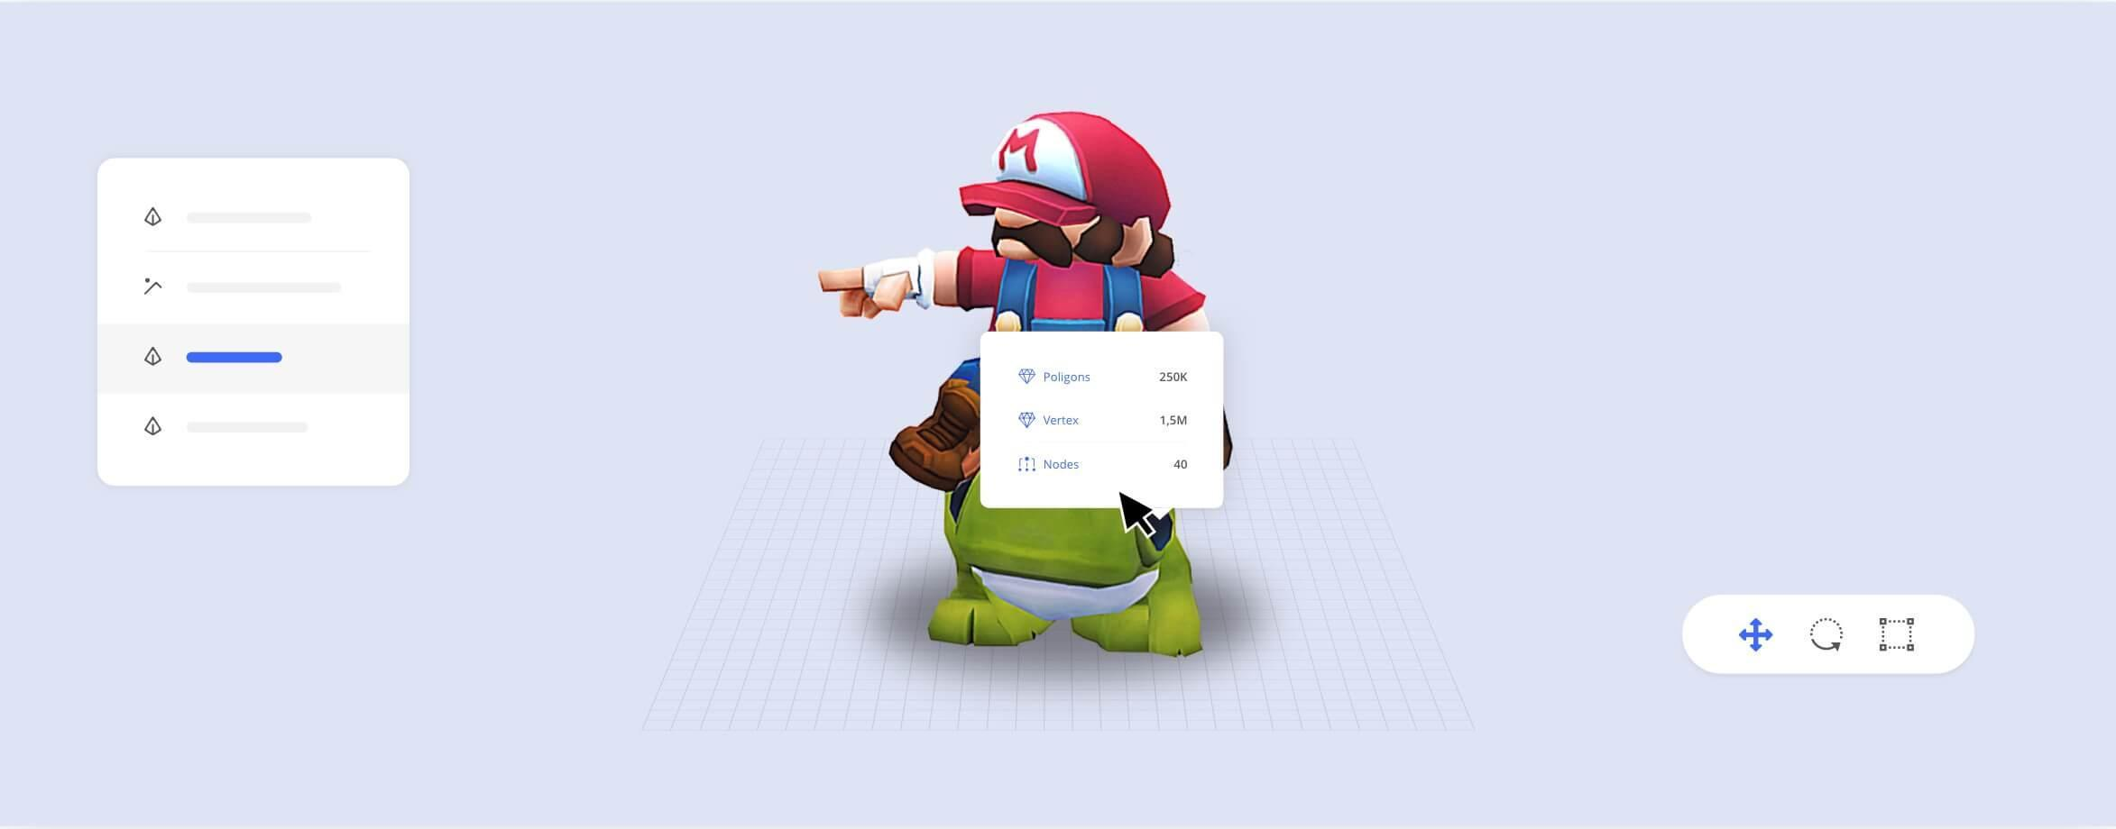
Figure 8.3. A 3D Model

3D models are the most widely used assets in Onirix Studio because they can simulate accurately almost any object, so they are perfect for merging virtual elements into the real world.
Widgets are a kind of shortcuts to create elements with predefined events. This allows users to create common interactions like showing a button to launch a URL in fewer clicks than creating individual labels and events (Fig. 8.4).

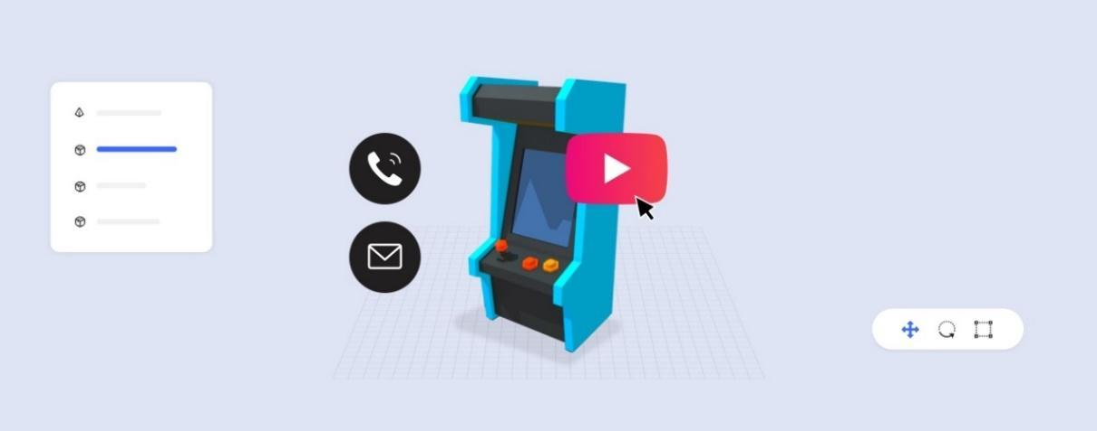
Figure 8.4. A widget

At this moment, Onirix supports the following widgets:
- External URL: A button that opens a web browser with a URL
- YouTube: A button than opens a browser with a YouTube video
- Phone: A button that opens the default phone app with a number
- Email: A button that opens the default email and creates an email draft to a recipient address.
All widgets can be replaced with regular elements and events (Fig. 8.5).
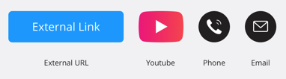
Figure 8.5. Regular elements and events

In order for the users to show the experience, they have to publish it. It can be easily done by using the "Share" menu inside the editor's top bar. After that, a public link to the experience exists where the user can share it with anyone (Fig. 8.6). Users can view the experience without installing a specific application since Onirix produces a Web AR experience.
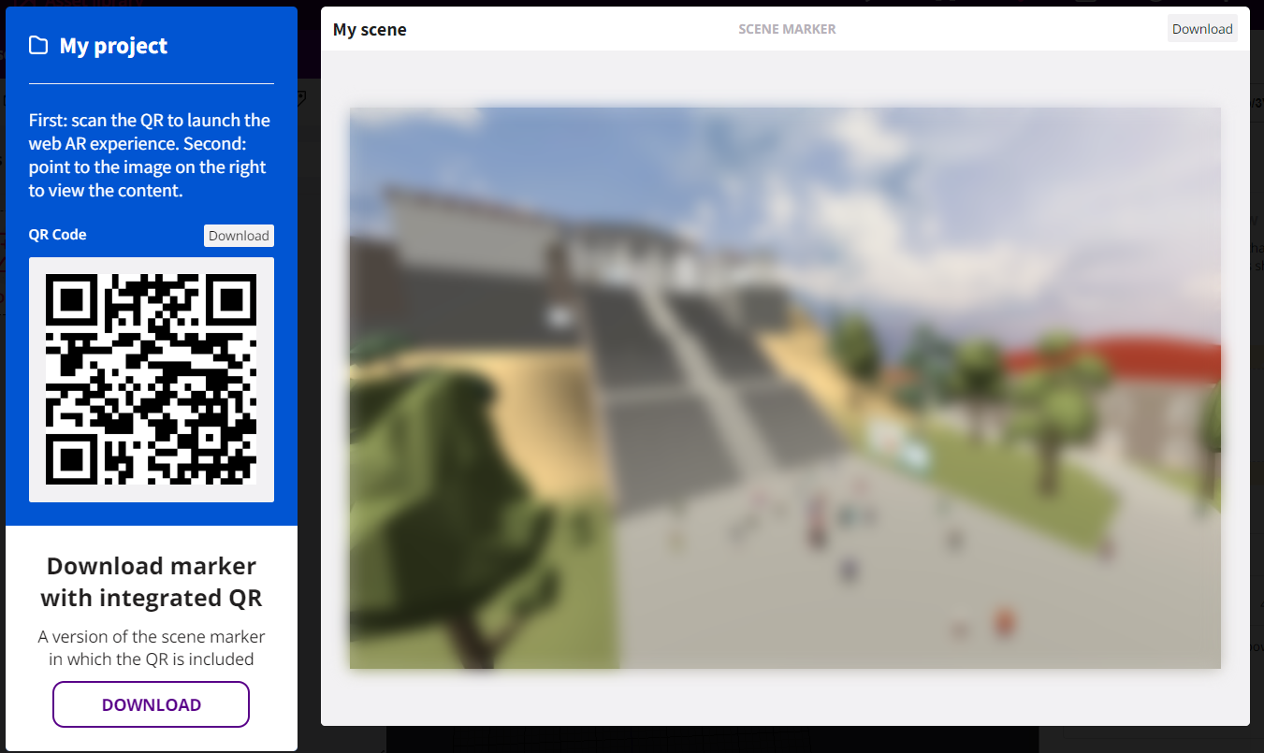
Figure 8.6. Publish an experience

Onirix SDK is a source development kit for Unity that allows to create custom or white label applications using Onirix as the AR content provider (Fig. 8.7).
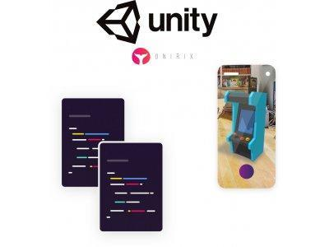
Figure 8.7. The logo of Onirix SDK

Onirix SDK doesn't require extensive maths or 3D graphics knowledge and it will set up the AR layer automatically. It already comes with a preconfigured solution of a fully working app that can be easily extended or modified.
With Onirix SDK users will be able to build applications with:
- Image tracking
- Image tracking with visual references
- Surface tracking
- Spatial tracking
- Geolocated AR (combine GPS with any of the previous tracking types).

Onirix is an interactive platform for teachers since it allows them to create experiences that will help students understand difficult concepts (Fig. 8.8). Especially for complicated assets, teachers can add labels on various parts and explain thoroughly their characteristics or functions (Figs. 8.9 – 8.11). This way, students can have a whole new learning experience even if they attend distance learning classes or follow a self-paced program (Fig. 8.12).
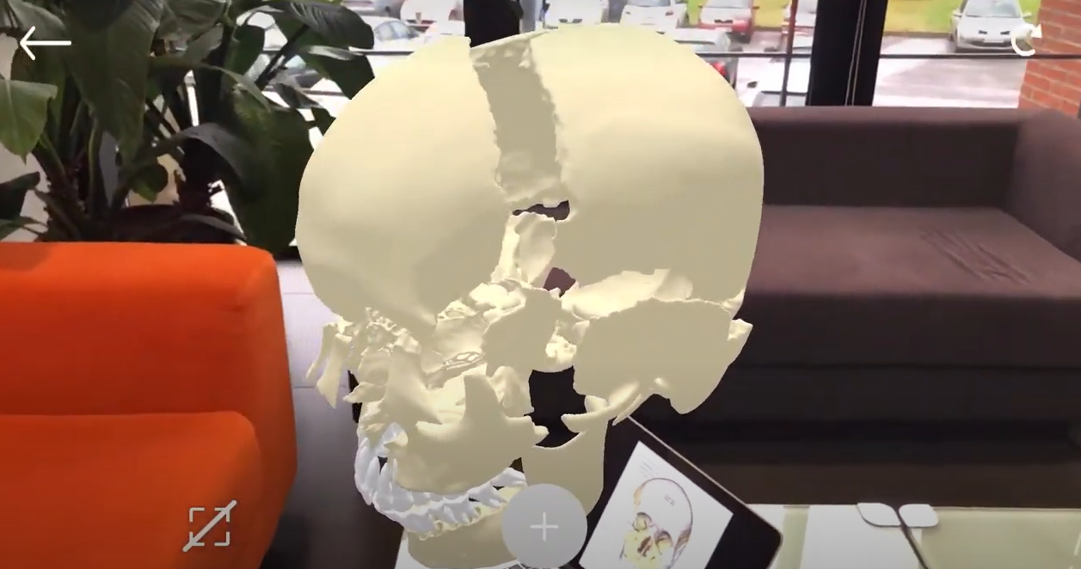
Figure 8.8. Onirix in medicine and training

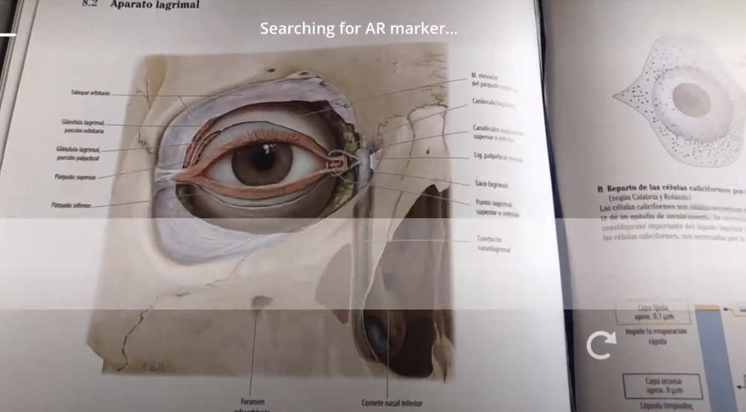
Figure 8.9. Scanning for markers that will display labels with information

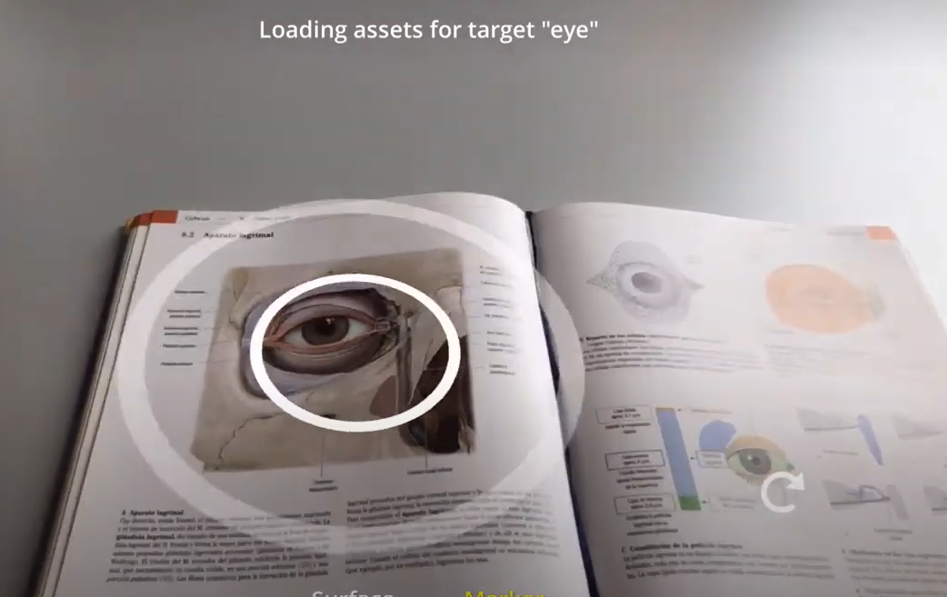
Figure 8.10. Loading assets after scanning
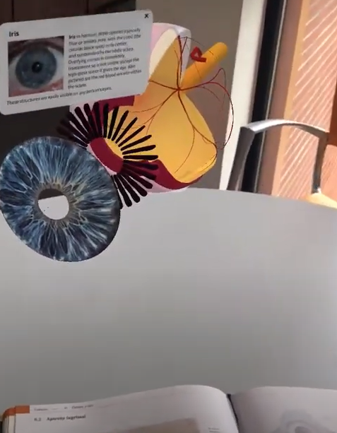
Figure 8.11. Showing the labels related to an asset

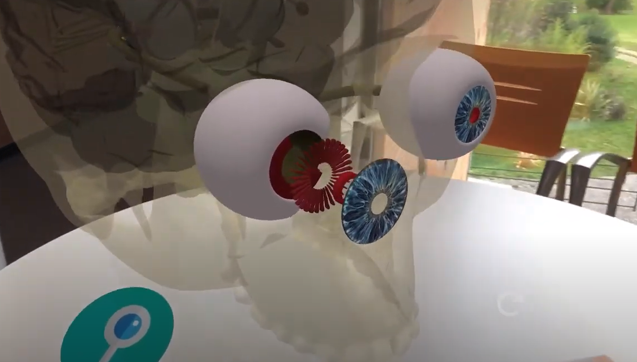
Figure 8.12. Displaying several components of an asset

Section 3. AR Head Mounted Displays (HMDs)

Augmented Reality (AR) is an essential part of the umbrella term Extended Reality (XR) which also includes virtual reality (VR) and mixed reality MR. AR is one of the main concepts within MR, and it is defined as a combination of reality and virtual reality where virtual objects lie on the real environment surface. Usually, researchers exemplify AR as locating virtual objects in a real environment.
AR can be experienced on various platforms, the applications described previously are widely available since users can find them on their phone or a tablet Android or iOS or even browser. It has its limitations mostly pronounced as users need to hold their device and view holograms through the screen of the phone, meaning users look at 3D models on a 2D screen - flattening the experience.
The famous author of “Wizard of Oz”, L. Frank Baum, has described already in the 19th century glasses that are able to overlay data onto the real world: “Therefore, that you may judge all your fellow creatures truly, and know upon whom to depend, I give you the Character Marker. It consists of this pair of spectacles. While you wear them everyone you meet will be marked upon the forehead with a letter indicating his or her character.” (The Master Key). The world’s first such untethered spectacles were released in 2016 by Microsoft Corp, called HoloLens. Since then, several HMDs have been developed, mostly for the enterprise market as their price ranges from 1,500$ to 3,500$. In this section, we will describe the most relevant one for the purpose of education: HoloLens 2.
HoloLens 2 was released in 2019 and is a headset that a user wears on their head with adjustable size for the circumstance of the head with a visor in front of their eyes. The HMD tracks the position and orientation of the head, eyes and hands using 4 visible light and 2 IR cameras. This means that use of the HoloLens 2 requires well-lit surroundings. In addition, it contains a depth sensor and IMU (accelerometer, gyroscope, and magnetometer). Users can record videos and take pictures with HoloLens resulting in 8-MP images and 1080p30 videos. HoloLens 2 is a standalone headset, meaning no additional hardware, such as a computer, is needed for using the headset. But there might be applications that will require the use of a computer for content creation or translating the user experience in the headset to the screen, so other participants of the session can see or guide the user. The HMD is wireless, and its battery lasts around 2-3 hours of active use or up to 2 weeks on stand-by and is rechargeable using a USB-C cable.
There are various ways users can interact with the HoloLens 2:
- Gestures: HoloLens can track hands and recognise certain movements and positions as specific actions.
- Gaze: HoloLens can also track eyes, so users are able to perform actions by looking at designated places, e.g., buttons.
- Voice commands: HoloLens has in-built microphone and speech recognition, usually a pop-up showing possible voice commands that can be performed in an application.
Possible interactions and more can be learned in a built-in tutorial application in HoloLens 2, created by Microsoft Corp. Information about basic usage can be found at: https://docs.microsoft.com/en-us/hololens/hololens2-basic-usage.
What makes the HoloLens especially powerful is its understanding of the environment and possibility of placing holograms that only the user wearing the HMD can see on specific positions in the world. HoloLens creates a real-time environment mesh, meaning that it can place holograms on walls, floor or tables. In addition, if the user places an object in a corner of the room and goes to another room and comes back, the object will stay at its original place. More than that, the user can carry the object to another room using gestures. An important note is that even though screenshots and promotional videos of AR HMDs show full scale holograms, in reality the augmented spectator view is limited and has a diagonal field of view of 52 degrees .
Lastly, HoloLens has Wi-Fi, Bluetooth connection and allows users to go into a browser and find a few of the standard Microsoft applications. The menus, especially settings, are quite similar to Windows’ settings.
To set up a HoloLens 2 for the first time, users would need a network connection (Wi-Fi or ethernet with a USB-C adapter), a Microsoft account and a well-lit space. The headset itself will take the user through the process similarly to the set-up of Windows computers. More detailed information about the set-up process can be found at: https://docs.microsoft.com/en-us/hololens/hololens2-start.
Looking at the many capabilities of the HoloLens 2, there exists a variety of applications. Although there are less than a user would find on an Android/iOS smartphone as the price of the headset is a limitation for development. Since it is mostly targeted at companies, users can find several companies able to develop applications specifically for their business. When it comes to education, the majority of applications have specific topics that it explores, but here are listed more open-ended applications for this HMD. In order to install any applications on HoloLens, users need to go to the Microsoft Store on the HoloLens itself and download it from there.

3D Viewer

Link: https://apps.microsoft.com/store/detail/3d-viewer/9NBLGGH42THS?hl=en-us&gl=US
Cost: Free
Description: Default Microsoft application on Windows and HoloLens that allows users to view and place 3D models, changing their size, rotation and position. In addition, it is possible to upload models from OneDrive.
Functionality: When the main menu is open on the HoloLens 2, the user can press on the 3D viewer icon to open the application. It will open a window with examples of 3D models that can be viewed. To choose a 3D model, the user needs to press on the desired object. It might take some time for it to download, but once it has appeared in the view, the user can move, rotate and resize the 3D model. It is advised that the user completes the HoloLens gestures tutorial, found in the Tips application to become familiar with the movement, rotation and resize functionality of 3D models. In addition to the models in the application, it is possible to upload new ones. It can be done by connecting HoloLens 2 to a PC using USB-to-USB-C cable and copying a .GLB file of a 3D model to HoloLens 2 similarly to how it can be done with a smartphone. If no files are seen when opening HoloLens 2 on the PC, it is advised to check if the user has signed into HoloLens 2. An example of how to upload a 3D model to the application is described below.

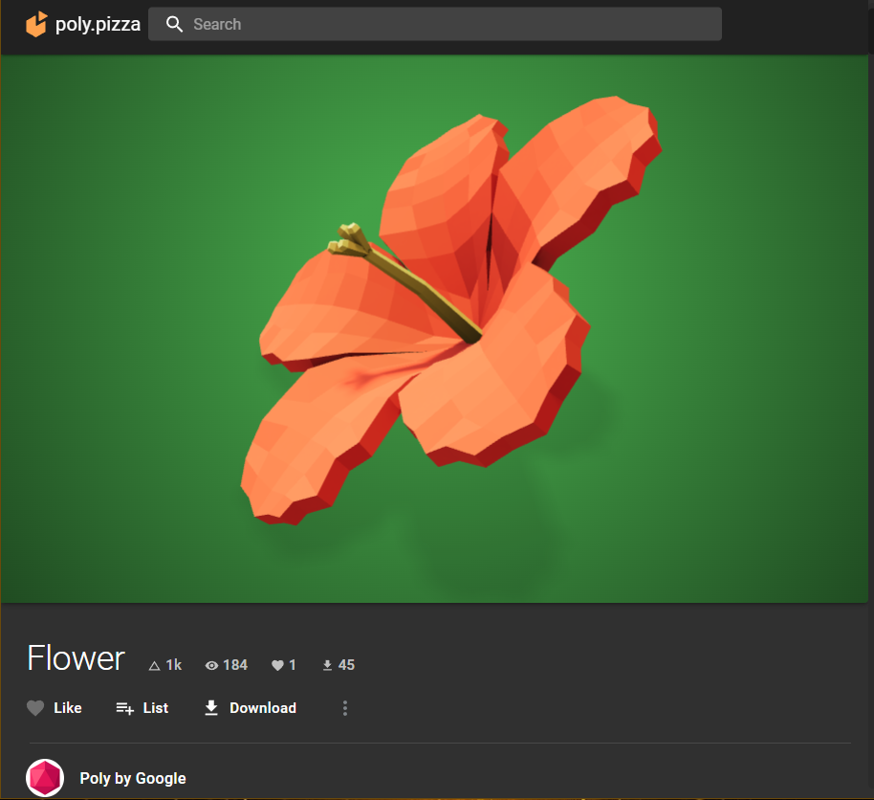
Figure 9.1. The 3D model in .GLB format is provided by Poly Google.
Source: https://poly.pizza/m/fg5U0dl1Sd3

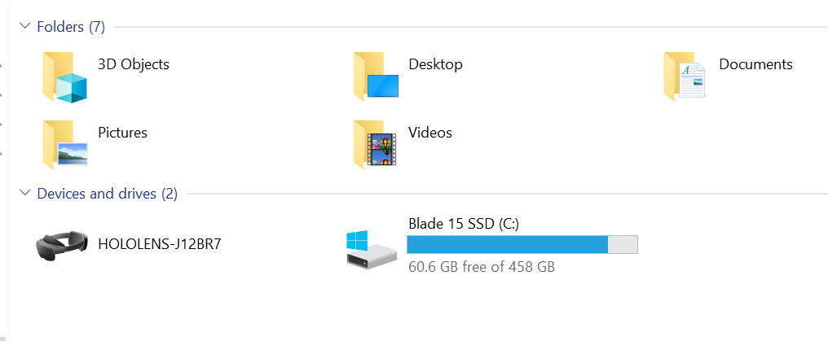
Figure 9.2. Once an unlocked and turned on HoloLens 2 is connected to the PC, it should appear in the File Explorer.

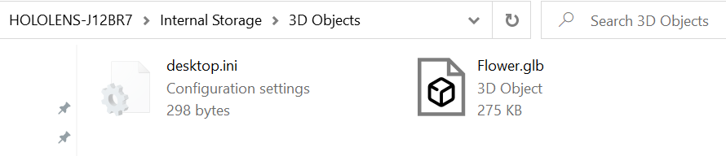
Figure 9.3. Add the file of the 3D model to HoloLens’ internal storage in 3D Objects folder

The same procedure can be done on the HoloLens 2 itself, as the user can go into a browser similarly to a PC. But the fact that the user will need to navigate it using gestures instead of a mouse and a keyboard might slow down the process.

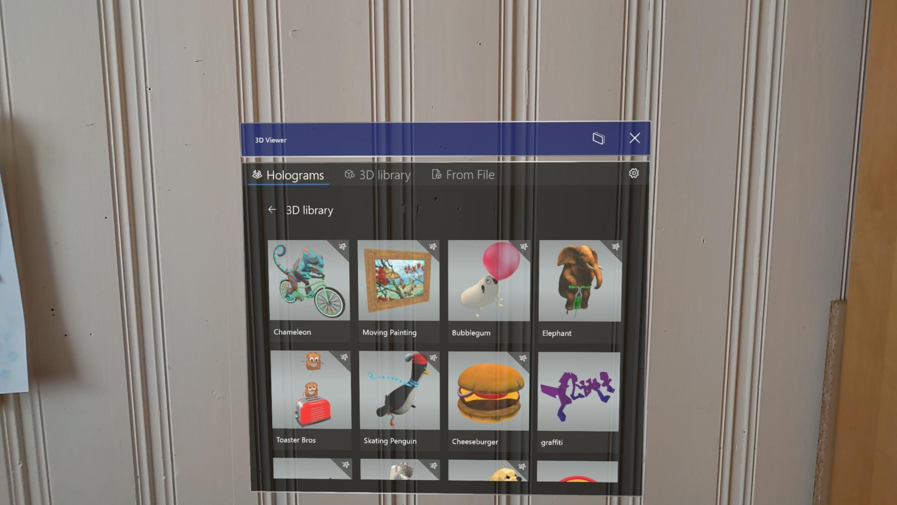
Figure 9.4. Once the 3D viewer application is opened in the HoloLens 2, user will see a library of available 3D models

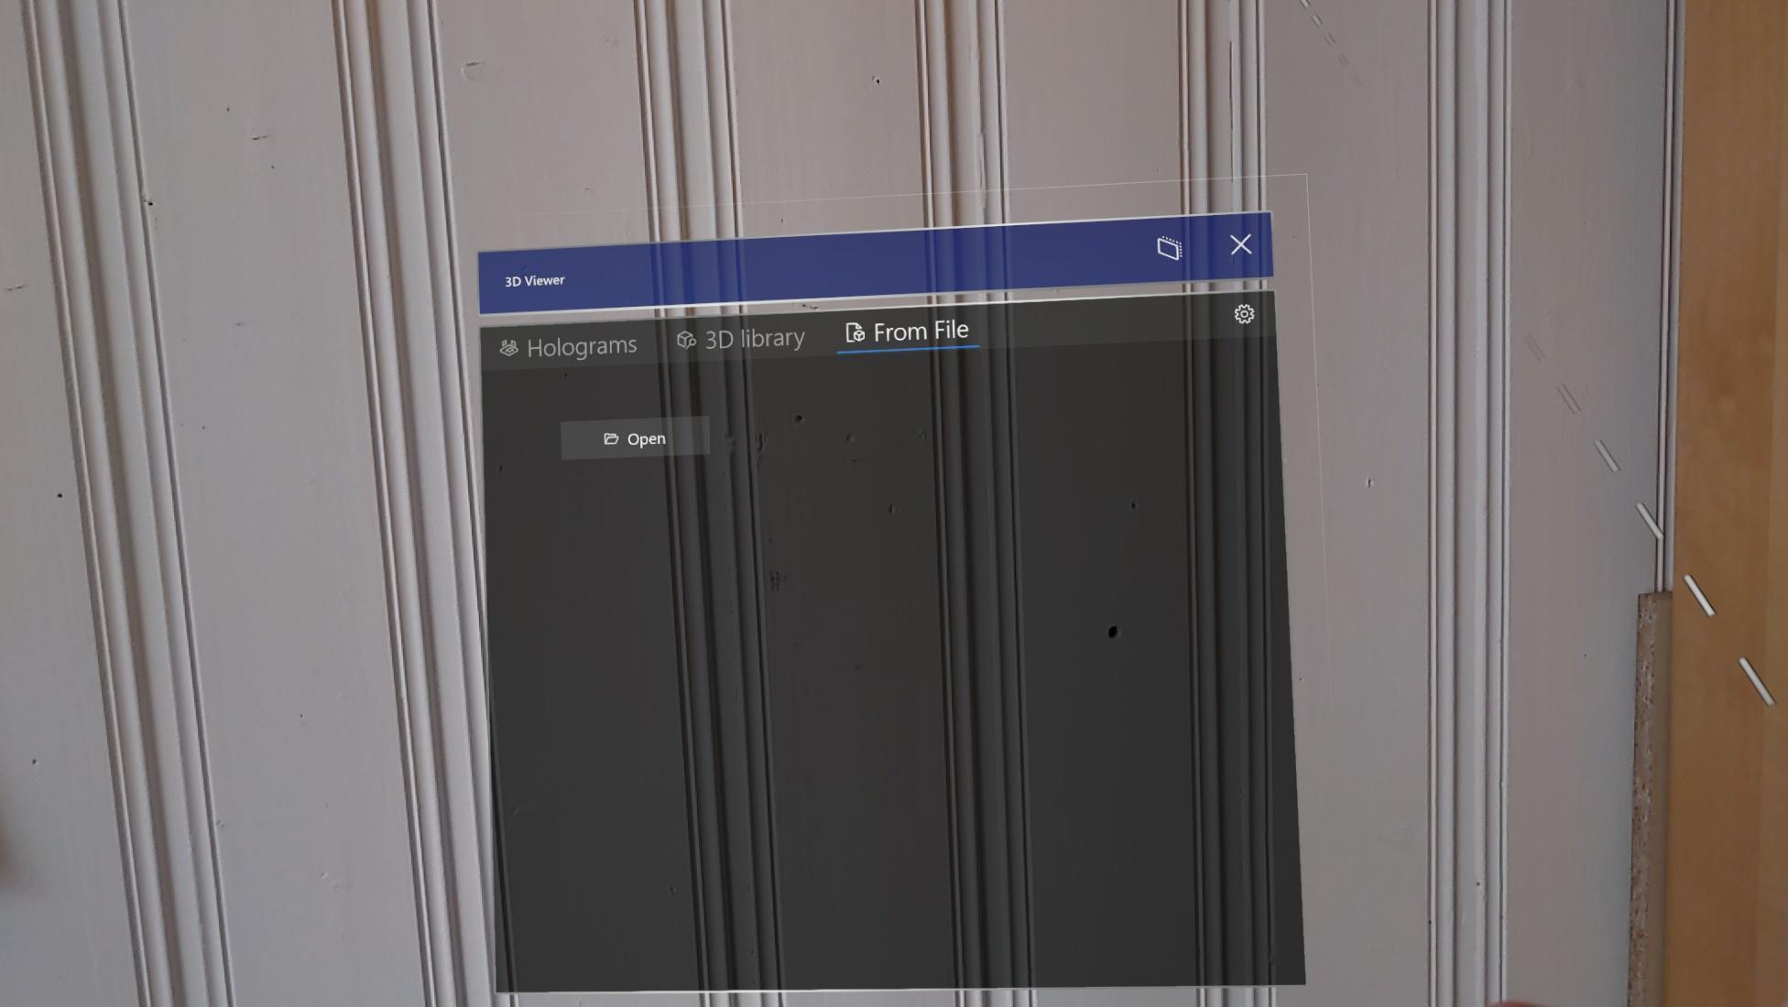
Figure 9.5. To upload a new 3D model, user needs to go to “From File” section and press “Open”

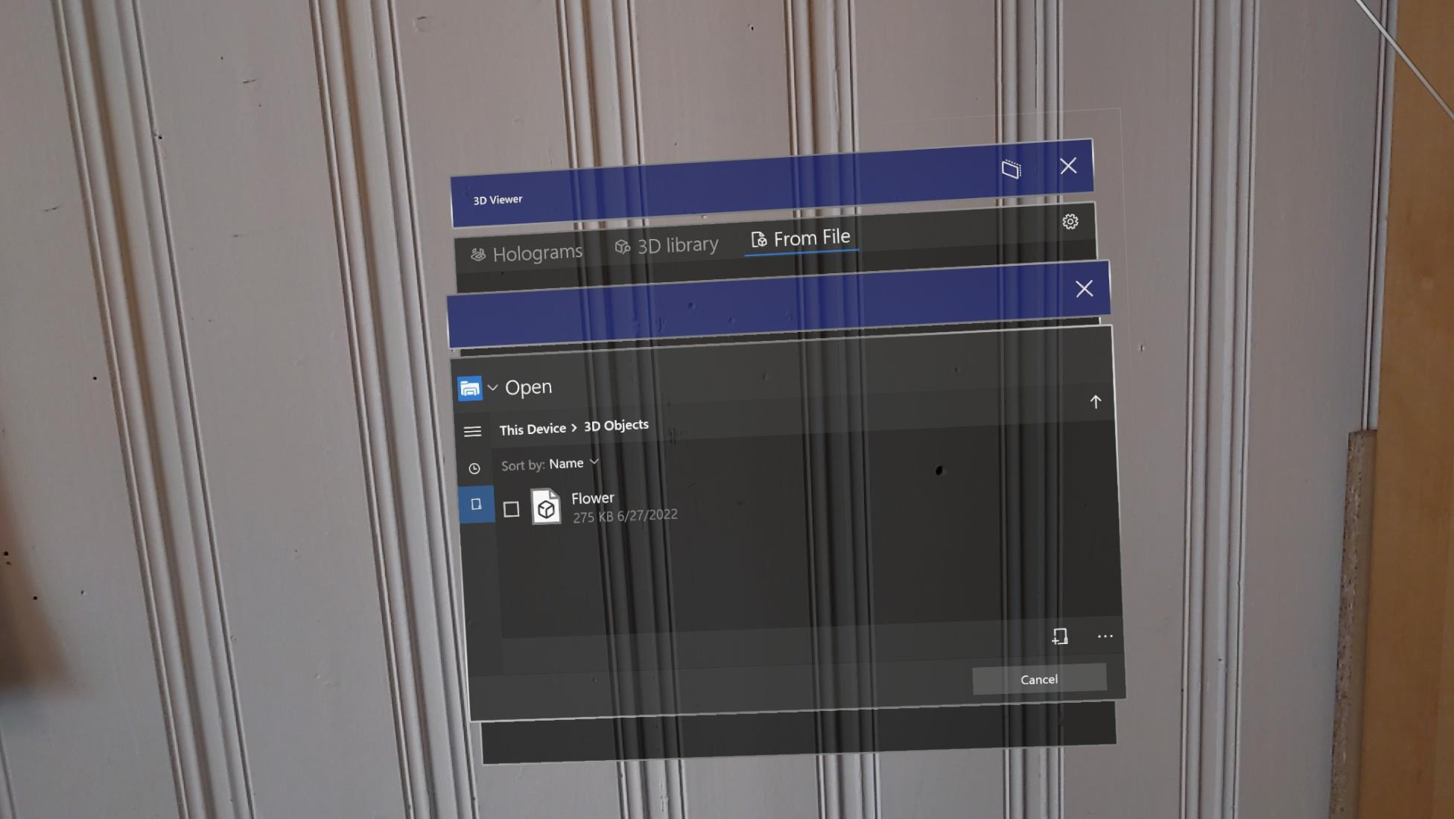
Figure 9.6. There, a File Explorer will appear, where users can navigate to the place where the 3D model was upload to and click on the file.

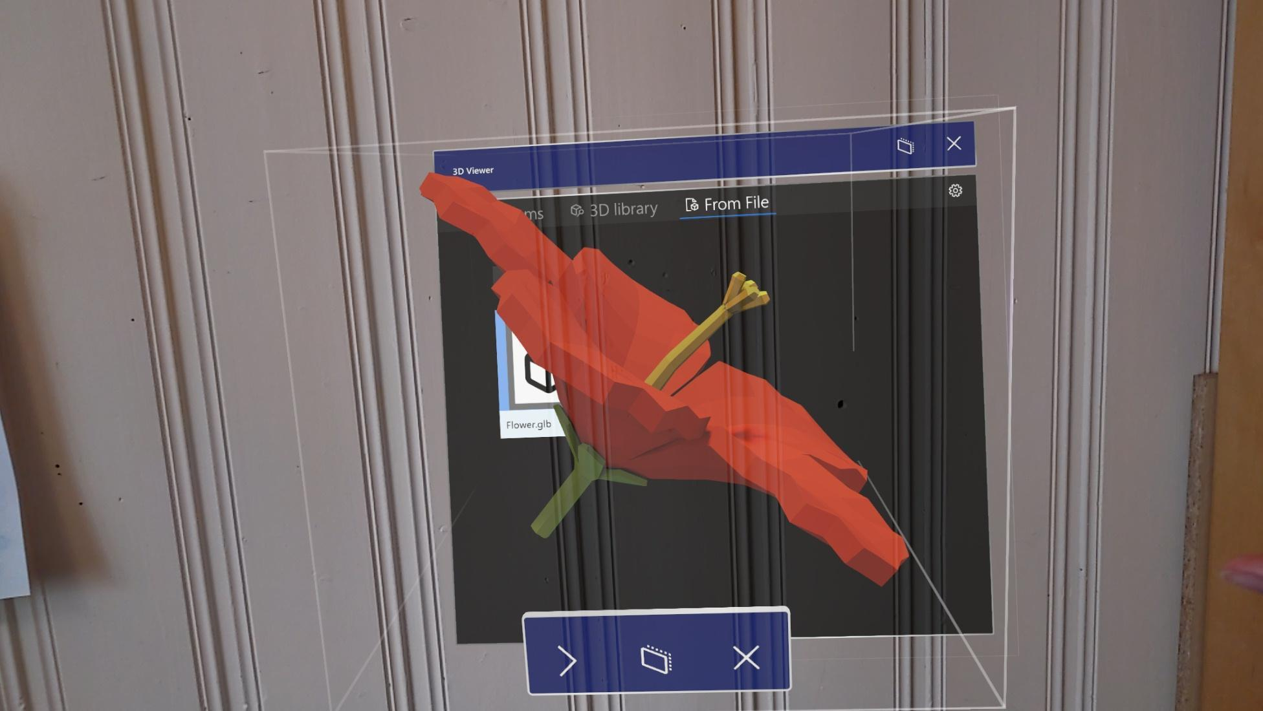
Figure 9.7. Once the 3D model is uploaded, the user can move, rotate and scale it

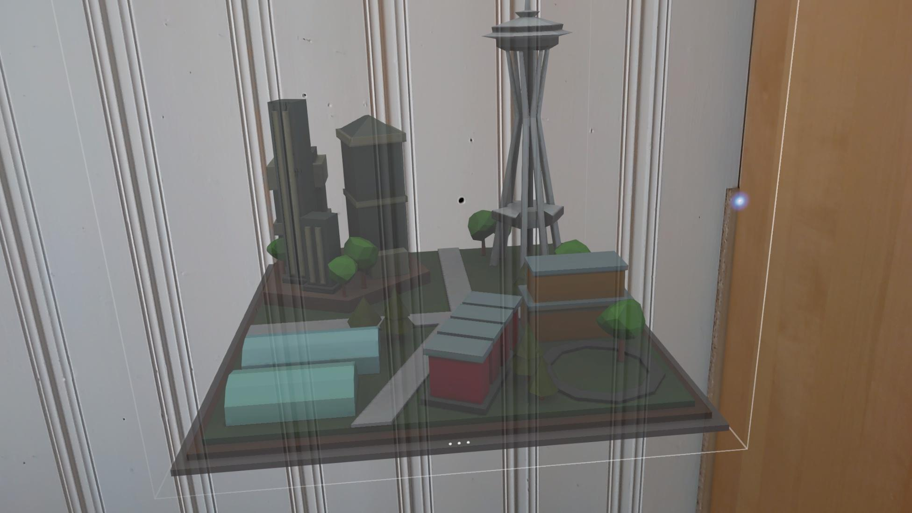
Figure 9.8. Model of an urban city allows for a discussion about infrastructure and placement

Microsoft Mesh App

Link: https://docs.microsoft.com/en-us/mesh/overview
YouTube: https://www.youtube.com/watch?v=bDJ-MA8vkj4
Tutorials: https://docs.microsoft.com/en-us/mesh/mesh-app/
Cost: Free
Description: Collaborative application that allows users to interact with each other, upload 3D models through OneDrive and file system, and annotate content.
Functionality: Allows for creating meeting rooms where users can collaborate with other users of HoloLens. Users can mute and unmute themselves as in other meeting applications on PC. The content in meeting rooms persists even when all users have left the room, meaning that it is possible to set up the content before the meeting. Mesh App has a library with 3D models, but it is also possible to upload new models through a file system similar to 3D viewer or by adding a 3D model to OneDrive after the application is installed. The file needs to be in the path MyFiles/Applications/Microsoft Mesh App/MyContent/ to be visible by the application. When the 3D models are added to the view, it will be shared to other users who have access to that meeting room. Mesh App has also drawing, erasing and stickers tools where users can choose the size and colour of the pen to add annotations to the content.

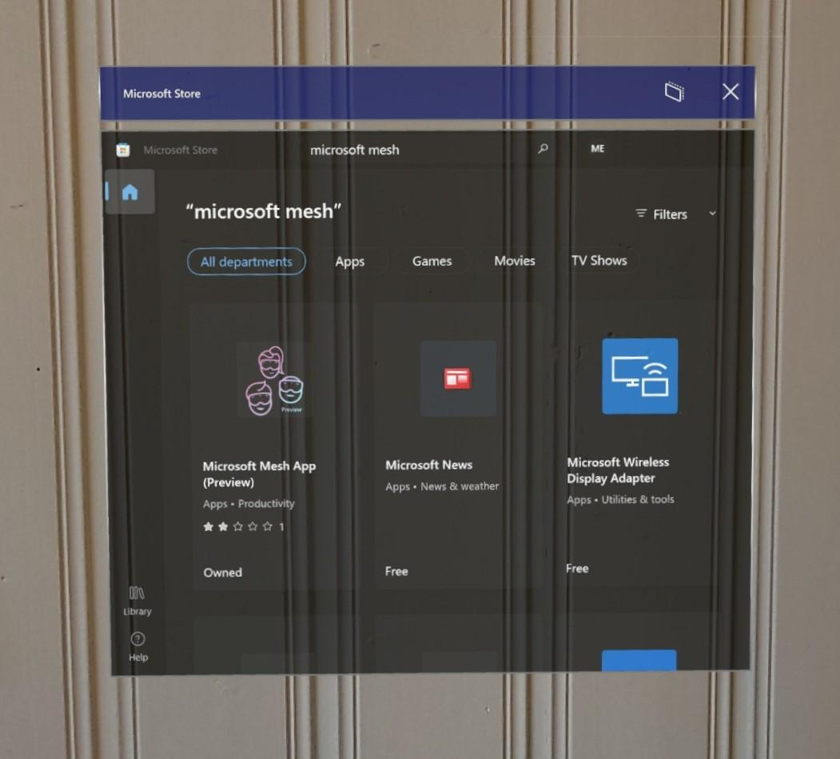
Figure 10.1. To acquire the application, the user will need to search for it in Microsoft Store on HoloLens 2 and download it from there
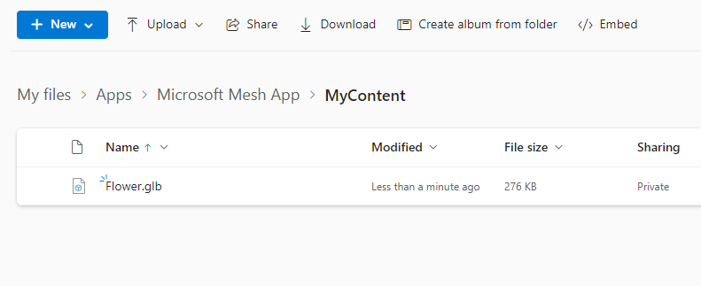
Figure 10.2. When the application is installed, a new 3D model can be uploaded through OneDrive

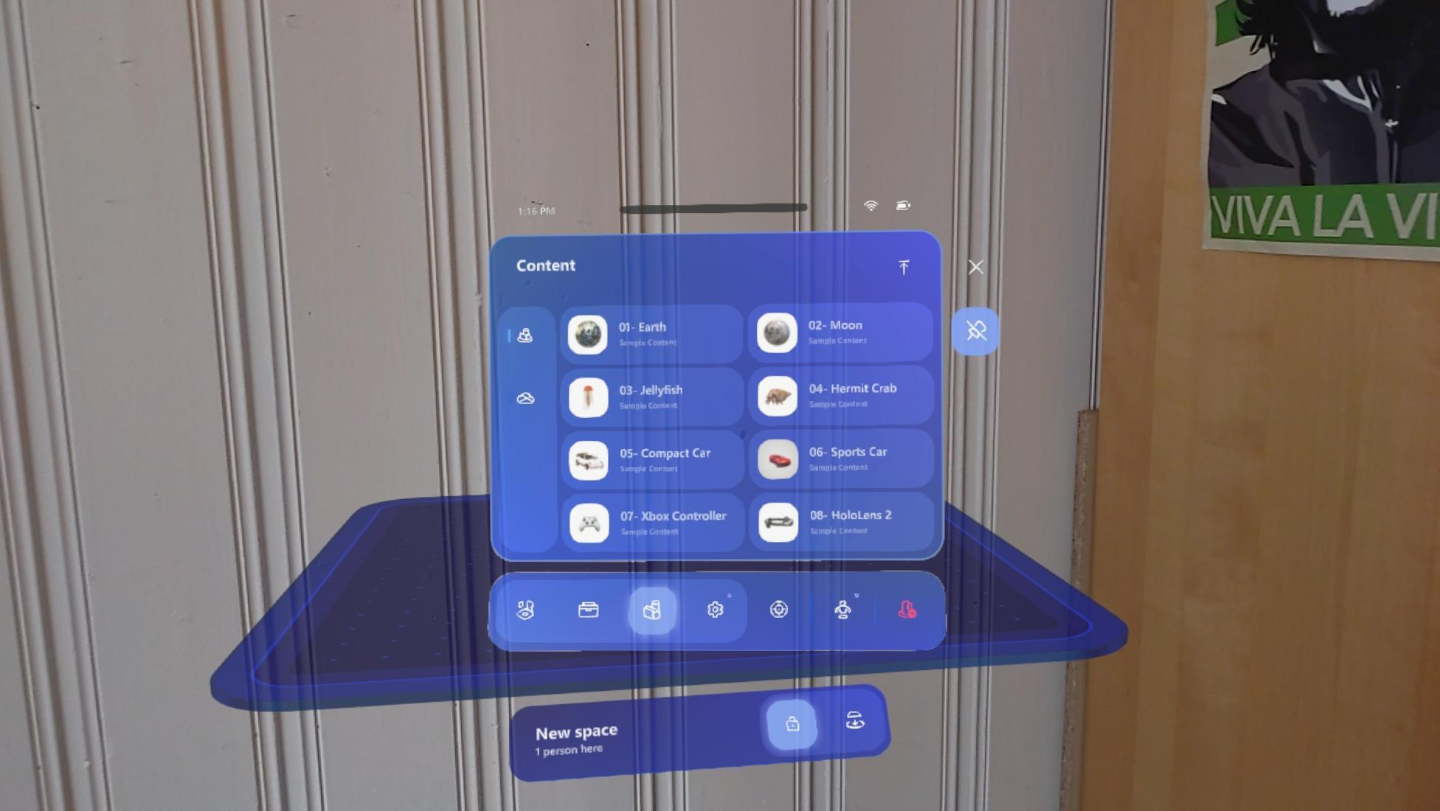
Figure 10.3. Library of 3D models with option to upload new ones

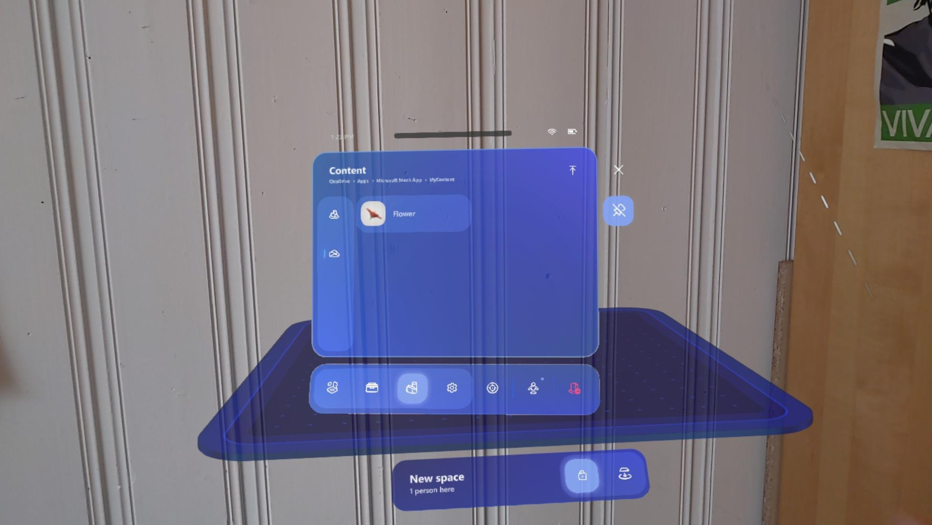
Figure 10.4. The uploaded 3D model will appear in the application

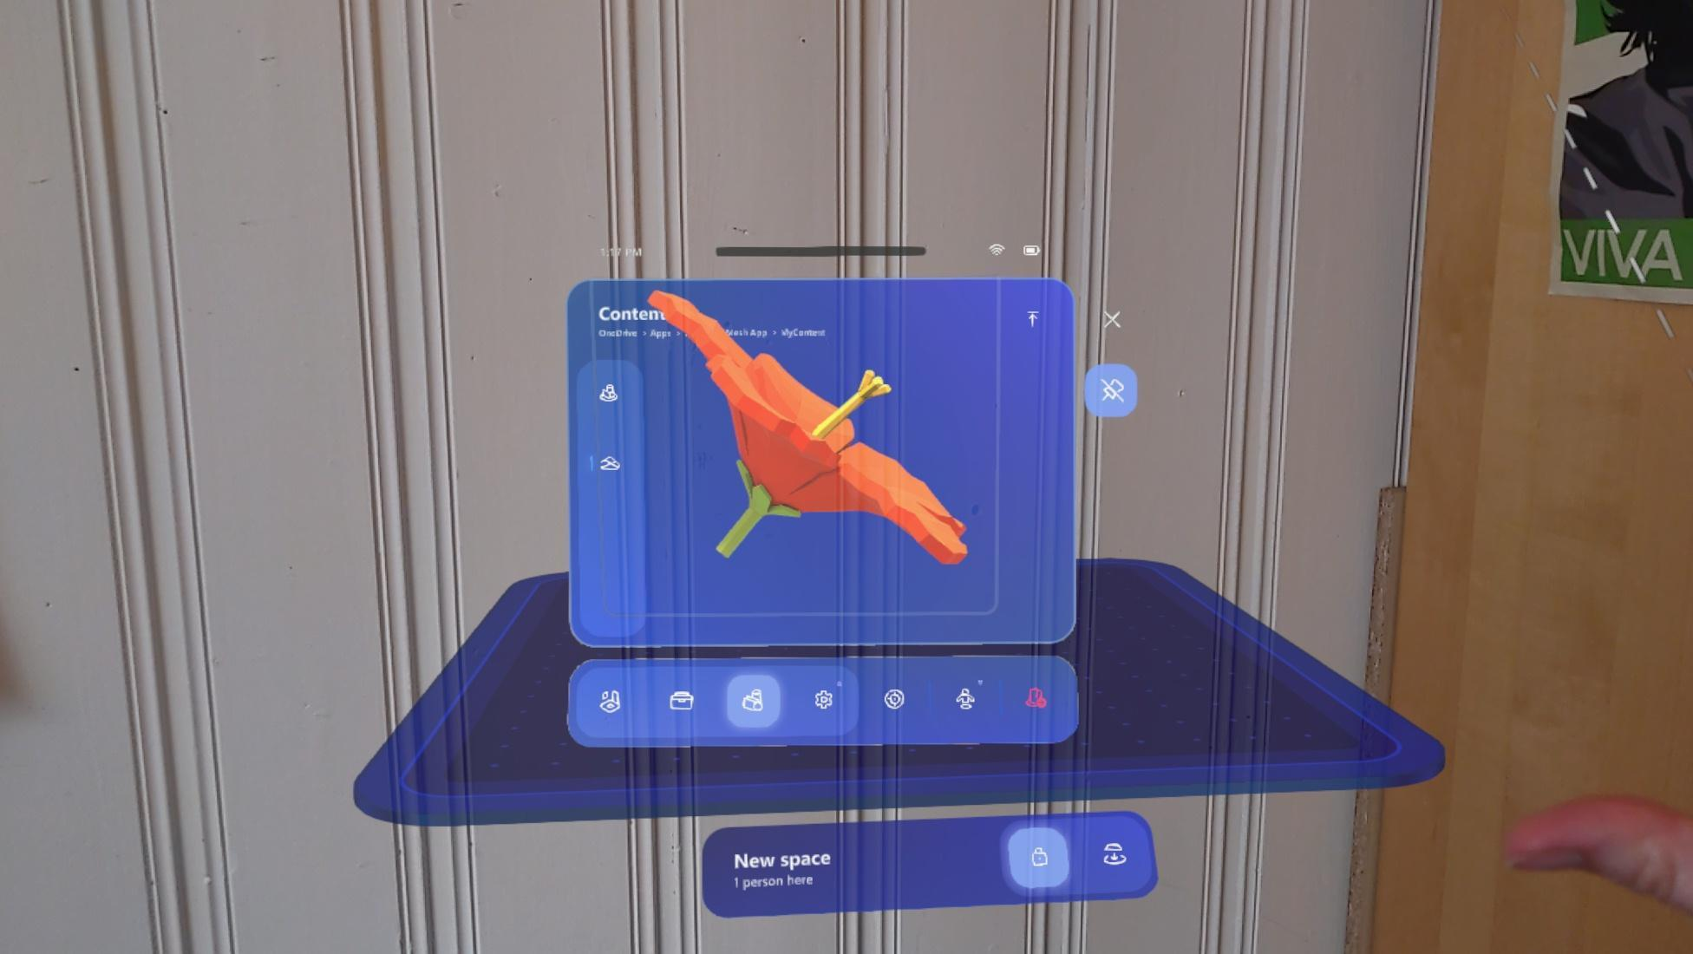
Figure 10.5. To view the model, the user needs to press on the file

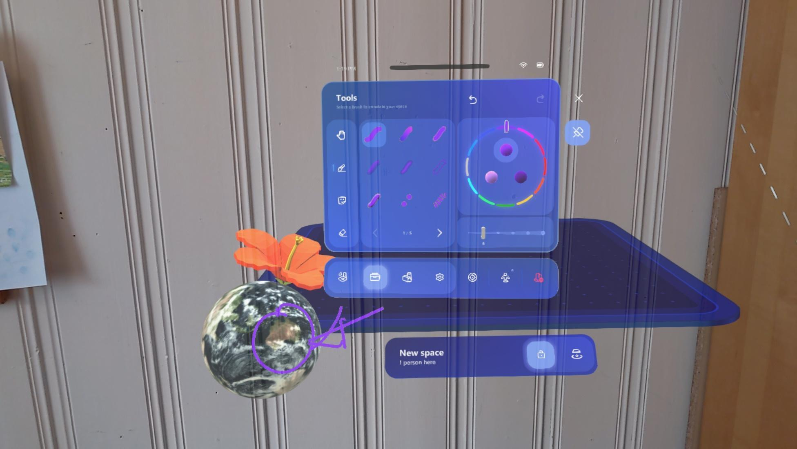
Figure 10.6. Drawing tools allow users to annotate

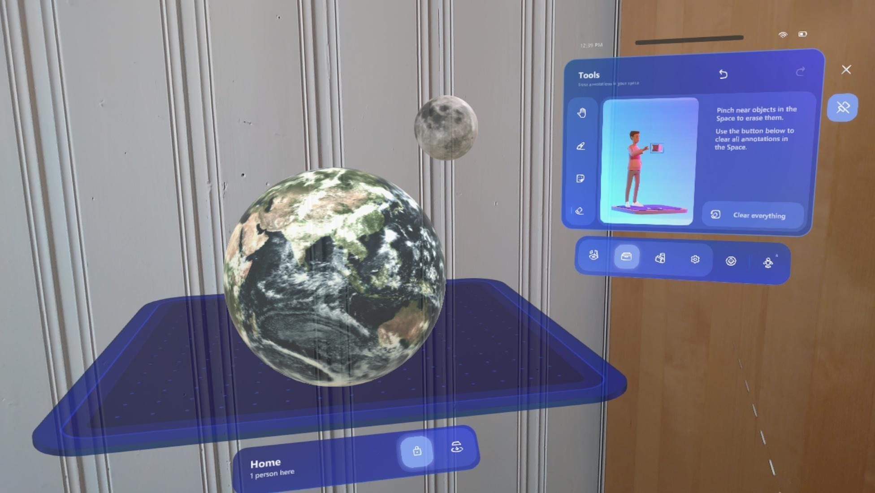
Figure 10.7. Students can build planetary systems together

3D Graffiti

Link: https://www.microsoft.com/en-us/p/graffiti-3d/9npqpk9ngtzr?activetab=pivot:overviewtab
Cost: Free
Description: Quick and simple application allows for annotation in 3D with different colours and sizes of the pen.
Functionality: Users will need to download the application form Microsoft Store on HoloLens 2. To open the menu in the application user will need to open a palm of their hand. There, it is possible to change the size and colour of the pen. To control the drawing, users will need to pinch their index and thumb fingers and move their hand.

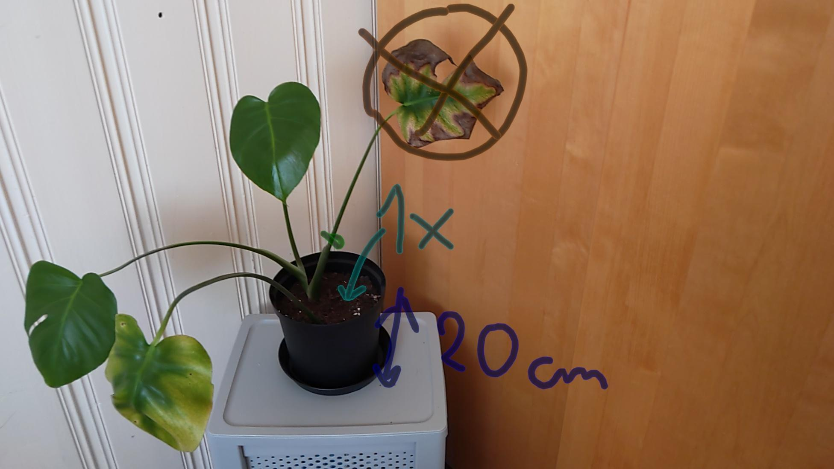
Figure 11.1. Giving instructions connected to real life objects by drawing in 3D

HoloAnatomy

Link: https://case.edu/holoanatomy/
YouTube: https://www.youtube.com/watch?v=tMRq_RCCuoc
Tutorials: https://docs.microsoft.com/en-us/mesh/mesh-app/
Cost: Free Demo, for full version requires contact with HoloAnatomy: https://case.edu/holoanatomy/contact
Description: A multiplayer application allowing for learning of anatomy of a human body by observing different layers and structures of the human body.
Functionality: The application has a teacher and student modes, where the teacher can control the size, position and layer of the body. Students can observe the same model together by joining the same room. The HoloAnatomy application also supports collaborative sessions with up to 98 simultaneous participants. The interactivity offered by the application is limited to changing between different views of the human body.
The demo application has only a teacher mode showing how a user could control the presentation.

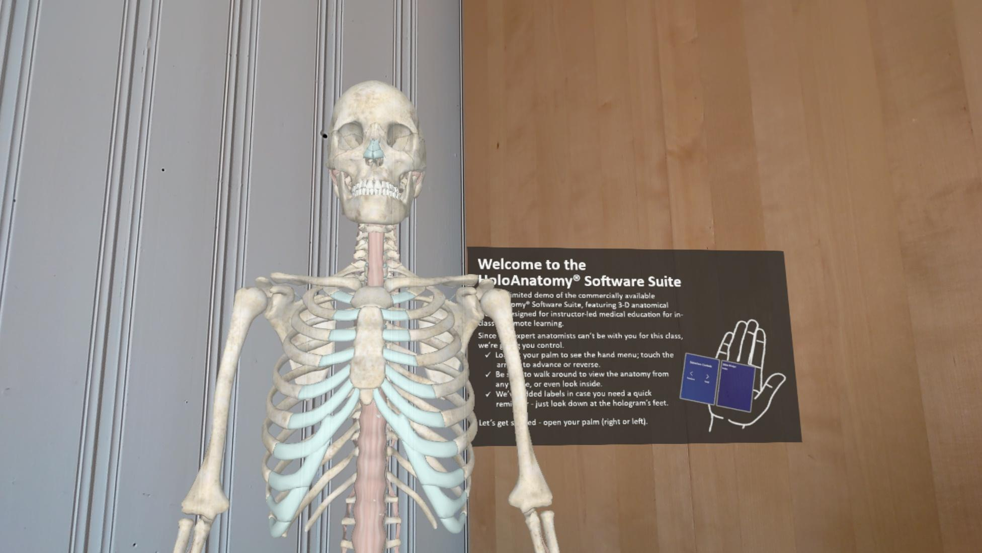
Figure 12.1. Showing the bone structure of a human body
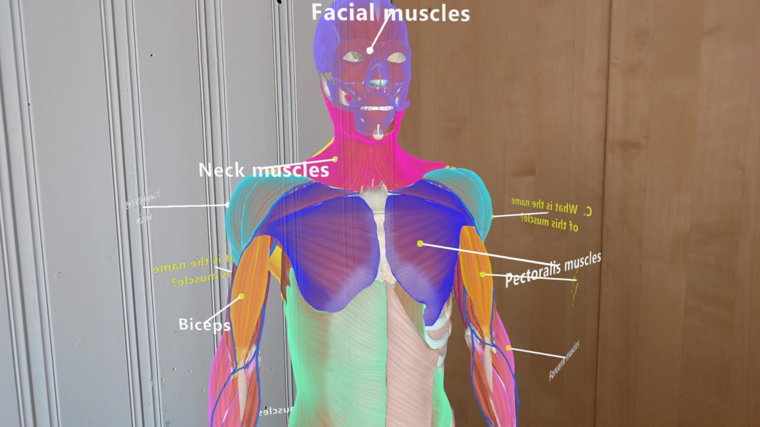
Figure 12.2. Muscles of a human body with highlighted names.

Nevrolens

Link: https://www.ntnu.edu/imtel/nevrolens
YouTube: https://www.youtube.com/watch?v=eaIQ1R6zBuk&t=1
Cost: Free
Description: The Nevrolens app is being developed by IMTEL VR lab of NTNU as part of the Nevrolens project in collaboration with the Kavli Institute for Systems Neuroscience of NTNU. The Nevrolens app provides an augmented-reality experience for learning about the neuroanatomy of the rat brain and is available on HMD Hololens devices, IOS and Android smartphones or tablets.
The brain system consists of a high-resolution 3D model of a rat brain model with the opportunity to observe different layers of the brain structure, where every part has its unique colour and description. The app is targeted for medical students to learn neuroanatomy, as part of a formal education or individually.
Functionality: The Nevrolens app offers various features for studying the 3D model of the rat brain in augmented reality. The user can place a model in the convenient place of the studying environment and move the model around in augmented reality to view it from different perspectives as well as change the size or spectator view.

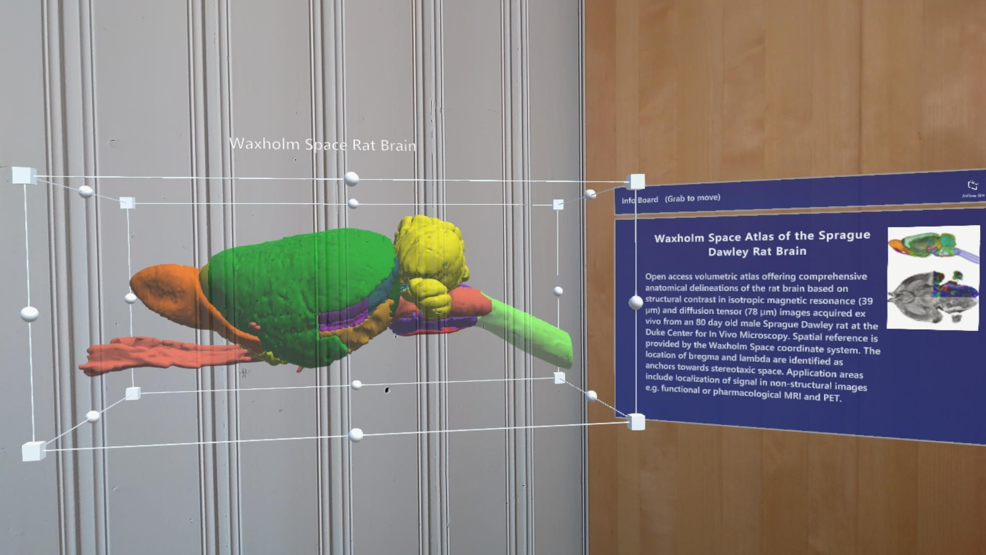
Figure 13.1. Model of the rat brain

The app allows users to explore the rat brain model and to test the acquired knowledge.
Nevrolens main features include:

- Brain dissection can be used to view custom or fixed axes (horizontal, coronal and sagittal) in the 3D model of the rat brain;
- Manipulations with the 3D model (move, rotate and scale);
- Model interaction, pointing at different brain parts, moving them to reveal the underlying structures;
- Textual descriptions of the different brain parts;
- Self-study, single user mode;
- Collaborative multi-user mode in which multiple learners, tutors or teachers synchronously interact with the 3D model. The collaborative mode allows multiple users to connect to each other through a system of digital rooms protected by secret codes. In the collaborative mode, the users can use voice chat and other synchronous collaboration features;
- User guidance, including contextual help and tutorials;
- Catalogue can be used to access a list of different brain parts or clusters of brain parts;
- Flashcards can be used to take an image of the spectator view, excluding the hand menu, add notes, and save the image;
- Save and load progress allow the users to save their current work locally on the device they are using or load their work from a previously saved session;
- Quiz feature presents a pool of 40 questions to the users that require selecting a brain part in the 3D model and allows them to test knowledge;
- Challenge each other feature that works in the collaborative mode allows learners to pose questions to each other and collaboratively answer them.

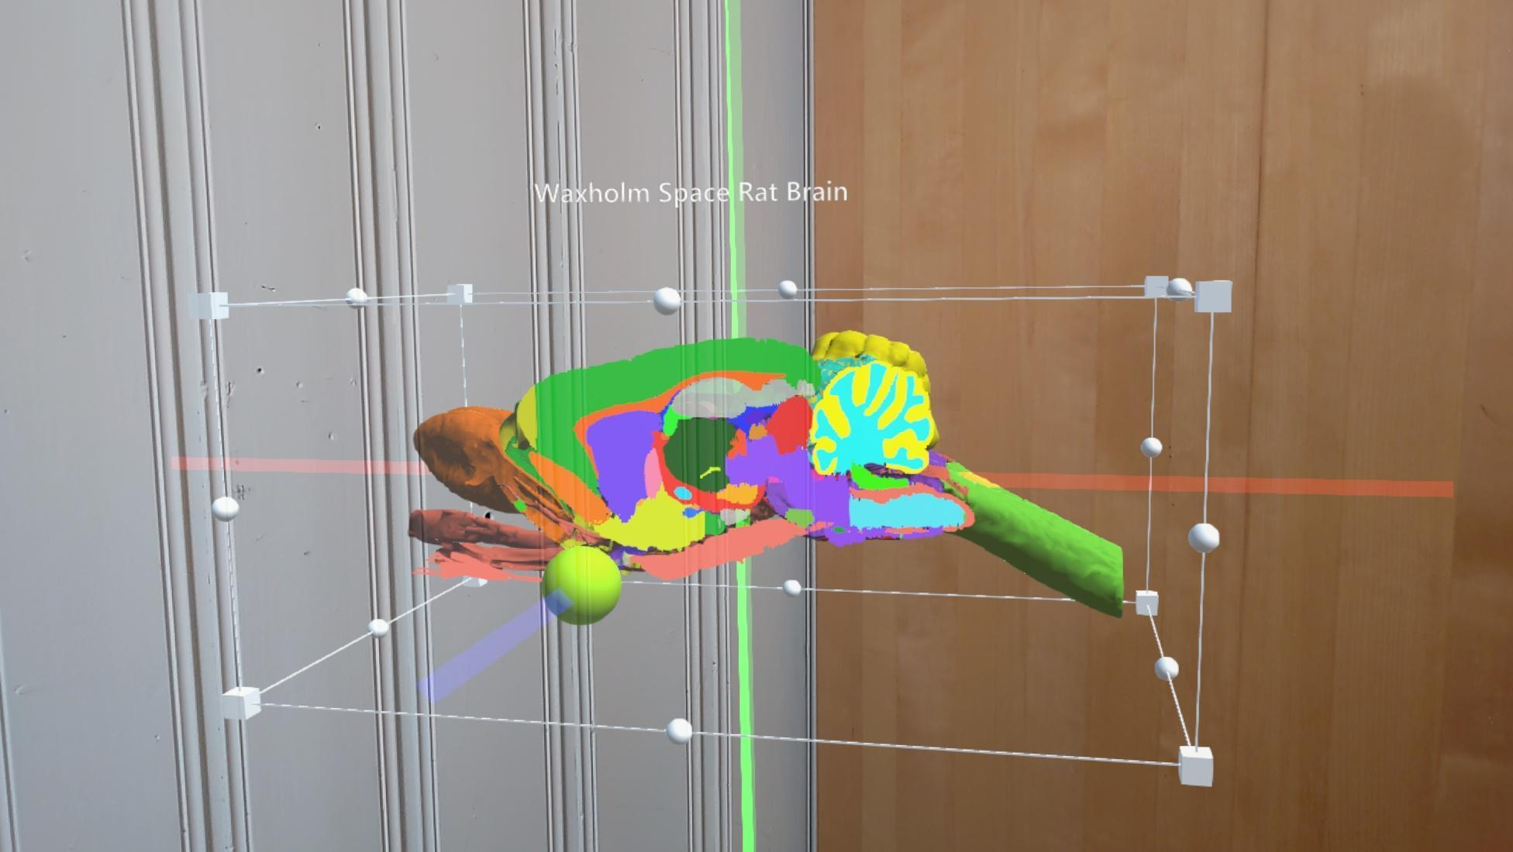
Figure 13.2. Dissection of the brain

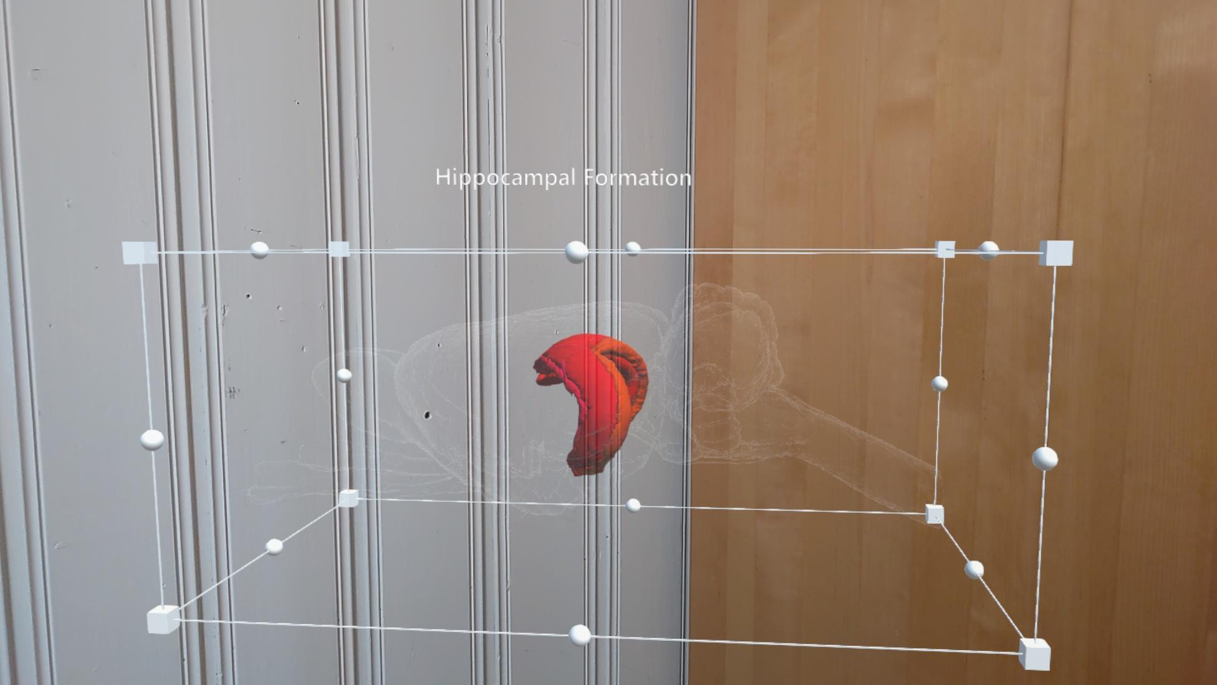
Figure 13.3. Viewing of separate areas of the brain

The app is being continuously developed and new features can be added.

Develop application for HoloLens

YouTube: https://www.youtube.com/watch?v=P8og3nC5FaQ
Tutorials: https://docs.microsoft.com/en-gb/windows/mixed-reality
Cost: Free, might require Unity Engine licence, more on that:
https://store.unity.com/compare-plans
Description: If it is relevant to develop an application for HoloLens 2, there exist several tutorials and ways to go about it. Microsoft has also created a free library to speed up the process.
Functionality: Usually the development of an AR application is done in Unity Engine: https://unity.com/ . It allows for visualisation of the models, running the application in a simulator and building to devices. Mixed Reality Toolkit (MRTK) needs to be downloaded and added to Unity Engine to be compatible with the HoloLens. Microsoft has created curated guide to start the development:
https://docs.microsoft.com/en-us/windows/mixed-reality/develop/unity/tutorials

List of Figures

Figure 1.1. Start screen 7
Figure 1.2. Sign Up 7
Figure 1.3. Creating a class 7
Figure 1.4. Adding students to a class 8
Figure 1.5. Students’ nicknames 8
Figure 1.6. Student login 8
Figure 1.7. Adding 3D objects 9
Figure 1.8. Import 3D objects from Sketchfab 9
Figure 1.9. Sharing AR scenes in the application’s home screen 10
Figure 1.10. Available lesson plans 10
Figure 1.11. AR scenes created by the students of a class 11
Figure 2.1. Sign in Page 12
Figure 2.2. Selection of a new project 13
Figure 2.3. Starting a new project 14
Figure 2.4 The types of projects 14
Figure 2.5. AR Scene for a Planar project (Scene Editor) 15
Figure 2.6. AR Scene for a Spatial project (Scene Editor 16
Figure 2.7. AR Scene for a Geo-Located project (Scene Editor) 16
Figure 2.8. 360 Scene (Scene Editor) 17
Figure 2.9. 360 view of a court 17
Figure 2.10a. HTML5 Scene Example 18
Figure 2.10b. HTML5 Scene Example 18
Figure 2.11. The Scene Editor 19
Figure 2.12. The Experience’s card 19
Figure 2.13. The Experience’s card (COMPLETED) 20
Figure 2.14. Project’s card 21
Figure 2.15. Public Gallery option 21
Figure 3.1. Web portal 22
Figure 3.2. Public Books section 23
Figure 3.3. Search filters 23
Figure 3.4. Augmentations of a Book 24
Figure 3.5. Display QR Code 24
Figure 3.6. My Books section 25
Figure 3.7. Create your Book section 25
Figure 3.8. Book details section 26
Figure 3.9. Augmentations section 26
Figure 3.10. Create augmentation section 27
Figure 3.11. Book display for trigger image cropping 27
Figure 3.12 Finish cropping 28
Figure 3.13. Home screen 29
Figure 3.14. Category list 30
Figure 3.15 Book list of a specific category 30
Figure 3.16 Augmentation over a trigger image 31
Figure 4.1. The Home Page for registering 32
Figure 4.2 Choosing the type of account 32
Figure 4.3. Create an account or Sign in 32
Figure 4.4. Create a new scene 33
Figure 4.5. Choosing the type of scene 33
Figure 4.6. A drag-and-drop object scene 34
Figure 4.7. The Environment and Edit button that allow editing a scene of a 360° tour 34
Figure 4.8. Choosing a picture and creating a new scene for it 34
Figure 4.9. The menu for the overview of scenes 35
Figure 4.10. An object dragged and dropped in the scene 35
Figure 4.11. The mask tool for making objects look like they are behind elements 35
Figure 4.12. Switching Scenes 36
Figure 4.13. Using the code blocks 36
Figure 4.14. Adding information about a place 36
Figure 4.15. Adding more objects and interactions 37
Figure 4.16. Various materials and colours that can be used for walls 37
Figure 4.17. Locking the walls of an exhibition after creating them 38
Figure 4.18. Putting objects in the exhibition to take their place in it 38
Figure 4.19. The actual exhibition 38
Figure 4.20. Selecting an environment of the story 39
Figure 4.21. Recording a new sound for the story 39
Figure 4.22. Assigning roles to the characters and putting bubbles for words above them 40
Figure 4.23. Deciding on characters’ actions 40
Figure 4.24. Connecting the scenes of the story 40
Figure 4.25. Setting the players’ movement 41
Figure 4.26. The lives of the player 41
Figure 4.27. Creating a new code block script 42
Figure 5.1. Register at H5P.org 43
Figure 5.2. Menu after login 44
Figure 5.3. AR Scavenger content type 44
Figure 5.4. Provide title and design the start screen of AR Scavenger 45
Figure 5.5. Sample markers 45
Figure 5.6. H5P interaction as augmentation 46
Figure 5.7. 3D model overlay as augmentation 47
Figure 5.8. View button and URL link 48
Figure 5.9. Final result in a mobile phone 48
Figure 6.1. Signup Page 50
Figure 6.2. Pricing 50
Figure 6.3. Support/Help link 51
Figure 6.4. Page for creating the first project 51
Figure 6.5. The “My Projects” page 52
Figure 6.6. Creating a new scene 52
Figure 6.7. A scene in edit mode 53
Figure 6.8. Adding objects to a scene 53
Figure 6.9. Selecting a video as an asset 54
Figure 6.10. Configuring the video 54
Figure 6.11. Adding animations 55
Figure 6.12. A motorbike as an introduced asset 56
Figure 6.13. The parts of a motorbike after completing their animation 56
Figure 7.1. Project types 57
Figure 7.2. Creating a new Blipp and upload markers 58
Figure 7.3. Providing a name and selecting images for the Blipp 58
Figure 7.4. The selected marker for the Blipp 59
Figure 7.5. Placing assets on the marker 59
Figure 7.6. Preview in mobile version 60
Figure 7.7. Actions on assets 60
Figure 7.8. Menu for animations and effects 60
Figure 7.9. The QR code of the project for preview 61
Figure 7.10. The QR code of the published project 61
Figure 7.11. The final result displayed on the mobile phone 62
Figure 8.1. Selection of scene type within a project 64
Figure 8.2. The Onirix scene editor 64
Figure 8.3. A 3D Model 65
Figure 8.4. A widget 65
Figure 8.5. Regular elements and events 66
Figure 8.6. Publish an experience 66
Figure 8.7. The logo of Onirix SDK 67
Figure 8.8. Onirix in medicine and training 67
Figure 8.9. Scanning for markers that will display labels with information 68
Figure 8.10. Loading assets after scanning 68
Figure 8.11. Showing the labels related to an asset 69
Figure 8.12. Displaying several components of an asset 69
Figure 9.1. The 3D model in .GLB format is provided by Poly Google. 72
Figure 9.2. Once an unlocked and turned on HoloLens 2 is connected to the PC, it should appear in the File Explorer. 72
Figure 9.3. Add the file of the 3D model to HoloLens’ internal storage in 3D Objects folder 73
Figure 9.4. Once the 3D viewer application is opened in the HoloLens 2, user will see a library of available 3D models 73
Figure 9.5. To upload a new 3D model, user needs to go to “From File” section and press “Open” 73
Figure 9.6. There, a File Explorer will appear, where users can navigate to the place where the 3D model was upload to and click on the file. 74
Figure 9.7. Once the 3D model is uploaded, the user can move, rotate and scale it 74
Figure 9.8. Model of an urban city allows for a discussion about infrastructure and placement 75
Figure 10.1. To acquire the application, the user will need to search for it in Microsoft Store on HoloLens 2 and download it from there 76
Figure 10.2. When the application is installed, a new 3D model can be uploaded through OneDrive 77
Figure 10.3. Library of 3D models with option to upload new ones 77
Figure 10.4. The uploaded 3D model will appear in the application 78
Figure 10.5. To view the model, the user needs to press on the file 78
Figure 10.6. Drawing tools allow users to annotate 79
Figure 10.7. Students can build planetary systems together 79
Figure 11.1. Giving instructions connected to real life objects by drawing in 3D 80
Figure 12.1. Showing the bone structure of a human body 81
Figure 12.2. Muscles of a human body with highlighted names. 82
Figure 13.1. Model of the rat brain 83
Figure 13.2. Dissection of the brain 84
Figure 13.3. Viewing of separate areas of the brain 85

Annex 1: Web links
A list of all web links to all platforms is available below (Table 1). The table also contains interesting AR platforms that are not included in the toolkit.
Platform | Web link
3DBear | https://www.3dbear.io/
AR-Media | https://www.inglobetechnologies.com/ar-media
AR-Scavenger | https://h5p.org/content-types/ar-scavenger
ARTutor | http://artutor.ihu.gr/about/
AWE | https://awe.media
BlippBuilder | https://www.blippar.com/build-ar
CoSpaces Edu | https://cospaces.io/edu/
JigSpace | https://jig.space/
Metaverse | https://studio.gometa.io/landing
Onirix Creative Studio | https://www.onirix.com/creative-studio/
UniteAR | https://www.unitear.com/
Vidinoti V-Director | https://www.vidinoti.com/v-director/
ViewAR | https://www.viewar.com/
ZapWorks Designer | https://zap.works/designer/
Table 1. Platform links

Annex 2: 3D models repositories
A list of 3D models repositories is available below (Table 2).
Repository | Web link
Free3D | https://free3d.com/
GrabCad | https://grabcad.com/
Libre3D | https://libre3d.com/
Sketchfab | https://sketchfab.com/
Thingiverse | https://www.thingiverse.com/
Turbosquid | https://www.turbosquid.com/
YouMagine | https://www.youmagine.com/
Table 2. 3D models repositories

